South-west marine ecosystems in 2014
Observations reported at the South-West Marine Ecosystems meeting 2015 and other sources

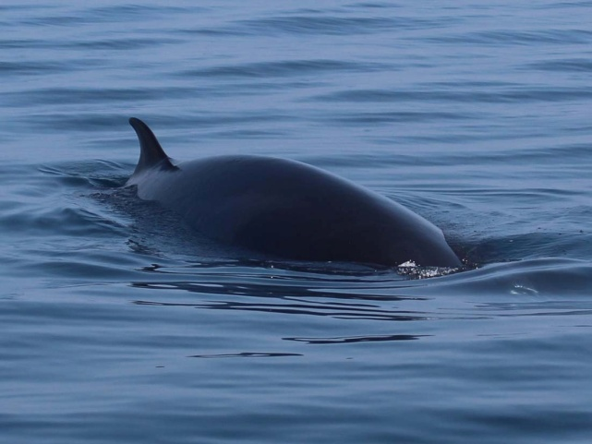 |  | 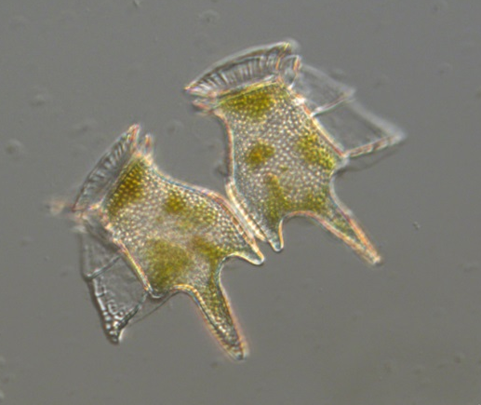
Sightings: minke whale, south-west Cornwall |  | Unusually high abundances: Dinophysis tripos
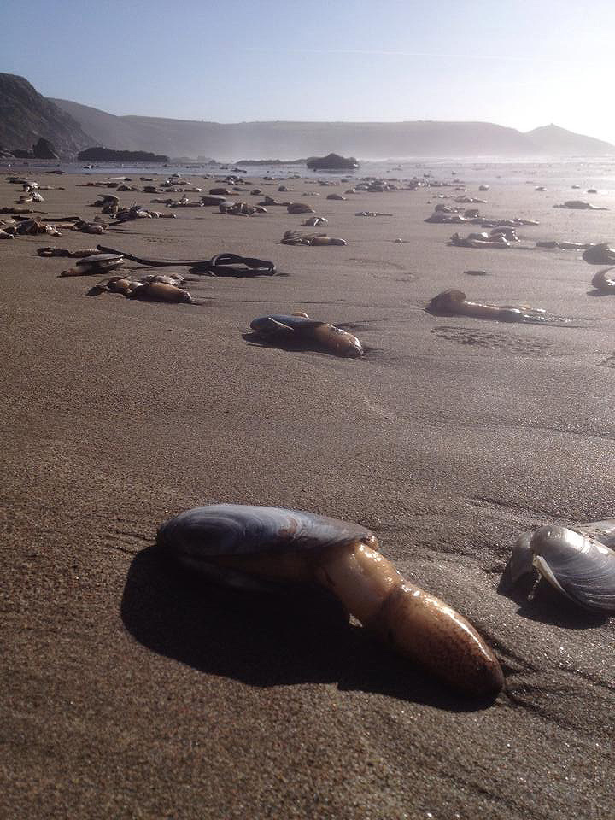 |  | 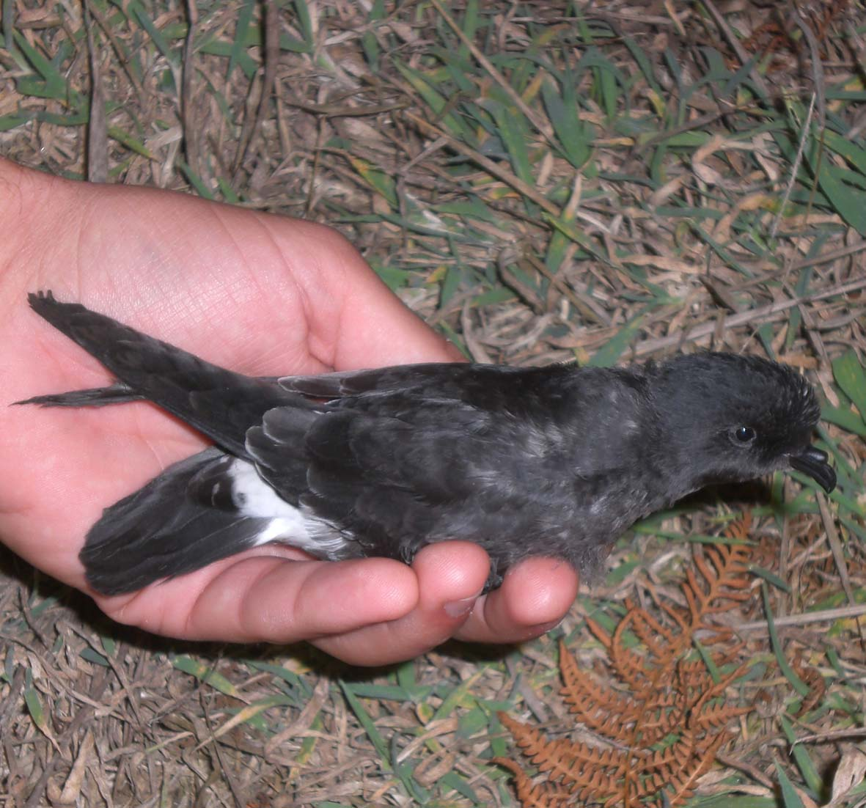
Storm impacts: washout of clams, Whitsand Bay |  | First records: stom petrel chick on Lundy
Edited by Keith Hiscock and Bob Earll with the section editors:
Angus Atkinson, Andy Bell, Doug Herdson , Tom Horton, Duncan Jones, Allen Kingston, Andrea McEvoy, Sue Sayer, Emma Sheehan, Alice M. Trevail, Claire Widdicombe and Ruth Williams
South-west marine ecosystems in 2014
A collation of observations reported at the South-West Marine Ecosystems meeting on 13th March 2015 with some supplementary material.
Introduction
Every year brings new events or variations on the ‘usual’. Recording those events will help us better identify patterns and linkages as well as the effects of, for instance, severe weather, climate change and the arrival of non-native species. Making and recording observations contributes to the fund of natural history knowledge that informs science, conservation and that enriches our lives.
We would like to thank the editors of each section and to the contributors of observations. Do keep on recording in 2015, and if you can add numbers to your estimates of ‘good’ or ‘bad’ that really helps to provide a measure of what is being reported, ready to submit your sightings etc. when the next South-West Marine Ecosystems meeting is held on 8th April 2016.
Keith Hiscock
Bob Earll
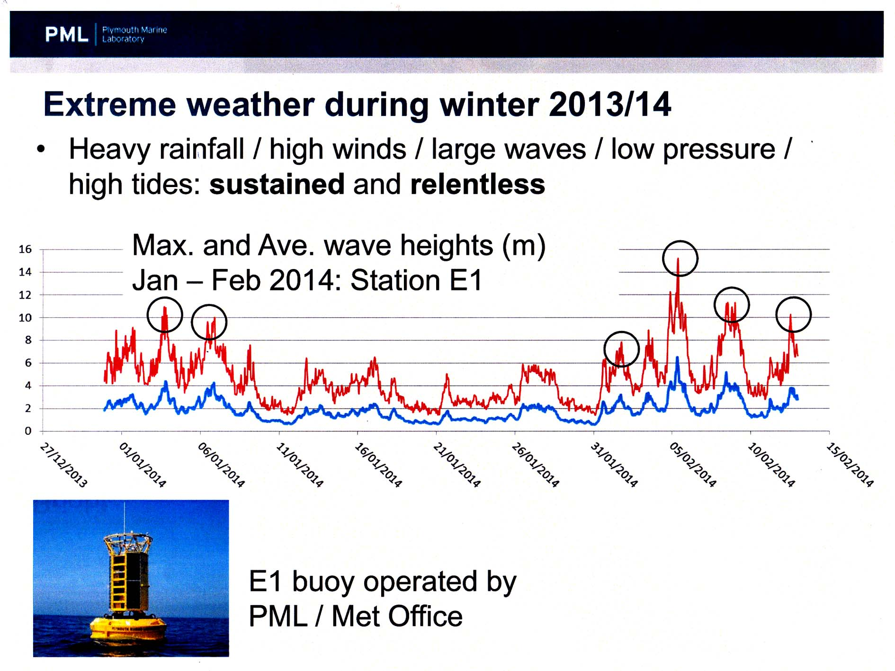
Maximum and average wave heights early in 2014 measured by the PML/Met Office oceanographic buoy at E1, south of the Eddystone reef. Wave heights in excess of 14m are described as ‘phenomenal’. (The buoy wave sensor was overwhelmed during the storms on the 14th February.) From a PowerPoint slide, courtesy of Dr Tim Smyth, Plymouth Marine Laboratory.

The year at a glance: highlights
2014 was the ‘Year of the storms’ with severe weather conditions that generated ‘phenomenal’ wave heights, culminating on 14th February with a massive storm. Movements of beach material and coastal erosion featured most conspicuously in the public perception of early 2014 but there were wash-outs of marine species and impacts from high water turbidity. Impacts on coastal geomorphology and subsequent recovery can be seen in reports available from http://www.coastalmonitoring.org/reports/ (you will need to ‘shop’ for relevant reports). Effects on marine life were summarized in a report in the Bulletin of the Porcupine Marine Natural History Society which can be accessed from http://plymsea.ac.uk/6490/ and will not be repeated here. Then, everything seemed to settle down to much as always (including plankton and very little damage to benthic marine life) except that there were notable and large numbers of jellies (Cnidaria: Scyphozoa and Ctenophora) from about April onwards. (However weekly monitoring at the L4 site, described in the next section, did not find elevated Ctenophore numbers in 2014). There were absences or low numbers of some expected species such as basking sharks and trigger fish.
Many people reported that the summer was drier and hotter that is to say ‘a proper summer’.

Plankton
Compiled/Edited by Keith Hiscock, Angus Atkinson, Claire Widdicombe and Andrea McEvoy
Introduction
Observations of plankton (free floating aquatic organisms from bacteria to jellyfish) are mostly from scientific sampling programmes at specific locations but include valuable and widespread observations by snorkelers and divers of jellyfish and of the ‘signs’ of some microscopic plankton. The sampling described here is from the Western Channel Observatory (WCO) programme (www.westernchannelobservatory.org.uk/) which has a 100-year history [information on long-term observations in the western Channel can be found in Southward et al. (2005) and a more recent summary of changes over the past 25 years at WCO sampling station L4, 13 km south of Plymouth, is given in Atkinson et al. (2015)].
Whilst casual observers are unlikely to ‘see’ small or microscopic plankton, algal species such as Phaeocystis spp. and (the non-native) Coscinodiscus walesii produce copious quantities of mucus which can be seen by divers, form foam on beaches and is sometimes noted as clogging fishing nets. ‘Needle’ plankton may appear in underwater photographs and the larvae of Luidia spp. are very conspicuous as small starfish in a mucus sheath. ‘Jellies’ (Phylum Cnidaria, Class Scyphozoa; Phylum Ctenophora) form the great majority of observations noted by participants in the SW Marine Ecosystems meeting).
Phytoplankton
There was an unusual start to the year with an early influx of rarely seen Trichodesmium in January which was ‘blown in’ during the storms and persisted until April [Gerald Boalch, Andrea McEvoy, Claire Widdicombe]. Identification by Karen Tait using molecular techniques named it as T. tenue, a colonial cyanobacteria normally associated with tropical waters. There was a normal spring plankton bloom. There were high levels of ASP toxin (associated with diatoms of the genus Pseudo-nitzschia, which commonly occurs during summer months) found in scallops caught in the Channel. The increased toxin levels started in May 2014 and persisted through the year and were probably due to warm water temperatures/mild winters [Katie Arnold and Claire Widdicombe]. Other phytoplankton species that are potentially toxic were regularly recorded in the WCO samples and include dinoflagellates Dinophysis acuta, D. tripos and Karenia mikimotoi. There was a coccolithophore boom in late summer-early autumn [Claire Widdicombe].

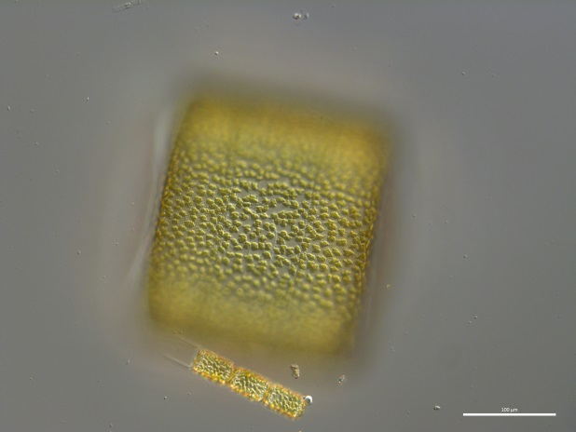 |  | 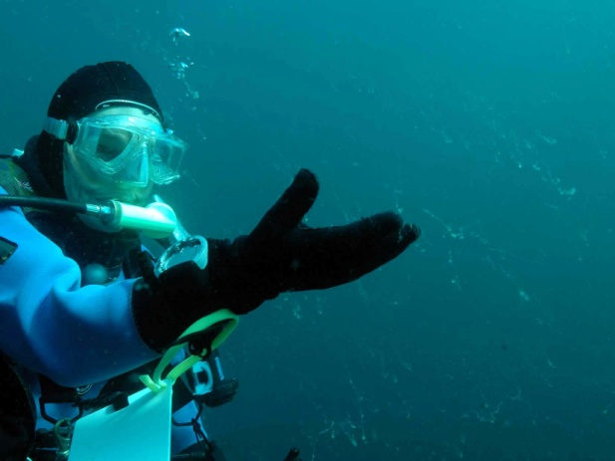
The marine diatom Coscinodiscus wailsii produces mucus which can clog fish gills and fishing nets. The organism is about the size of a full stop but is usually detected by divers when it forms strings of mucus in the water column that also foul seabed species. (Images: Plymouth Marine Laboratory and Keith Hiscock.)

A bloom of diatoms (like the spring bloom) was present in December 2014 [Gerald Boalch] and contained the unusual occurrence of diatoms such as Helicotheca tamesis and Bacteriastrum hyalinum [Claire Widdicombe].
T. tenue was also observed during the Autumn and persisted in the Celtic Sea for several weeks. There were high abundances of diatoms in December including unusual observation of diatoms, Bacteriastrum sp(p) [Claire Widdicombe].
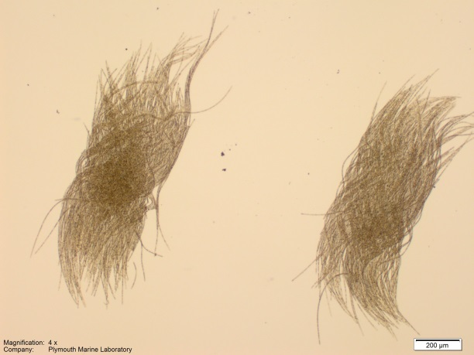 |  | 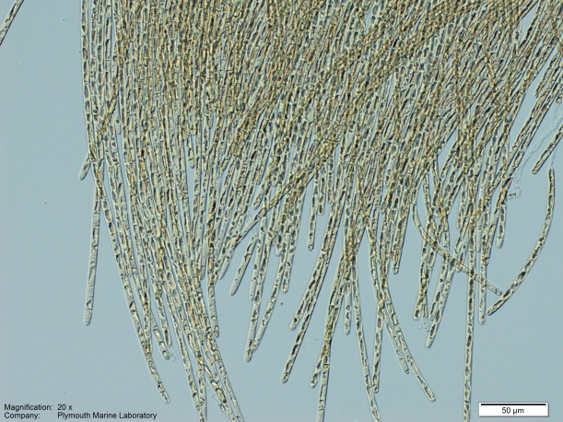
The cyanobacteria Trichodesmium tenue. A highly unusual occurrence was recorded at the WCO between January and April and again during September (Images: Claire Widdicombe).

There was a bioluminescent bloom on the south coast of Cornwall (Falmouth Maenporth) for an extensive time in mid-summer [Sally Rangecroft].
Despite some comments about plankton being ‘much as always’, the last few years have not been consistent with any ‘normal’ pattern of phytoplankton and may represent a changeover in the Russell Cycle [Gerald Boalch].

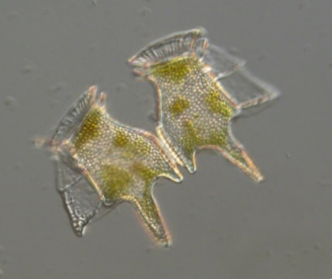 |  | 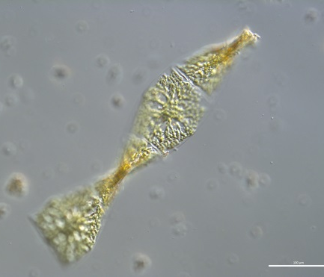 |  | 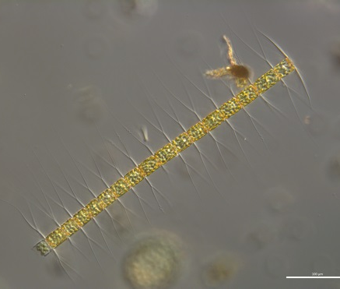
The potentially toxic Dinophysis tripos was un-usually abundant during summer months (Image: Claire Widdicombe). |  | Helicotheca tamesis and Bacteriastrum hyalinum have not been regularly observed in WCO samples for several years (Image: Claire Widdicombe).

Zooplankton, especially ‘jellies’
There was an early influx of the larvae of the starfish Luidea spp. and the swimming worm Tomopteris helgolandicus, most likely brought about by the south-westerly strong winds in late winter [Richard Kirby].
Based on the weekly zooplankton sampling by PML at the L4 time series site, observations to note in 2014 are firstly that the calanoid copepod Microcalanus sp was found in moderate numbers during April. It is normally associated with the lower part of the water column and not generally found at L4. Second, the siphonophore Muggiaea atlantica was almost absent from L4 in 2014. This is unusual as they are normally common in high numbers in the spring or early summer. It should be stressed that the nets used at this site are not suitable for catching the larger, rarer organisms such as barrel jellyfish which, based on observations in 2015, are often found in higher numbers closer inshore. (PML sampling during 2015 is attempting to assess the biomass of barrel jellyfish relative to the other zooplankton.) [Claire Widdicombe].
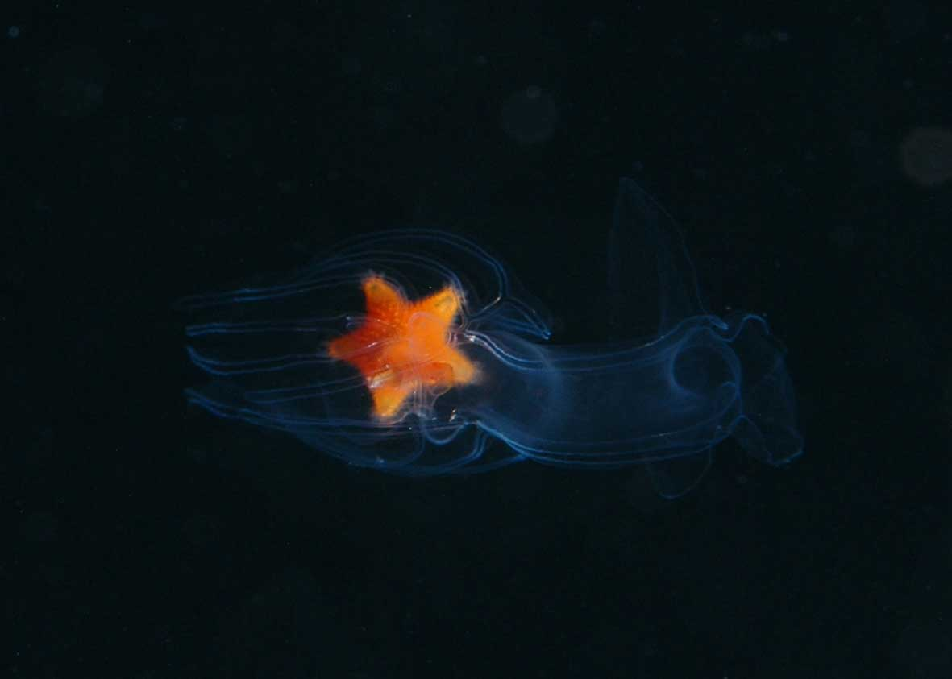 |  | 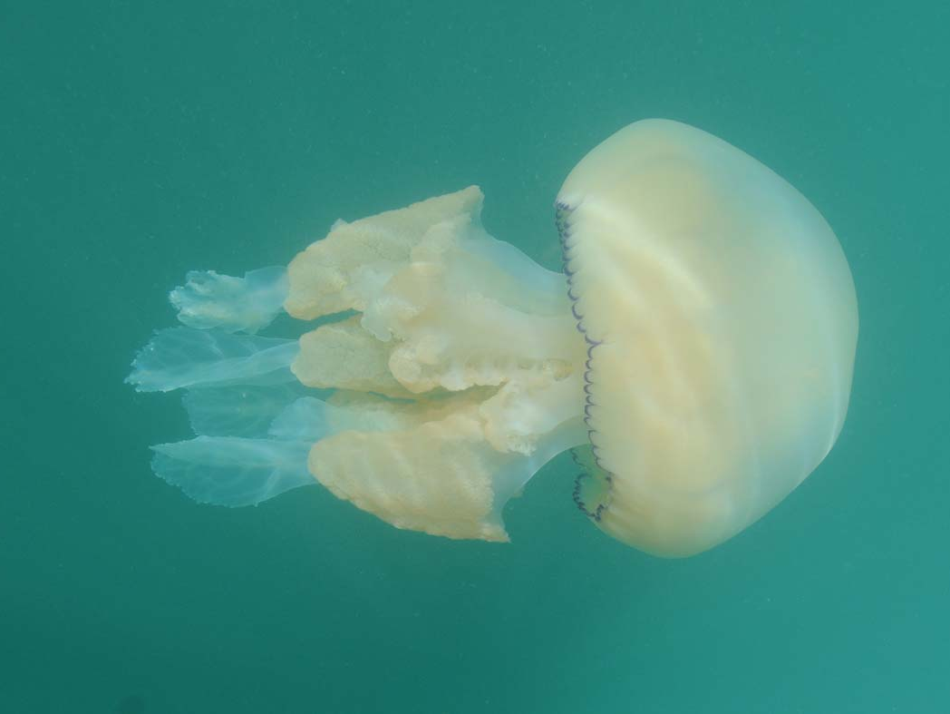
Larva of the starfish Luidia sarsi, present earlier than usual. (The starfish is about 4mm across.) (Image: Keith Hiscock) |  | The barrel jellyfish Rhizostoma pulmo, present in large numbers from about April. (Total length about 70 cm.) (Image: Keith Hiscock)

There were significant influxes of gelatinous plankton in 2014. Barrel jellyfish (Rhizostoma pulmo) were most conspicuous and were reported as in large numbers off south Devon and south Cornwall by many participants. Contributors of information are acknowledged here where their records are linked to dates and/or locations. In and near Penzance Harbour on 13 June [Brian Craven]. “From March/April started hearing reports of masses of Rhizostoma pulmo further east [than Mounts Bay] and further out to sea, from fishermen and other wildlife tour operators. In April they started appearing in Mount's Bay in large numbers, from the east. Stayed all summer through many different weather systems and tides. Also large numbers of compass jellyfish. Continued into winter.” [Gill Bridges]. Niki Clear observes that Rhizostoma were being reported by fishermen caught in deepwater trawls off south Cornwall. “Sightings of barrel jellyfish in Fowey River - never seen before” [Margaret Gardener]. Dense aggregations of barrel jellies around Penzance and South Penwith in May/June - also many small (approx 10cm) blue Cyanea [Paul Somerfield]. “Abundance of Rhizostoma pulmo from early May until end of year” [Julie Hatcher, Dorset]. By-the-wind Sailors and mauve stingers 300+ of each on Chapel Porth beach in December [David Williams]. “Masses of small jellyfish (probably moon jellyfish [Aurelia aurita]) at Penhale throughout the summer. Blue jellies [most likely Cyanea lamarckii] abundant also here and Porthtowan” [Brian Williams]. South Devon - Crystal jellyfish (Aequorea forskalea] in Salcombe [Nigel Mortimer, 27 July].
The sightings of highly conspicuous jellyfish in the water column may ‘overwhelm’ sightings of other jellies, especially ctenophores but possibly also siphonophores (Cnidaria: Hydrozoa) that may have been present. Rachel Gillingham notes “Masses of barrel jellyfish and other jelly species - also Ctenophores (comb jellies)”. Plankton hauls off Plymouth as part of the WCO work reported many ctenophores. However, 2014 was not a ‘good year’ for Siphonophores such as Muggia.
There are remarkably few observation from north-facing coasts but Dave Jenkins observes “Jellyfish Aequoria species present on Woolacombe beach from 5/8/14 to 3/3/15. Greatest number on 31/8/14”.
(An interesting observation by Gill Bridges in relation to the jellyfish blooms, was “Many people assumed leatherback turtles would ‘follow’ them - only saw one.”)
References cited
Atkinson, A., et al. Questioning the role of phenology shifts and trophic mismatching in a planktonic food web. Prog. Oceanogr. (2015), http://dx.doi.org/10.1016/j.pocean.2015.04.023
Southward, A. J., Langmead, O., Hardman-Mountford, N. J. et al. (2005) ‘Long-term oceanographic and ecological research in the western English Channel’, Advances in Marine Biology, vol 47, pp. 1-105.

BENTHOS
Edited by Emma Sheehan
Introduction
The benthos in 2014 was greatly impacted by the severe storm events over winter 2013/2014, causing species wash-outs and movements of sediment. However, some species have had a good year, with large numbers of juvenile lobsters and brown crabs noted in Lyme Bay. There have been new recordings of species showing signs of range expansion, including seaweeds and bryozoans. Marine litter is posing a threat to benthic marine organisms, highlighted by the appearance of pink sea fans wrapped up in fishing line.
Storm impacts
Impacts of the severe storms in winter 2013/2014 are summarized in Hiscock (2014). The following, with some additional information, are highlights.
Reef habitats and species were damaged where sand, cobbles, pebbles and small boulders were mobilized, damaging or displacing the species living on them and causing scour to adjacent habitats, such as bedrock. The scour also caused abrasion of limpet shells and many were very thin. Damage was particularly conspicuous in intertidal areas where ‘hotspots’ of damage occurred to barnacles, boulders were displaced from rock pools and some rock pools drained where boulders blocking an exit became displaced. Damage caused by mobile hard substrata also occurred in subtidal areas where seafans were displaced and the lower part of the skeleton scoured. Severe damage occurred to some wrecks where plates (with their attached biota) were overturned or covered by displaced material. Many pink sea fans Eunicella verrucosa were washed-up on strandlines.

 |  | 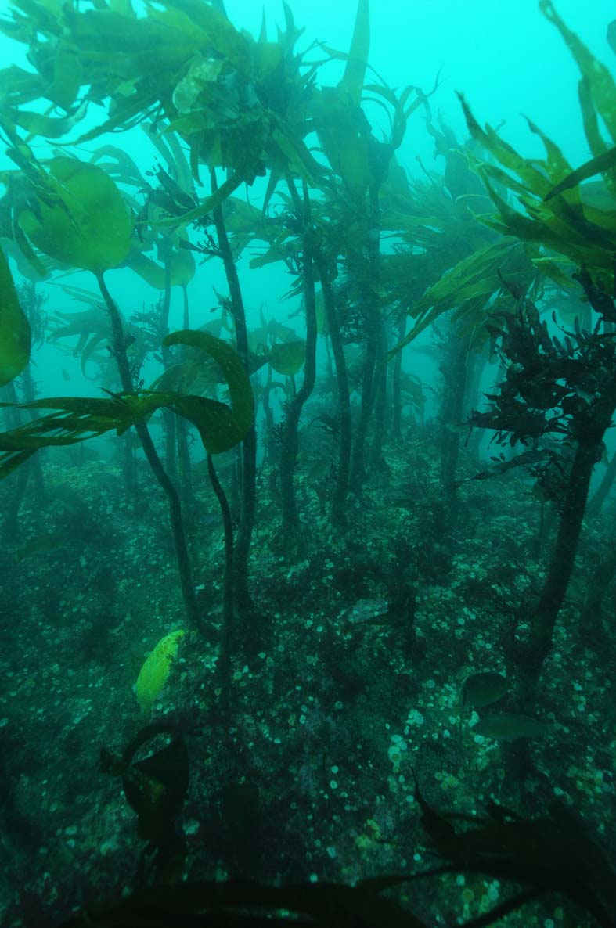
There were some significant ‘wash-outs’ as a result of the winter storms. Here, otter shells, Lutraria lutraria at Whitsand Bay, south Cornwall on 20th February. (Image: Darren Newton.) |  | ‘Milky water’ persisted after the storms but the benthos on reefs was much as always. Here on 9th April at Hand Deeps offshore of Looe. (Image: Keith Hiscock.)

Although some intertidal species such as mussels were detached by waves, the great majority of species living on inter- and sub-tidal reefs appeared unaffected including kelp forests, sea fan forests, attached anemones, soft corals, Ross coral Pentapora foliacea and large ascidians etc. Colonization on the Scylla artificial reef was much the same after the storms as in 2013.
Sediments were greatly disturbed on open coasts and there were wash-outs of burrowing species, conspicuously including otter shells Lutraria lutraria and razor fish Ensis sp(p). There were local strandings of mantis shrimp Rissoides desmaresti. Burrowing policemen anemones Mesacmaea mitchelli were displaced and seemed not to be able to re-burrow as they continued to be caught in surface trawls during the summer. King scallops Pecten maximus were displaced, buried or otherwise damaged, and areas previously fished were unproductive. Seagrass beds, which usually occur in local shelter, were largely unaffected but, at Long Rock near Penzance, considerable damage occurred.
There was a significant decrease in the abundance of benthic organisms in Lyme Bay after the storms. In particular, the abundance of pink sea fan Eunicella verrucosa, Ross coral Pentapora foliacea and branching sponges significantly decreased. The abundance of king scallops Pecten maximus also decreased, with the quality of scallops compromised; there were lots of empty shells and a reduction in muscle mass. Also in Lyme Bay, a huge amount of static gear was lost by the fishing industry, which has consequences for ghost fishing and damage to benthos.
[Keith Hiscock, Jason Hall-Spencer, Zetty Deraman, Emma Sheehan, Adam Rees, Sarah Gall]
Observations
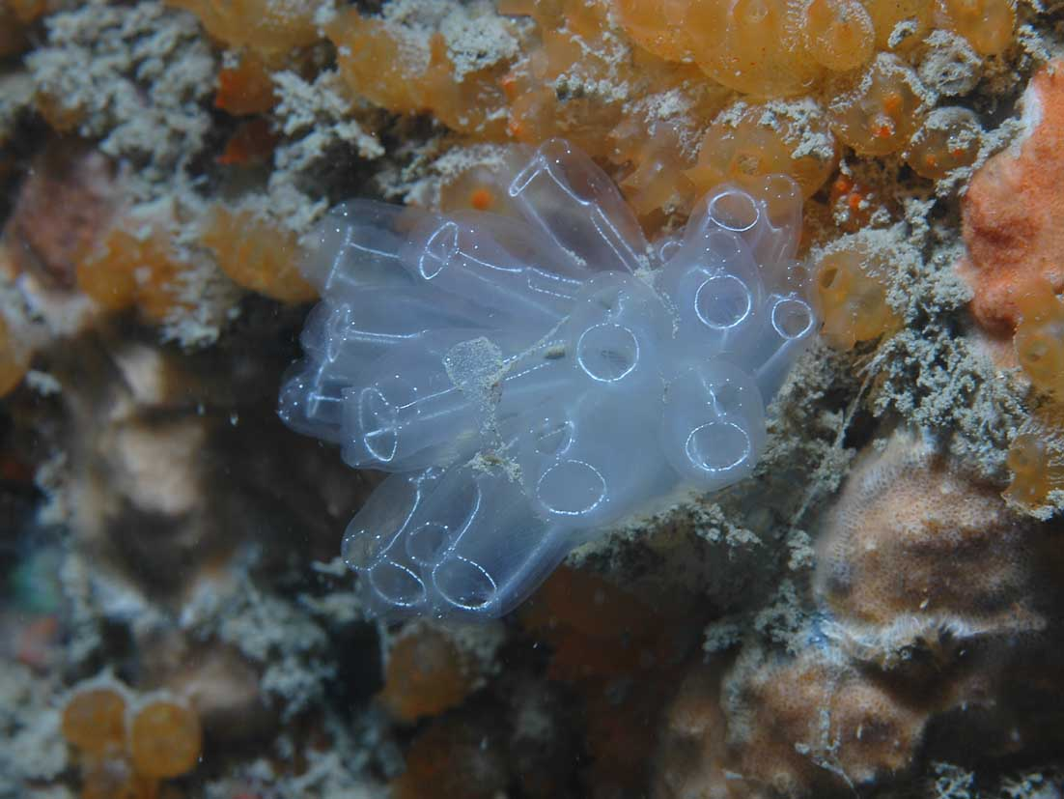 |  | 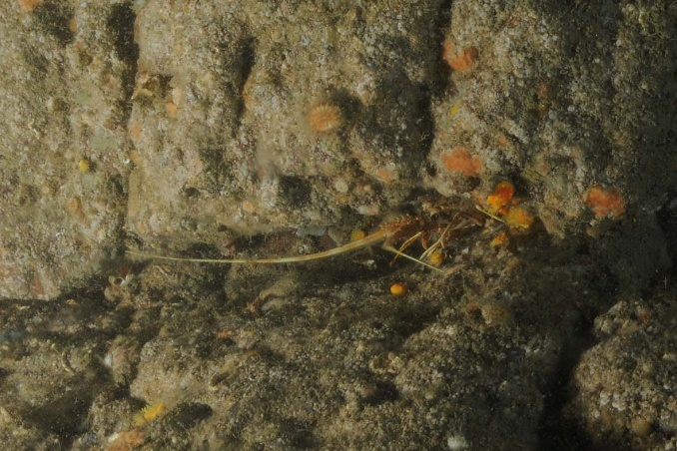
Football seasquirt Diazona violacea recruit. Image: Keith Hiscock |  | Crawfish/spiny lobster (Palinurus elephas) recruit offshore of Plymouth Sound in May 2014. Image: Keith Hiscock

There has been a remarkable recruitment of football sea squirts Diazona violaca in some areas of South Devon. This was first observed in 2008 and has continued into 2014. There have been several sightings of juvenile spiny lobsters Palinurus elephas on the reefs in Falmouth Bay and off Plymouth. The depilatory sea hare Aplysia depilans has been found to be breeding at Marazion, Cornwall; a presence of egg masses in a rock pool. There were three individuals recorded which measured up to approximately 30 cm in length. In the Plymouth University Lyme Bay Study, policeman anemone Mesacmaea mitchellii was observed for the first time.
[Keith Hiscock, Tony Sutton, Liam Faisey, Esther Hughes, Emma Sheehan]
Non-native species
There were some range extensions recorded but no new NNS for the south-west in 2014. The ascidians Corella eumyota and Perophora japonica were observed in St Ives Bay [David Fenwick] and Undaria pinnatifida, Corella eumota and Bugula stolonifera in Watchet [Christine Wood]. A particularly significant record was of the red seaweed Pikea californica (Captain Pike’s weed), which had been known from the Isles of Scilly at wave-exposed locations since the 1960s and was found for the first time on mainland Britain both within and on the outside of Newlyn Harbour from late 2014 [David Fenwick]. The seaweeds Umbraulva olivasens, Chrysymenia wrightiiand Dictyota cyanoloma were observed in Falmouth. There has also been a significant increase in the cover of the seaweed Caulacanthus okamurae since Spring 2014 in the Plymouth and South Devon area. There were other locations studied for NNS by the Bishop Group at the MBA: see www.mba.ac.uk/bishop or @NNSatMBA.
[Christine Wood, Lisa Rennocks]

Interactions with use and management
There was a large number of large pink sea fans Eunicella verrucosa in Lyme Bay. However, large amounts of monofilament fishing line has been noted to be wrapped around them, with fishing plastic washed-up in bundles full of sea fan skeletons. This was also observed in Chesil Beach, Newquay and Wembury, showing how recreational angling from boats is having a clear impact on the health of pink sea fans.
2014 was a great year for juvenile lobsters in Lyme Bay with large numbers caught in fishing pots. The brown crab Cancer pagurus, which was expected to be impacted, was also very abundant.
There has been a rapid spread of electric pulse fishing in the Southern North Sea, including UK flagged vessels that are owned by the Dutch.
[Will Maclennon, Jason Hall-Spencer, Emma Sheehan, Adam Rees]
References
Hiscock, K. 2014. After the storms. Porcupine Marine Natural History Society Bulletin, 2, 45-48. (http://plymsea.ac.uk/6490/).

FISH AND REPTILES
Edited by Doug Herdson
Overview
There were some ‘highlights’ (unusually high abundances) and some ‘low lights’ (much lower abundances than usual) of species.
Storms
The storms in early 2014 seemed to have remarkably few obvious effects.
There were no strandings that were not ‘normal’ or ‘expected’ for particular times of the year.
Elasmobranchs
There were very few sightings of basking sharks (Cetorhinus maximus): the numbers were about a third of those in most recent years, and were mainly along the north coast. Nearly all of the sightings were early, i.e. between April and June including [Tim Jones from the LFS logbook] three sightings off the east side of Lundy between late April and mid-May.
A probable bluntnosed sixgill shark (Hexanchus griseus) was seen in Newlyn Harbour in September.
A marbled electric ray (Torpedo marmorata) was caught in Whitsand Bay in September.
[Tom Horton, Brian Craven, Niki Clear, Sophie Banham, John Richardson, Tony Sutton, Amelia Bridges, Liam Faisey, Cat Gordon, Hannah Jones, David Fenwick Snr.]
Pelagic species
There were large shoals of ‘whitebait’ or ‘baitfish’ in shallow areas in the second half of 2013, and this was repeated in 2014. Small clupeids – young herring, pilchard and sprats (= whitebait) were abundant in shallow bays in Devon and Cornwall in the latter half of 2014. (The few I was able to identify were all juvenile herring (Clupea harengus).) CEFAS’s Peltic survey (CEND2014 Cruise report), which monitors the small pelagic fish community in October around the Cornish Peninsula, found juvenile sprat to be more widespread and more abundant than in previous years. As a consequence, there was a vast influx of mackerel into inshore areas from August onwards. Attempts to avoid the intense predation by mackerel and other fish were the probable cause of mass strandings of small clupeids on beaches, in harbours and rockpools along the south coast. The reason for the high abundance of small clupeids would be speculative but small fish generally follow plankton.
[Jeroen Van Der Kooij, Douglas Herdson, Hannah Jones, Martin Attrill, Gill Bridges, Amelia Bridges, Adam Rees, Matt Carter, Liam Faisey, James Duffy, Liv Spencer, Llucia Mascorda, Emma Sheehan, Katie Arnold, Paul Somerfield, Elizabeth Elliot, John Hepburn]
2014 was an ‘anchovy year’, with large shoals of anchovy (Engraulis encrasicolus) occurring off Portland in early October and moving west to south Devon and Cornwall from the end of the month through to December. The 7th Derbio (Trachinotus ovatus) recorded from British and Irish waters was caught amongst a shoal off Rame Head.
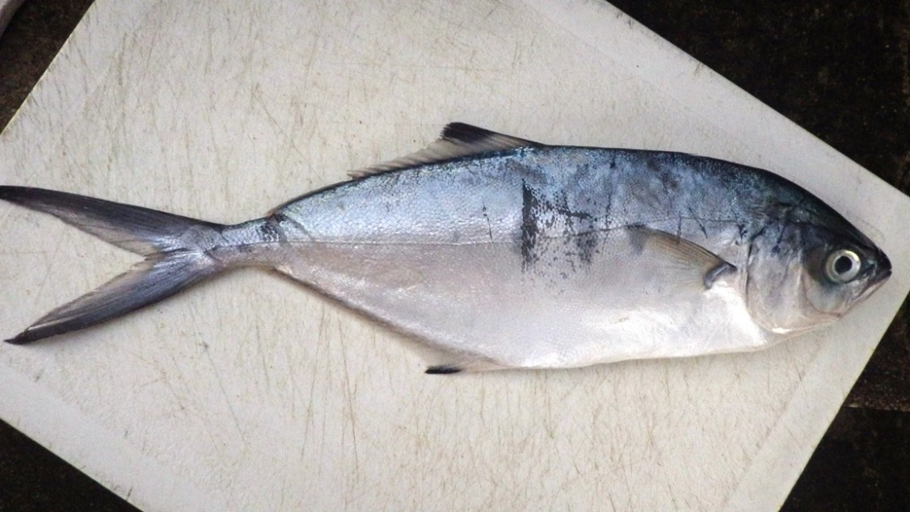
Derbio caught amongst an anchovy shoal off Rame Head (Image: Douglas Herdson).
[Jeroen van der Kooij, Sophie Banham, Douglas Herdson]
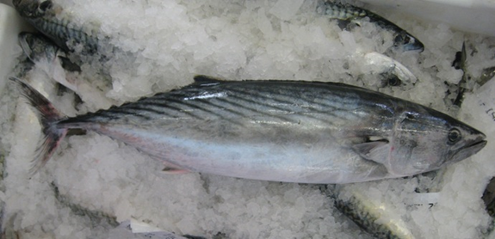
Bonito (Image: Douglas Herdson).
2014 was an ‘outstanding’ year for bonito (Sarda sarda) and a major ‘feature’ of the year from the Channel Islands to Cornwall; numbers being regularly found amongst the mackerel, presumably feeding on the small clupeid aggregations The bonito were nearly all juveniles, whereas in other good years (2003 and 2012) they had been adults.
[Liam Faisey, Jo Zeimann, Douglas Herdson]
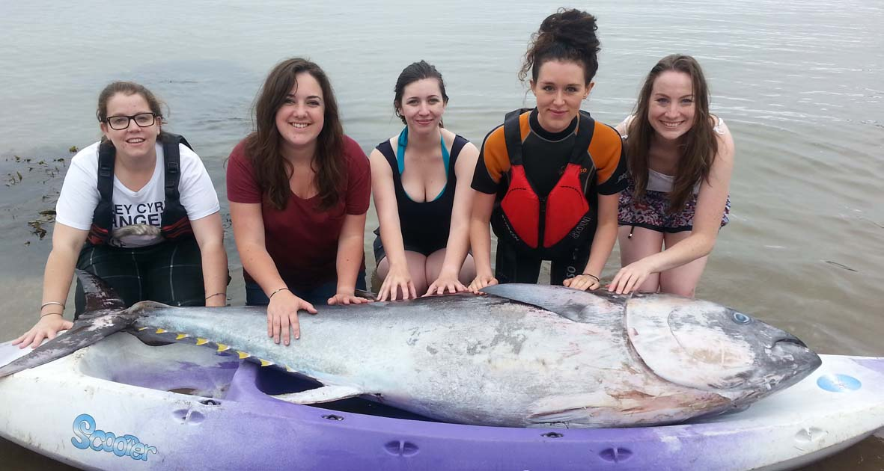
A bluefin tuna found dead in Cawsand Bay during the summer (Image: Claire Wallerstein).
2014 was a good year for bluefin tuna (Thunnus thynnus), possibly better than 2011; but there are no catch data as it is no longer legal to land them. One was filmed swimming around a boat off Start Point and there were also a number of probable sightings. Further sightings of bluefin tuna were made on the Peltic survey in October, when several individuals were observed 30 miles north of Land’s End chasing schools of garfish in an area where large schools of mixed sprat and sardine were also present. Bluefin tuna were also found dead at Portland (Dorset) and Kingsand (SE Cornwall).
[Tom Horton, Amelia Bridges, Mark Beech, Claire Wallerstein, Alan Steer, Jeroen van der Kooij, Douglas Herdson]
It was a poor year for ocean sunfish (Mola mola), with a few being seen around Tintagel and Scilly. Reports to Cornwall Wildlife Trust showed a 60% decline from 2013; with the largest group of just four compared with regular shoals of up to 20 in 2013.
[Tom Horton, John Hepburn, Paul Somerfield, Brian Craven, Caz Waddell]
Demersal species
2014 was a good year for cod (Gadus morhua), with a large influx of cod to inshore waters around SW, possibly as a result of large numbers of recruits in 2010; when young codling were abundant, especially around Scilly.
[Liam Faisey, Douglas Herdson]
The adult stock of bass (Dicentrarchus labrax) was down in 2014, due to poor recruitment in 2008 - 2012. However, 2014 was a good year for the juveniles with abundant 0 and 1 year bass in the estuaries.
[Al Kingston, Libby Ross, Sophie Banham]
A lumpsucker (Cyclopterus lumpus) nesting in in Falmouth Bay in May is notable because this species normally breeds earlier in the year in southern Britain.
[Tony Sutton]
There were just two reports of seahorses in 2014. A spiny seahorse (Hippocampus guttulatus) in Kingsbridge Creek in the autumn, and a short-snouted (Hippocampus hippocampus) at Station L4 south of Plymouth in November.
[Nigel Mortimer, Sophia Banham]
Two variable blennies (Parablennius pilicornis) were photographed in Plymouth Sound. This species was first recorded in Britain, near Plymouth, in 2007.
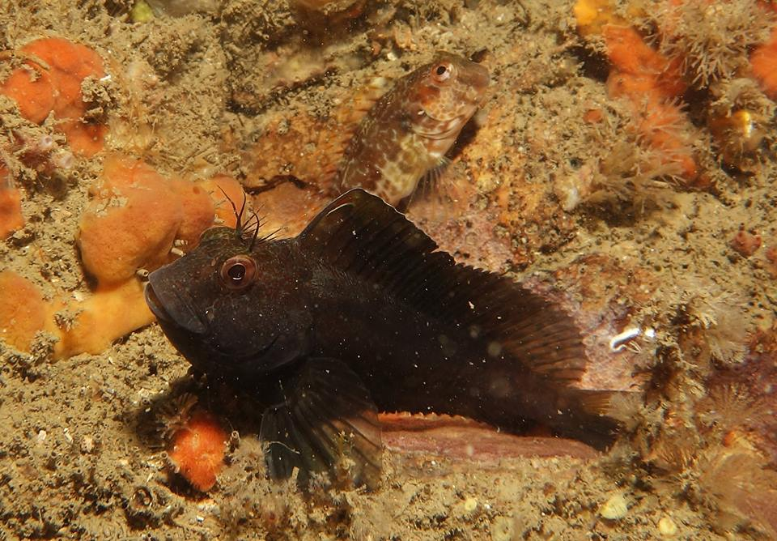
Two variable blennies were found in Plymouth Sound in July (Image: Guy Mitchell).
[Guy Mitchell]
Between 2007 and 2009 there were about 14 records of the pufferfish (Lagocephalus lagocephalus), then none until 2014. When at least four were washed up: three over the summer in Cornwall, and one in Dorset and another caught on rod and line in Torbay in November. The species was first recorded in the south-west by Borlase (1758) and there have been occasional records since.
[Liam Faisey, Douglas Herdson]
There were very few records of triggerfish (Balistes capriscus) before November and only one known record by divers. Then one was filmed by an ROV in Falmouth Bay and another caught at Bigbury, and there were strandings in mid-winter, mainly on the north coast.
[Tony Bicknell, Sophie Banham, Keith Hiscock, Amelia Bridges, Dave Jenkins]
Turtles
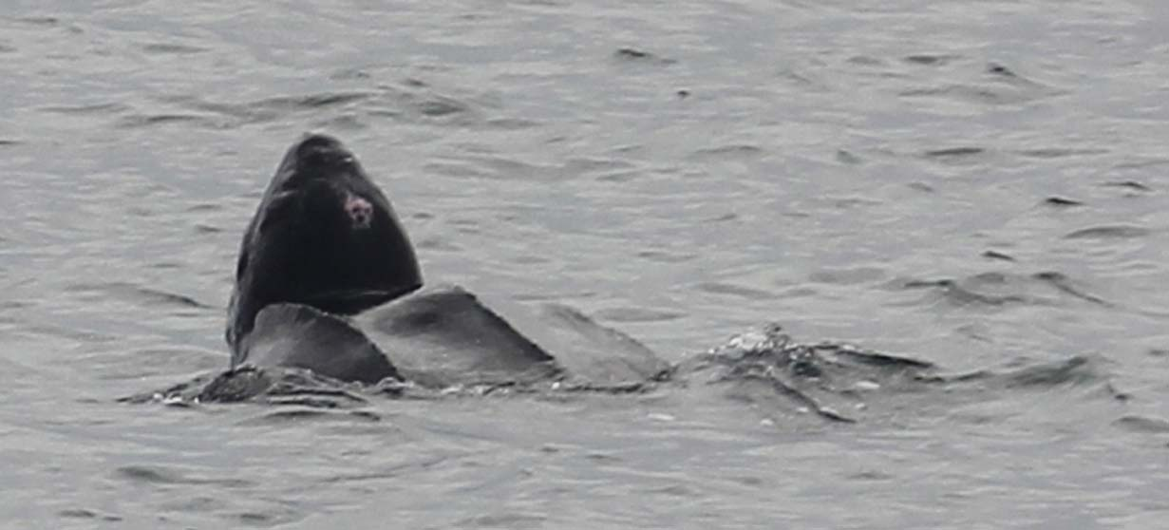
Despite the abundance of jellyfish, there were only three sightings of live leatherback turtles
(Image: Marine Discovery, Penzance).
2014 was a record year for strandings of Kemp's ridley turtle (Lepidochelys kempii) nationally, but only one was found in the south west. There were three reports of leatherback turtles (Dermochelys coriacea) off Cornwall from May to August, and 3 or 4 stranded dead from October to December; a further four unidentified turtles were seen swimming in the sea from Dorset to Cornwall (British Isles & Republic of Ireland Marine Turtle Strandings & Sightings Annual Report 2014, R.S. Penrose & L.R. Gander. 2015)
[Emily Duncan, Duncan Jones]

SEABIRDS
Edited by Alice M. Trevail
Introduction
2014 was a year of both success stories and tragedies for the seabirds of the South West. Manx shearwaters and storm petrels are succeeding following rat eradication on Lundy and the Isles of Scilly, and the region is of increasing global importance for the critically endangered balearic shearwater. However, severe storms during the winter of 2013/14 culminated in a major wreck of seabirds, predominately auks, around the UK, of which the south west was no exception. Marine litter poses a threat to all marine life of the South West, as highlighted by monitoring of northern fulmars and entanglement of seabirds in ghost gear.
Storms
Following extreme storm events during the winter of 2013/14 a severe wreck of seabirds was seen ubiquitously around the south west during the early months of 2014, particularly February. The wreck consisted predominately of auks: observations from SWME15 (Saunton beach, Chesil Beach and Dawlish Warren) described varying ratios of guillemots, Uria aalge, and razorbills, Alca torda, although UK-wide the wreck effected 29 seabird species. Mousehole Bird Hospital (www.mouseholebirdhospital.org.uk) were reportedly at capacity with undernourished and weak auks. According to the RSPB, over 1,000 dead seabirds were found on beaches of Cornwall, Devon and Dorset during February alone (http://www.rspb.org.uk/news/details.aspx?id=365357).
[Russell Wynn, Dave Jenkins, Julie Hatcher, Hannah Jones, Will Maclennon]
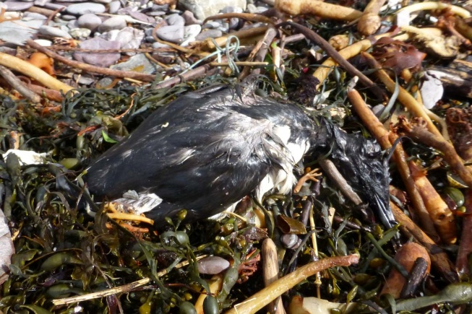 |  | 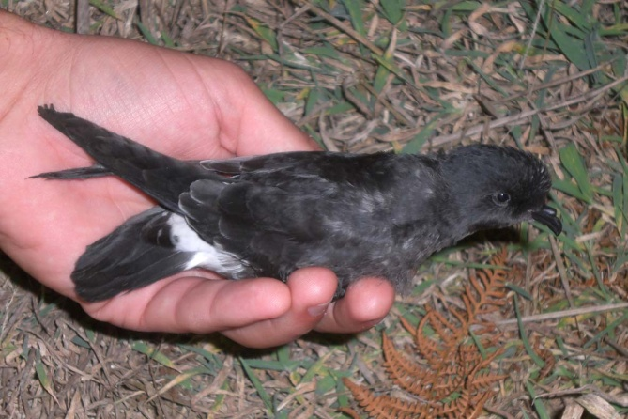
Guillemot, Uria aalge, - one of many on the strandline at Wembury Beach after the storms. 27 February (Image: Keith Hiscock). |  | Storm petrel, Hydrobates pelagicus, chick on Lundy (Image: Tony Taylor).

Rat eradication
A major success story for the seabirds of the South West UK from 2014 is the eradication of non-native rats from two Isles of Scilly islands, St Agnes and Gugh, as well as continued population increases following rat eradication on Lundy 10 years ago.
The rat eradication at Lundy was a partnership between RSPB, Landmark Trust, National Trust, and Natural England and was completed in 2004. Habitat restoration has resulted in a tenfold increase in the manx shearwater, Puffinus puffinus, population and the first ever confirmed breeding of storm petrel, Hydrobates pelagicus, on Lundy in October 2014.

The St Agnes and Gugh project is a partnership between RSPB, IoSWT, Duchy, IoS AONB, Island Rep and Natural England, and is still in the final monitoring phase. 2014 saw the first fledging of Manx shearwater in living memory, the first fledged kittiwake, Rissa tridactyla, on the Isles of Scilly in five years, and an increase in lesser white toothed (Scilly) shrew activity in the first summer after the removal phase. The St Agnes and Gugh project is currently the largest community based rat removal project for seabirds attempted globally to date.
Visit the Isles of Scilly Seabird Recovery project website for details: www.ios-seabirds.org.uk
[Keith Hiscock, Paul St Pierre]
Further notes on Lundy
The substantial turn-around in puffin fortunes at Lundy continued with a 30 July 2014 count of 240 individuals on the water in Jenny’s Cove alone, by far the highest since rat eradication. Anecdotal evidence suggests that the island’s breeding gulls, especially lesser black-backed gull, herring gull and kittiwake continue to decline. There was some evidence from observations at colonies that the prolonged stormy conditions of winter 2013/14 led to increased winter mortality at sea amongst the island’s breeding guillemots.
[Tim Jones]
Balearic Shearwaters
Observations from SWME15 have highlighted the increasing presence of Europe’s only critically endangered seabird, the balearic shearwater, Puffinus mauretanicus, around the SW. In January in St Ives Bay, balearic shearwaters were recorded on 8 out of 11 days of sea watching fieldwork. In July, rafts of ca. 200-300 individuals were observed between Jersey and Guernsey. Concentrations were recorded west of Lyme Bay and west of Lundy Island during Cefas’s October 2014 Peltic Research Cruise associated with large numbers of sprat and sardines. Indeed both a 260% increase in Balearics seen from the Peltic Research cruise compared to 2013 and a record Cornish count of balearic shearwaters in October indicate the global importance of the SW UK.
More information: https://www.birdguides.com/webzine/article.asp?a=4768
[Rachel Davies, Russell Wynn, Alice Trevail, Jeroen Van Der Kooij]
Marine litter, PIB & Pollution
One northern fulmar, Fulmarus glacialis, was recorded with plastic in its stomach after washing up on Chapelporth beach, Cornwall, in December 2014. The fulmar was autopsied as part of the South West Fulmar Project, which aims to monitor marine litter in the region using seabirds as indicators. Contact southwestfulmars@gmail.com for more information or if you find a beached fulmar. At the gannet colony on Grassholm Island, S Wales, gannet chicks die each year from entanglement with plastic litter, particularly lost fishing nets, brought back by parents as nest material. http://www.rspb.org.uk/community/placestovisit/ramseyisland/b/ramseyisland-blog/archive/2014/06/04/gannets-galore.aspx
A possible minor repetition of the 2013 PIB event in the Southwest was reported from accounts of dead birds at Whitsand bay in 2014. Records of pollution around the South West include palm oil at Whitsand, Season and Looe, as well as oil, PBB, ‘oil rancid lumps’ and ghost fishing gear.
[Alice Trevail, Gill Bridges, Laura Guy-Wilkinson]
Other observations
During the 2014 Peltic Cruise around the SW, 30th Sept – 19th Oct, 2,200 observations were made of 38 bird species. Gannets, Morus bassanus, were most common, but otherwise the demography was different to 2013 with more manx shearwaters and storm petrels and fewer auks, kittiwakes and skuas. [Jeroen Van Der Kooij]
Cormorants, Phalacrocorax carbo, and Shags, Phalacrocorax aristotelis, were few in number for the first half of 2014 in Falmouth Bay. [Tony Sutton]
At Barks Head, Tintagel, eight red throated divers, Gavia stellata, were recorded on 23/1/14. One long tailed skua, Stercorarius longicaudus, was recorded on 21/10/14. Uncountable numbers of manx shearwaters were recorded on 13/8/14. A storm petrel was recorded from 2-21/10/14. 1000+ kittiwakes were recorded in passage in 1 hour on 21/10/14. [Brian Craven]
Shearwaters were recorded in dense aggregations of off Seven Stones in May as well as off Land’s End during early August. [Paul Somerfield, Kate Williams]
A mixed flock of ca. 1600 terns arrived in the Hayle Estuary on 27th August and stayed for a few days, including common terns, Sterna hirundo, arctic terns, Sterna paradisaea, roseate terns, Sterna dougallii, sandwich terns, Sterna sandvicensis, little terns, Sternula albifrons, and black terns, Chlidonias niger. [Kate Williams]
Gannets were seen in dense aggregations off Seven Stones in May. They were also observed flocking in hundreds, possibly thousands, in the Celtic Deep during early July displaying activity different to feeding – perhaps socializing. A westward flyby of 150 gannets in 40 minutes was observed off Great Sleaden Rocks in South Devon on 18/10/14. Flight was low over the sea along the tide line off Start point in groups of up to 5. [Paul Somerfield, Fiona McNie, Bob Earll]
Off Great Sleadon Rock, South Devon, 26 shearwaters were seen flying east along the Start Point tide line, as well as 37 gannets flying mainly west plunge diving on 27/5/14, 7-8:10pm. [Bob Earll]

Seals
Edited by Sue Sayer
Across Devon and Cornwall, particularly along the south coast, new seal sites were recorded ( Start Point, St Austell Bay) and systematic monitoring coverage of these and other sites was expanded (St Austell Bay, Roseland, Lizard, Longships) in Cornwall. St Austell Bay has already been linked by 15 different identified seals to eight other sites including two Special Areas of Conservation (SACs) – the Isles of Scilly and Skomer in Pembrokeshire. The Lizard has also already been linked by 14 seals to 11 different sites including the same two SACs. This reinforces the important role Cornish coastal habitat plays in supporting seals breeding in assessed SACs.
Lost fishing gear recording was added to all CSG seal monitoring protocols on land (around the SW coast) and at sea (along most of the north Cornish coast).
Wave Hub continued to fund CSG to conduct routine monitoring at the West Cornwall sites in the coastal shadow of the facility.
Marine Energy in Far Peripheral and Island Communities (MERIFIC) Intereg project successfully delivered with our lead partners at the University of Exeter (http://www.merific.eu/)
A seal census was completed by volunteers in April 2014 covering all Cornwall sites.
Boat surveys (26 in total) were funded by volunteers, World Animal Protection; Cornwall College and Wave Hub. These deliver important data on all species and other issues such as lost gear; build local knowledge capacity; provide a watching brief, engage locals in active marine research and result in BND ID too.
There were land based surveys in 2014/15 at 14 sites around Cornwall.
At Lundy, seal population monitoring continued throughout the summer season with two surveys per month. The highest population was recorded in August with 199 individuals observed. Two volunteers, Rachel Fell and Charlotte Eich, spent two weeks working on the island’s seal image bank and were able to identify 99 individuals. This catalogue will be merged with Sue Sayers Lundy database. [Beccy MacDonald]
Entanglement: Cornwall Seal Group
In Nov 2014, CSG were funded by World Animal Protection to update their research findings on seal entanglement to 2014 (from 2000) as well as to conduct land and sea based lost fishing gear surveys. Entanglement rates for grey seals in Cornwall were found to have been constant for a decade and are still thought to be the highest rates recorded for any phocid seal species anywhere in the world and of an order of magnitude higher than that associated with population level effects in other seal species. (See Sayer, Hockley & Allen, 2015)
Strandings: Cornwall Wildlife Trust Marine Standings Network
A spike in seal strandings did occur associated with the 2013/14 winter storms during November and December 2013 and remained high into January and February 2014. 2014 saw the most stranded seals reported since records began in 2000 with 30% of these being in January and February 2014. However, seal strandings in 2014 actually peaked in Oct, although this spike was not as high as the spikes in seal strandings that occurred in October 2008 and September 2010. Between March and December 2014, seals strandings appeared similar to those recorded in other years, so it seems the winter storms of 2013/14 were responsible for the high number of seal strandings in 2014. (The three years with the next highest number of seal strandings in descending order were 2013, 2010 and 2005.)
Rescues and rehabilitation: British Divers Marine Life Rescue (BDMLR) and the Cornish Seal Sanctuary (CSS)
The storms of the winter 2013/14 were not repeated in the winter of 2014/15. With the closure of seal rehab facilities in Wales in 2014 and knock-on effects for the English RSPCA centres, the BDMLR facility in Cornwall was busier in the winter of 2014/15 stabilizing and holding pups until space became available at the CSS or RSPCA West Hatch. BDMLR reported an increase in call outs in 2013/14 compared to the four preceding seasons but these were exceeded by call outs in the 2014/15 season. Perhaps the large number of call outs in 2014 was also driven by the high numbers of call outs in January and February 2014 associated with the 2013/14 winter storms.
CSS had three fewer rehabbed seal pups in 2014/15 than during the previous season (and three more than during the 2011/12 season). So the winter storms of 2013/14 led to a small percentage increase in the number of pups rescued and rehabbed.
Unmanned Aerial Vehicles (UAVs) and seals
CSG have worked with Paul Harry (WiSe accredited and CAA licensed) UAV commercial operator to produce a best practice guide on UAVs and seals and applied for a license to operate on National Trust land.
Notable news:
- In Feb 2014 278 seals had been identified at more than one site in Cornwall, by 27/05/15 there were 393.
- Eight different entangled young seals were rescued in 138 days by BDMLR – one known to die. There are still large numbers of them out in the wild.
- Hooded seal St Ives 15/08/14.
- Seal Mum ‘Waves’ pupped at West Cornwall (2007), Hells Mouth (2013) and North Cornwall (2014) demonstrating that seal mums may not employ fixed site fidelity for pupping.
- Common seals: 16 confirmed sightings in 2014.
- Seals from Holland (‘Victor’ at Par) and France (‘Sate’ at West Cornwall).
- Key defied all previous knowledge having a pup on the Lizard where she has spent all year.
- Known since 2006, adult female S230 ‘Spade’ died after changing her previously ‘clockwork’ pattern of movements in her final year of life. Her seasonally repeated movements tracked her to points between SE Cornwall and SW Wales.
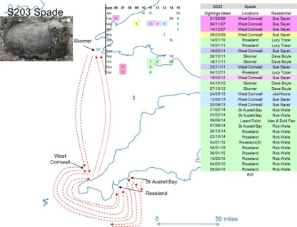
Recorded locations and possible routes taken of one seal from 2006 to 2015.
Other information
Data on seal bycatch was published in 2014 by the Sea Mammal Research Unit (SMRU) and Centre for Research into Ecological and Environmental Modeling (CREEM). Estimates for seal bycatch were 469 in the SW approaches as a whole in 2013 mostly in gill, tangle and trammel nets ().
Novel findings have been reported in research outside the SW of England about fatal interactions between grey seals and a very limited dataset of other individuals including cetaceans. Despite the research paper authors stating it is too early to rule out other causes of corkscrew injuries, the JNCC and Marine Scotland have removed the need to mitigate against ducted propellers on wind farm service vessels. The described interactions have not been witnessed in 15 years of intensive observations across Cornwall.
DEFRA has excluded seals from the MCZ process despite the UK having a special responsibility for grey and common seals under the EU Habitats Directive.
Research reports in 2014
Sayer, S. & Hockley, K. 2015. Wave Hub shadow seal research 2014 to 2015. Report to Wave Hub.
Sayer, S., Hockley, K. & Allen, R. 2015. Entanglement and its effects on grey seals (Halichoerus grypus). 2000 to 2013. Cornwall and North Devon. Report to World Animal Protection.
Sayer, S. & Williams, K. 2015. Ghost gear in Cornwall 2014 to 2015. Report to World Animal Protection.
These reports are not in the public domain, contact sue@cornwallsealgroup.co.uk for more information.

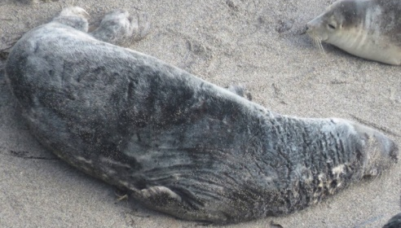
The oldest known wild seal in Cornwall. 28/08/00 to 11/05/15 – at least 25 years old - and still going strong (Image: Cornwall Seal Group).

CETACEANS

Edited by Tom Horton, Allen Kingston, Duncan Jones & Ruth Williams

General Overview
Of the 409 reports collected at the conference, 51 (14%) were related to cetacean species. The general consensus was that 2014 was a good year for observing cetaceans with “[a] large variety of cetacean species frequently seen throughout the summer months around Cornish coast” [Rachel Davies] and even “lots more observations of species being seen together more often” [Katie Drake]. There are however also converse reports with John Hepburn in Plymouth reporting “No live dolphins seen this year”, so the good year for observing cetacean species in Cornwall may not apply elsewhere throughout the Southwest, although this report is only intended as a perspective and is by no means exhaustive.
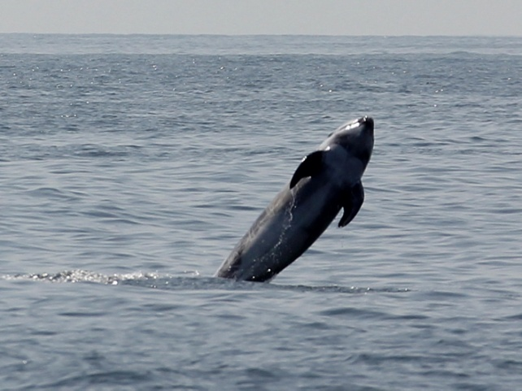
Risso’s dolphin (Image: Marine Discovery, Penzance). |  | Minke whale (Image: Marine Discovery, Penzance).

Harbour Porpoises
Regular sightings in Lyme Bay (July-Oct) [Rachel Davies] and around the Cornish coast with an “anomalously coloured (white)” individual sighted from St. Agnes Head on the 31st of August [Kate Williams], “Insane numbers of porpoises (approximately 90)” counted from Marine Discovery on the 5th of September and ‘good numbers’ seen on a four-hour boat trip in Falmouth Bay [Brian Craven]. Kate and David Williams recorded a peak in sightings late in the year, Aug-Dec.

Common Dolphins
Regular sightings in Lyme Bay (July-Oct) [Rachel Davies] including a pod of almost 50 off Orestone in early April [Will Maclennon], and another pod of 30+ out of Torbay in early July. Also regular sightings off Cornish coast: Falmouth, Mount's Bay, St Ives Bay, Newquay and Padstow.

Bottlenose Dolphins
Regular sightings in Lyme Bay (July-Oct) [Rachel Davies]. ‘Clet’, the wandering bottlenose dolphin also made appearances all around Cornwall once again. Fin ID’s have also aided in tracking him on his extensive movements; ranging from Brittany to Mull and numerous places in between [Niki Clear].

White-beaked Dolphins
Regular sightings in Lyme Bay (July-Oct) and even a sighting in Falmouth in late December with positive ID’s made from the MARINElife south-west photo ID database which now stands at 62 individuals. [Rachel Davies]

Risso’s Dolphins
Many reports indicate that 2014 was a great year for observing Risso’s dolphins [Rebecca Allen]. Cornwall Wildlife Trust recorded over 100 sightings for the year [Katie Arnold] and Marine Discovery recorded them on 9 separate occasions as opposed to only twice in 2013 [Hannah Jones]. They were also recorded with calves in south Lyme Bay in mid-October [Rachel Davies]. Fresh cuttlefish that had apparent ‘teeth’ marks on them, fresh, with flesh still attached and evidence of ink; was hypothesised as a result of local cetacean feeding activity and may be linked to Risso’s in the area [Niki Clear].

Minke Whales
Many reports indicate that 2014 was a great year for observing minke whales [anonymous comment], with key areas being between the Lizard and Dodman Point [Matt Carter] and Mounts Bay and the surrounding areas.
From Lundy [Tim Jones from the LFS logbook]:
There were three convincing records of minke whales entered in the LFS logbook in May/June. A group of three Risso’s dolphins were off the east coast on 23 August. Otherwise the usual occasional sightings of common and bottlenose dolphins and harbour porpoise. The largest pods of common dolphins were 70 reported on 26 May and 13 September.

Other Notable Records
Killer whales (Orcinus orca) were reported to Cornwall Wildlife Trust on four dates and four separate locations: Bude, Trevose Head, Cape Cornwall and St Austell Bay, where Rob Wells reported seeing one from a kayak when there were “unprecedented amounts of mackerel in the bay” [Rob Wells]. There were a number of reports of fin whales in the Celtic Deep; including a record of “approximately eight different groups of fin whales in a small area, plus unidentified whales” during the beginning of July [Fiona McNie]. There was also a sei whale recorded on 20/8/14 and a Kogia sp. (likely pygmy sperm whale) on 1/8/14; both in Mounts Bay.

Surveys
A cetacean survey with the Irish Whale and Dolphin Group yielded very few sightings and 2014 was heralded as a very poor year.
MARINElife surveys from Ilfracombe/Bideford to Lundy in the summer (Apr-Oct) reported a greater number of dolphin sightings, primarily commons compared with 2013 [Rachel Davies].
Seaquest Southwest surveys reported elevated ‘good’ cetacean sightings during surveys, including bottlenose dolphins, harbour porpoises, Risso's dolphins, a minke whale and a white harbour porpoise [Kate Williams].

Surveys from on board Scillonian III, observer – David Curtis
Date | Results | Location
13.6.14 | (1) common dolphin  (2) harbour porpoise  (1) minke whale | Penzance to Wolf Rock  Wolf Rock to St Mary's  Wolf Rock to St Mary's
22.8.14 | (1) common dolphin  (2) harbour porpoise  (1) minke whale | Penzance to Wolf Rock  Wolf Rock to St Mary's  Wolf Rock to St Mary's
26.9.14 | (3) dolphin sp.  (3) dolphin sp.  (1) harbour porpoise  (1) common dolphin | Penzance to Wolf Rock (09:12)  Penzance to Wolf Rock (09:45)  Wolf Rock to St Mary's (11:05)  Wolf Rock to St Mary's (11:50)
24.10.14 | (15) common dolphin  (15) dolphin sp.  (1) harbour porpoise | Penzance to Wolf Rock  Penzance to Wolf Rock  Wolf Rock to St Mary's
31.10.14 | (3) common Dolphin  (6) common Dolphin  (1) minke Whale | St Mary's to Wolf Rock (15:30)  St Mary's to Wolf Rock (16:25)  Wolf Rock to Penzance (16:50)

Strandings
Although the Marine Strandings Network report on 2014 is not yet available there were 88 stranded cetaceans including one Risso’s dolphin in Cornwall [John Hepburn] and several juvenile dolphin carcasses stranded on the north Devon coast [Llucia Mascorda].

Other Reports/Papers on Cetaceans
MARINElife – Report produced on white-beaked dolphins for Natural England [Rachel Davies] and a second study on photo-identification of bottlenose dolphins 2007-2014 funded by DEFRA and led by Tom Brereton, Rachel Davies, Duncan Jones and Callum Laver [Rachel Davies].
Cornwall Wildlife Trust – Both Seaquest Southwest and the Marine Strandings Network reports for 2014 are due imminently.

MANAGEMENT
Edited by Andy Bell
Overview
The storms and their impacts early in 2014 led to management actions or proposed management actions to reduce impacts of future such events, although many changes to beach profiles will recover naturally. Management measures were formulated or being formulated especially by IFCAs to protect features in the first tranche of MCZs designated in late 2013. The consultation on the second tranche of MCZs was in preparation during 2014 and the House of Commons Environment Committee ‘majored’ on MCZs in its report on Marine protected areas.
Marine Litter
Generally the issue of marine litter has been higher profile in the media and on social media. It has particularly combined with the activity of local groups. This may be due to litter being a MSFD Descriptor. Typical items reported include oil, rancid palm oil lumps, short cut net pieces and, on Warbarrow Bay, cigarette packaging from a wreck.
Waste arising from the storms of the previous year meant that there were a great number of pots and associated strings being washed up on the beaches. It can only be surmised that there are some still remaining and ghost fishing on the seabed.
Storm Impacts
Associated with the storms and the logistic issues of dealing with bird casualties and seal strandings have been highlighted as a feature of 2014.
Dealing with the flood and storm impacts meant a diversion of funding for evidence providing R&D within Defra was diverted to practical flood and coastal recovery. Flooding has consequently become much higher on the political agenda with a possible downgrading of the profile of Marine Environment Policy (Marine Strategy Framework Directive).
The storm impacts (for instance, over 10m loss of dune front in North Devon) raised the question over the resilience of the SW beaches to recover. Investigations have been instigated whether soft engineering and beach nourishment might be applied before the next winter.
The Shoreline Management Plan second version for North Devon and Somerset, SMP2 produced over 4 years ago has finally been approved having been assessed for IROPI (issues of overriding public interest). The large part of the hold-up was from the Welsh Assembly Government due to the overlapping interest of the Severn estuary.
MPAs including MCZs
Although the designation of Tranche 1 MCZs commenced in 2013; highlights include first designation of a deep-water offshore site (the Canyons) with restrictions on bottom towed gear. The management measures of the Tranche 1 MCZs is still not finalised in many cases. This is partly due to the increased workload on the IFCAs to ensure appropriate management of the European Marine sites.
February 2014 Defra indicated the possible sites that would be included in the Tranche 2 consultation on new Marine Conservation Zones around England. These included 37 sites in total (9 in the southwest including a mid-Channel proposal). Data were gathered by Natural England to add confidence to the designations, where it was lacking. The Tranche 2 sites consultation would start in 2015.
The House of Commons Environmental Audit Committee reported on marine protected areas on 21 June 2014 and the Government response was received on 8 September. The report focussed on MCZs including issues of clarity for stakeholders, the need for more survey, the need to put forward more than 37 sites in the second consultation, the need for full management plans for the first tranche by November 2014 and the importance of addressing management requirements clearly especially in relation to the role of the MMO.
Fisheries Management
The increase in minimum landing size of 42cm has been proposed for Bass (Dicentrarchus labrax), as part of a Bass Management plan. The plan also includes vessel weekly catch limits. These measures need to be ratified by the EU Parliament, Commission and Council of Ministers.
The MMO in England imposed a ban on landing skates and rays (Rajidae) in ICES Blocks VI and VII from October 2014 due to reaching the quota limit very early in the year. This caused fishermen to leave North Devon (ICES VIIf) who had not yet landed large amounts of ray from the Bristol Channel to fish elsewhere since fishing for other target species in the Bristol Channel could be compromised by by-catch of other species close the quota limit.
The Devon and Severn IFCA undertook a consultation on introducing a permit system for recreational take of shellfish.
Science, Policy and Practice Interface
One or two observers have noted the lack of communication between government agencies, Universities, NGOs and other partnerships about the research, surveying, monitoring and policies that they have been carrying out or implementing.
North Devon UNESCO World Biosphere Reserve, Poole Harbour and the Whitsands Bay to Looe area were case study sites for applying marine ecosystem services to support decision making for marine planning under the ValMER project funded by INTERREG IV (www.valmer.eu).

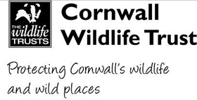
Seaquest Southwest Summary Report 2014

Seaquest Ad-Hoc Sightings
‘Ad-hoc sightings’ are casual records of marine life, reported as-and-when animals are observed. This is in contrast to ‘effort-based’ data which comes from trained volunteers conducting surveys over a specific time period to actively search for the animals.
Ad-hoc sightings of marine wildlife are always encouraged, and can be sent to Seaquest Southwest via the CWT website at www.cornwallwildlifetrust.org.uk/marinesightings. Alternatively the information can be emailed to seaquest@cornwallwildlifetrust.org.uk or reported by phone to the Marine Conservation Officer on 01872240777 ext. 208. If possible, photos should always be included with sightings as they help to confirm species identification.
1,212 ad-hoc records for whales, dolphins, porpoise, seals, basking sharks and ocean sunfish were sent into Seaquest during 2014. These involved a minimum of 4,497 animals, and stretched the length and breadth of Cornwall.
In short 2014 could be described as a rather unusual year for marine animals.
Basking shark numbers were extremely low with a total of only 76 sightings involving 110 animals. The majority of these were from a period of two weeks in late April to early May.
In contrast we had large numbers of cetaceans, including a number of unusual records such as 8 orca (described from 3 separate locations though sadly not confirmed with pictures); 100 Risso’s dolphins (three times the ‘typical’ number), 2 sightings of pilot whales, a Sei whale (only the 15th record for the UK); and a dwarf/pygmy sperm whale (a first for Cornwall).
2014 was a record year for barrel jellyfish, with the largest numbers reported since 2002. There were with 75 sightings of 384 animals, although they were most definitely under-recorded. Jellyfish sightings across the board were high in 2014, presumably as a response to one of the warmest summers in recent years.
Intriguingly, numbers of ocean sunfish, were down by about 60% from last year. In addition to the lower numbers we also noted that in 2013 they were seen regularly in large shoals of up to 20 individuals, whereas in 2014 the largest group size was reported as 4. We’re seeking information from a ‘sunfish expert’ as to whether this was a national trend, and if so what may be behind it, so watch this space for updates on the story!

SPECIES | NUMBER OF RECORDS | NUMBER OF INDIVIDUALS
Common Dolphin | 122 | 1440
Harbour porpoise | 341 | 1254
Grey Seal | 356 | 731
Bottlenose Dolphin | 105 | 567
Cetacean Species | 46 | 120
Basking Shark | 76 | 110
Risso's Dolphin | 28 | 100
Ocean Sunfish | 81 | 93
Minke Whale | 22 | 27
Harbour Common Seal | 12 | 13
Dolphin Species | 6 | 11
Dwarf Sperm Whale | 1 | 10
Orca (Killer Whale) | 3 | 8
Striped Dolphin | 4 | 4
Leatherback Turtle | 3 | 3
Pilot Whale | 2 | 2
Sei Whale | 2 | 2
Seal | 1 | 1
White-sided Dolphin | 1 | 1
Total | 1212 | 4497
Table 1: Numbers of ad-hoc species records reported to Seaquest Southwest during 2014.

Marine Strandings in Cornwall and the Isles of Scilly - 2014 Annual Report
Report by Cornwall Wildlife Trust Marine Strandings Network
Executive Summary
Data on marine organisms that stranded on the shores of Cornwall in 2014 were collected by the Cornwall Wildlife Trust Marine Strandings Network (CWT MSN). All species were recorded in the database. However, cetaceans, seals, basking sharks and turtles were examined and recorded in detail by trained volunteers of the Network.
A total of 88 cetaceans were recorded in 2014. Short-beaked common dolphins (Delphinus delphis) represented the majority of strandings (40%, n=35) followed by harbour porpoises (Phocoena phocoena) (27%, n=24). There were also two bottlenose dolphins (Tursiops truncatus) recorded (2%).
CWT MSN volunteers retrieved 15 cetaceans for post-mortem examination. Unusually, bycatch was not found to be the cause of death in any of the animals. One common dolphin and one bottlenose dolphin died due to live-stranding (13%, n=2), six died due to disease (40%) and three died due to starvation (20%). Among the rest of the cetaceans examined, one common dolphin died with possible boat strike (7%), one due to bottlenose dolphin attack on harbour porpoise (7%), and a further two harbour porpoise deaths were due to blunt trauma, possibly caused by bottlenose dolphin attack (13%).
Of those not sent for post-mortem, but examined by MSN volunteers in-situ using the Bycatch Evidence Evaluation Protocol (BEEP), 10% (n=8) of the 73 total were found to have features consistent with bycatch, based on recognised net entanglement features such as fin edge cuts/slices, encircling net marks and severed appendages. The remaining cases (n= 65, 90%) were considered inconsistent with bycatch, or were inconclusive based on the data available due to the fact that the carcasses were unsuitable for examination due to decomposition.
93 grey seals (Halichoerus grypus) were reported to the MSN: this is the highest ever annual number of recorded seal strandings, of which 46% (n=43) were categorised as pups measuring less than 120cm. The majority of seal reports were between January to March and October to December, which coincides with the breeding and weaning seasons. The unusually high number of strandings early on in the year is thought to have been caused by the winter storms experienced in late 2013 and early 2014. 2014 saw the first record of a stranded hooded seal for Cornwall. Thanks to collaborative work with Cornwall Seal Group (CSG), two seals (2%) were identified from their photo-ID catalogue. Five seals were both suitable and accessible for post-mortem examination in 2014. 60% (n=3) were found to have died due to disease. In the remaining 40% (n=2), one seal died of entanglement and the other the cause of death was unknown.
2014 saw a very high annual count of dead birds reported, with 1930 birds recorded through 369 individual reports. The majority of these strandings have been attributed to the impact of the severe winter storms experienced across the UK.
The Marine Strandings Network collects records of all species of stranded marine life in Cornwall. Sadly many species are vastly under-recorded but the MSN team are working to raise awareness amongst recorders and the general public to remedy this. During 2014, one basking shark was reported as well as three turtles; two leatherbacks and one turtle of unknown species. Several jellyfish, hydrozoa, crustaceans, blue mussel, cuttlefish and a European squid were also reported to the MSN hotline during the year.
Data were captured in the Marine Strandings Network database. Data on cetaceans, seals and turtles were entered into the UK Cetacean Strandings Investigation Programme (CSIP) database and in the case of turtles, also submitted to the Database of Marine Turtle Records for the United Kingdom & Eire. Data analysis is ongoing.

