Briefing 1 Defra’s Marine Natural Capital and Ecosystem Assessment (mNCEA) programme - land-sea interface’ (LSI) work package on ‘Mobilising marine social capital’

The EAST MARINE ECOSYSTEMS (EASTME) Pilot

Version: 30/8/2023 Bob Earll, Ruth Williams & Jessica Churchill Bissett

Also watch this briefing on our SWME YouTube Channel EASTME and the main idea South-West Marine Ecosystems.

NB Since making the video we have learnt that the EASTME Pilot has received Defra’s financial backing; this was pending when we made the YouTube video.

- What is the context in terms of the marine Natural Capital Ecosystem Assessment Programme?

This proposed project – the East Coast Marine Ecosystems (EASTME) pilot - forms part of the ‘Natural Capital approaches at the land-sea interface’ (LSI) project, which is being led by the Environment Agency (EA) under Defra’s Marine Natural Capital and Ecosystem Assessment (mNCEA) programme. The proposed work will deliver the LSI project’s work package on ‘Mobilising marine social capital’, which aims to build networks and relationships among people in marine and coastal communities including citizen scientists, academics, managers, policy makers and the public, to collate data on marine ecosystems and enable regional scale reporting on the state of marine natural capital.

- What is the EAST Marine Ecosystems pilot?

The central idea behind the EAST Marine Ecosystems (EASTME) pilot is to use the South-West Marine Ecosystems (SWME) model and to see whether this can be applied to another English region. SWME is an annual, regional programme of communications and reporting on the marine environment which has a large outreach to the marine community in the south-west [See Briefing 2]. It runs on an annual cycle to report change and the state of south-west marine ecosystems in a timely way to influence research, management and recovery. The ideas for East Coast Marine Ecosystems (EASTME) Pilot arose from an initial scoping project funded via Defra mNCEA – LSI programme in May 2023.

In essence EAST Marine Ecosystems will be a programme of communication and reporting observations and findings from a wide range of existing current work and projects that apply to the East marine and coastal region. The pilot will cover events in 2023.

- What did the EASTME Scoping Project highlight?

A Scoping Project (Objective 1), to see whether the SWME Annual Reporting & Social Capital Model can be applied in another English region was completed in May 2023. It was undertaken by co-design with NCEA and SWME colleagues and identified all the main components of the work involved with the proposed EASTME Pilot which has enabled this to be costed.

The other objectives now being considered are:
- Objective 2 Understand and design a process to deliver one pilot region in 2023 and report on this to guide work in relation to expanding this to other regions.

- Objective 3 Liaison with other national organisations and NCEA projects and programmes to maximise the benefits to this project. The go-ahead for this project has now been given which will take place in July, August & Sept 2023.

- Where? Why was the East marine region selected?

The scoping project identified and described in outline six English marine regions broadly along MMO planning and IFCA management boundaries. It was decided to pilot this idea in the East marine region mainly because it is the region most unlike the south-west of the five other UK regions. The East region covers the EAST marine planning region. This will be known during the pilot as EAST Marine Ecosystems – the EASTME Pilot – which will complement the SWME name. It would run from Flamborough Head in the north to the southern Suffolk border, including the Humber and Wash.

- How will the EASTME Pilot be run?

South-West Marine Ecosystems began based around its annual conference. The EASTME Pilot will be run using a similar conference model and the Scoping project has already explored and described a number of key points for this including, why, who, when, where, how much and how it would be organised.

- Why have an EASTME Pilot? Aims and Objectives

The SWME programme has a clear aim and set of objectives which are elaborated in the SWME Model. EASTME could draw directly upon these, but it is envisaged that they will be refined in the early meetings of the EASTME Pilot to account for any regional differences and specific needs. The starting point for EASTME could be:

The aim of EASTME Pilot is to enable and produce an annual report on the state of the EAST marine ecosystems and build the social capital among organisations, networks and individuals active within this region who are involved in research, management and recovery of the marine environment.

The objectives could cover:
a. Communication & Networking (annual)
b. Audience & Collaboration
c. Regional resonance
d. The State of the East Seas - report
e. Ecology of marine species - reporting
f. Management of south-west marine ecosystems
g. Marine Education and Outreach
7. Who will be involved? Will you be consulting in setting this up? How does the social capital come into play?

Building social capital, supporting and helping existing marine networks, bringing people together and outreach is at the heart of the SWME model. The largest of the work elements of the EASTME Pilot is that involved with stakeholder engagement and the creation of Communities of Interest, Communities of Practice and organising teams for each thematic topic, as well as overall steering and co-ordination (Fig 1). This is fundamental to the success of EASTME and will need to take place before the proposed conference.

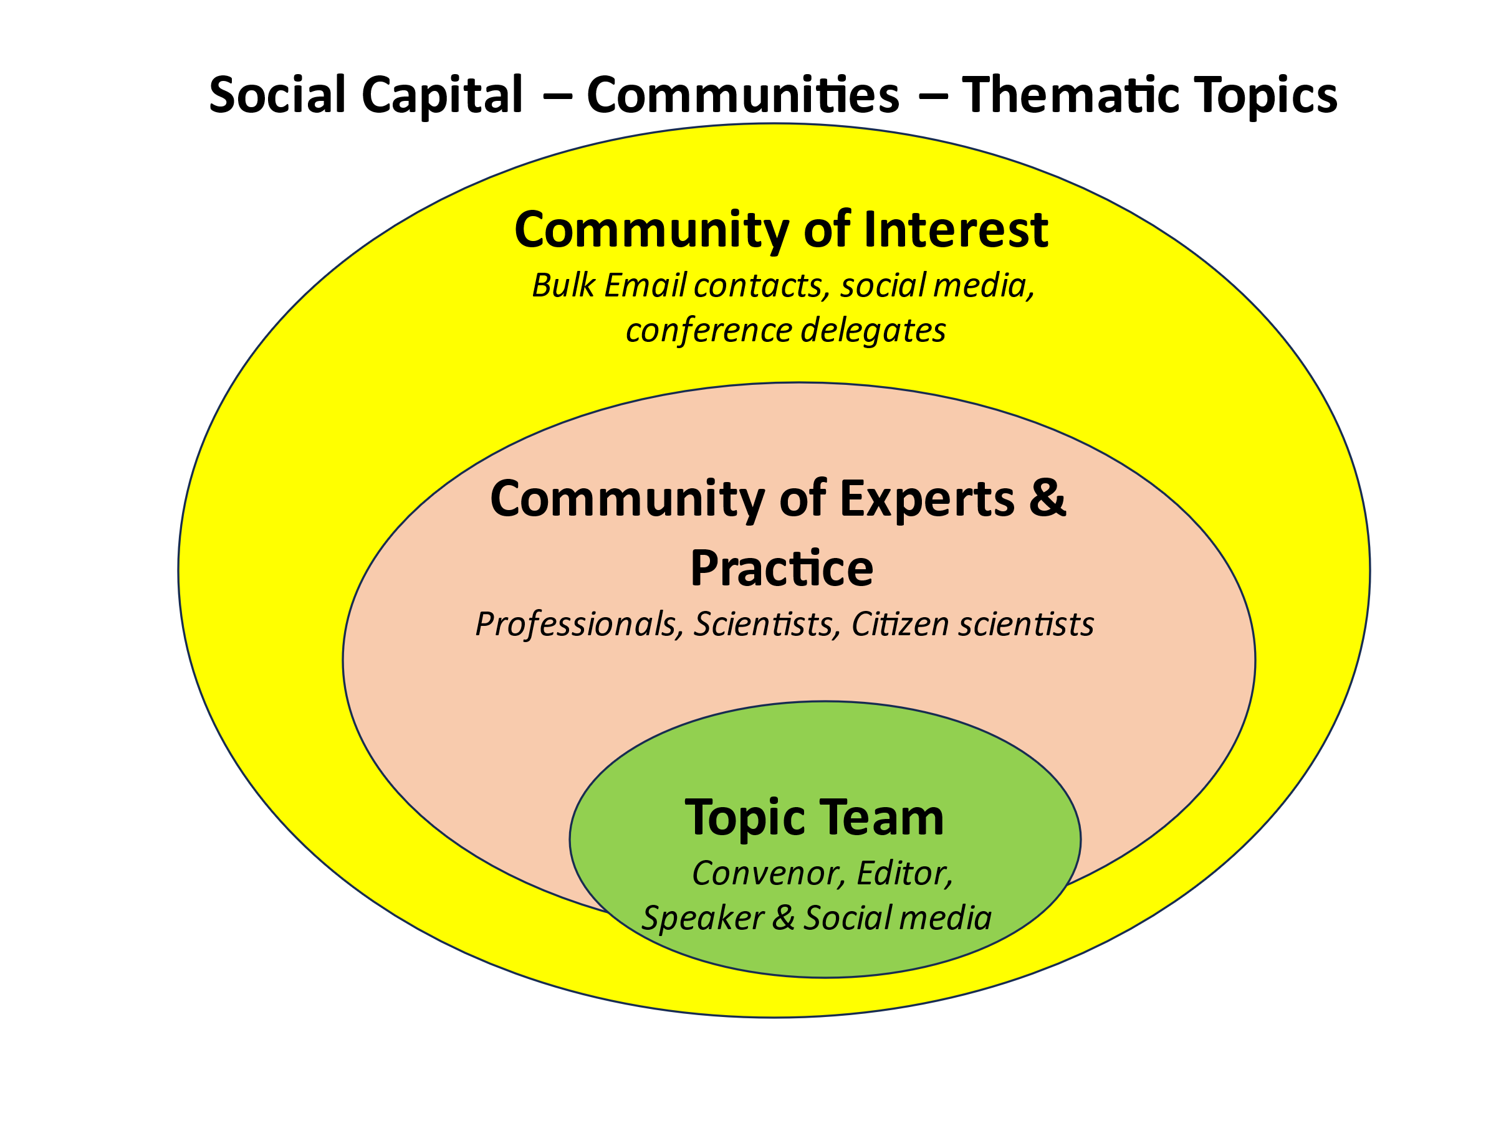
- What thematic topics will EASTME cover?

The structure of what will be reported on will follow broadly the same thematic topics used by SWME, which link closely with the descriptors and policy actions of the UK Marine Strategy; a table has been produced demonstrating this (see Table 1 in SWME briefing 2). SWME reports on the following thematic topics . The natural systems topics include:
- oceanography (including meteorology & storms)
- plankton
- seabed and seashore ecology
- fish
- seabirds
- seals and
- cetaceans.

The management topics include:
- marine planning and licencing,
- marine protected areas
- fisheries
- water quality and
- plastic pollution.

These thematic topics link closely with the descriptors and policy actions of the UK Marine Strategy; a table has been produced demonstrating this (Table 1). It seems likely that coastal flood and erosion is likely to be a major issue on the east coast that will also need to be included.

- What outputs are you hoping for from the EASTME Pilot?

Our main aim from EASTME Pilot is to be able to set it up so that it continues to function following this initial pump-priming investment. There will be a variety of outputs focusing on the East marine region which will arise from this process, including reports and videos of the thematic topics from the conference and the development of all necessary communications infrastructure, including an EASTME website, YouTube channel and Mailchimp bulk emailing.

There will be a report on the pilot project and process as a whole that will feed into thinking about how this process might be applied to other regions. Much of the work done to prepare EASTME would have a wider application to other regions.

- When will the EASTME Pilot begin and what are the key dates?

The EASTME Pilot will be a significant project which will take some time to prepare. Defra have confirmed their financial backing for the project (July 14th 2023). It is envisaged that we will work towards a conference in the spring of 2024.
The conference will be in a location in the East of England.

- Have you done any thinking about how this idea might work in other English regions?

The Scoping project discussed the ambition of how the idea might be applied to other English regions. It is envisaged that a proposal to cover the other English regions could be prepared in September 2023. Following discussion it was agreed that this wider programme could be called Marine Ecosystems Annual Reporting & Social Capital (Acronym: MEARS).

References
South West Marine Ecosystem – State of South-West Seas Annual Reports – since 2014. Weblink: http://swmecosystems.co.uk/annual-reports
South West Marine Ecosystems Thematic Topic Webinars covering the years 2021 and 2022.
YouTube Channel Link

Table 1. SWME Thematic Topics and UKMS Descriptors
 | D1 is Biodiversity, D4 is Foodwebs
 | Ecological components e.g. Seals
SWME Thematic Topics | UKMS Descriptors & Policy response
Natural systems
Oceanology & Meteorology | D7 Hydrographical conditions
Plankton | D1 & D4 Pelagic habitats
Seashore and seabed | D1 & D6 Benthic habitats; also D4
 | D2 Non-indigenous species
Fish & turtles | D1 & D4 – Non-commercial fish – [turtles may end up as part of pelagic habitats]
Coastal & Marine birds | D1 & D4 Birds
Seals | D1 & D4 Seals
Cetaceans | D1 & D4 Cetaceans
Management categories | Policy Response categories
Marine planning
Marine Protected Areas & Recovery & Restoration | MPAs are policy responses rather than descriptors
Fisheries | D3 Commercial fish
Water Quality | D5 Eutrophication
 | Overlap with Pelagic Habitats
Mainly coastal e.g. sewage | D8 Contaminants
 | D9 Contaminants in seafood
Plastics pollution | D10 Marine litter
Not covered | D11 Underwater Noise

