**DRAFT FOR COMMENT Version 3rd August 2018**

***South-West Marine Ecosystems Report 2017***

|  |  |  |
| --- | --- | --- |
|  |  |  |
|  |  |  |
| Blue fin tuna continued to be seen often in 2017. School of blue fin tuna – Simon Rogerson |  | Strandings of the Portuguese Man O’War *Physalia* in summer were very common in 2017;these were on the Isles of Scilly Thomas Porth |
|  |  |  |
| The sightings of the humpback whale inshore off South Devon in the Spring for several weeks raised huge interest Photographer? Dan Jarvis can you help? |  | New record of the nudibranch *Felimida kronhi* was recorded at Porthkerris by David Rogers and Sue Gates |

**Edited by Bob Earll, Keith Hiscock & Richard White**

**Lead section editors:**

**Tim Smyth, Peter Miller, Angus Atkinson, Keith Hiscock, Doug Herdson,**

**Sue Sayer, Alex Banks, Colin Speedie, Dan Jarvis, Duncan Jones, Sarah Clark, Claire Wallerstein & Delia Webb**

**South-West Marine Ecosystem Conference & Activities Objectives**

The Objectives for the SWME conferences and activities have been developed with the delegates and were revised in 2017; they are as follows:

1.      **Networking**   Through the conferences, website and mailings, to provide a networking opportunity for a wide cross section of people to meet, exchange views and build networks for the south-west’s marine ecosystems in order to:

* Provide active support for existing networks enabling and building citizen science projects;
* To encourage collaboration between users, researchers/scientists and managers/policy makers;
* Encourage links between researchers on science projects throughout the region’s seas (e.g. the English Channel, Bristol Channel, Celtic Seas and the wider Atlantic Ocean).

2.      **Annual Events & Recording** To use the annual conference to record observation on ecological and oceanographic events of the previous year that have affected the south west marine ecosystems and to make the linkages between environmental and biological phenomena. To publish these observations annually. To promote the recording of observations through the year and ongoing regional and national marine recording projects through the SWME website.   
   
3.      **Ecology of marine species**   To promote research studies that focus on the ecology of marine species, planktonic, benthic and ‘mobile’ species (fish, birds, mammals, turtles) and the ecosystem that supports them.  To understand the status of populations of marine species in the region’s seas and how they are responding to environmental and anthropogenic pressures. To enable stories to be told about the ecology of our common species, their distribution, movements and numbers, and importantly to highlight the gaps in our knowledge.  
   
4.      **Management of south west marine ecosystems**   to encourage strong relationships between policy makers and scientists; to promote science and the evidence base that underpins management of human activities in the coastal and marine environment with a view to supporting and promoting the health of south west’s marine ecosystems.

5. **Marine Education and Outreach**  To highlight marine education and outreach programmes in the south west. To support the development of new programmes that promote marine management and make use of marine science. To promote good practice in environmental education, interpretation, signage and outreach.

… and to come together to celebrate being part of the SWME!

**South West Marine Ecosystems Annual Report 2017**

**Contents**

**Page Numbers**

**South-West Marine Ecosystem Conference & Activities Objectives …………………**

**Introduction, Interactions and Questions – Making the Links** ……………………………

Bob Earll, Keith Hiscock & Richard White

## Background Oceanography – Western Channel Observatory ……………………………

Tim Smyth, Peter I. Miller

**Plankton Observations** ……………………………………………………………………………………..

Angus Atkinson

**The Seashore and Seabed** ………………………………………………………………………………..

Keith Hiscock

**Fish & Reptiles** ……………………………………………………………………………………………………

Doug Herdson

**Marine and Coastal Birds South West** ……………………………………………………………..

**Seals** ………………………………………………………………………………………………………………

Sue Sayer

**Cetaceans** ………………………………………………………………………………………………………….

Colin Speedie, Dan Jarvis and Duncan Jones

**Management Issues**

**Fisheries & MCZ’s and** ………………………………………………..

Sarah Clark

**Litter, Plastics, Nurdles and Microplastics** ………………………………………………………..

Claire Wallerstein & Delia Webb

**Marine Spatial Planning, Development & Outreach** …………………………………………………

Richard White

**Why produce the South West Marine Ecosystems annual report?**

The overall purpose of the report supports the objectives of the conference, collecting observations, supporting recording and science, helping to build networks and provide feedback to everyone involved and to help make a difference in protecting and managing our marine environment. A detailed breakdown of reasons includes:

1. **Describing ‘normal’ patterns of events** e.g. the oceanographic and planktonic systems
2. **Marking major events** **and their effects** e.g. the major winter storms of 2014-15 or the PIB incident
3. **Highlighting significant ecological and population changes** including:

* **Trends** e.g. the increase in seabirds on islands after rat control and blooms of barrel jellyfish.
* **Good years & bad years** **– relative status - trends** For species like jellyfish e.g. basking sharks, sunfish, bottlenose dolphins
* **Recording recovery** e.g. seabird populations after rat eradication on islands

1. **Highlighting Remarkable sightings** e.g. Bowhead whale, Cornwall in 2016 or the Dalmatian pelican
2. **Acting to focus interest**  Publishing provides a focus for further research, year on year e.g. tuna, spiny lobster, bottlenose dolphins
3. **Posing questions and exploring interactions – making the links** between environmental, species, habitat and management changes
4. **Telling stories about what we know and providing access – education & outreach**
5. **Making a difference – managing human activities** e.g. wildlife entanglement, fisheries for crawfish or wrasse, the spatial allocation for developments or protected areas, acting on plastics

The talk will illustrate these points from the SWME annual reports for 2014, 2015, 2016, which can be accessed from the SWME website <http://swmecosystems.co.uk/annual-reports>

**South West Marine Ecosystems Annual Report 2017**

*A collation of presentations made, observations reported at the South-West Marine Ecosystems meeting on 13th April 2018 and supplementary material.*

**Introduction,**

Editors: **Bob Earll, Keith Hiscock & Richard White**

Contact: [bob.earll@coastms.co.uk](mailto:bob.earll@coastms.co.uk) & [khis@mba.ac.uk](mailto:khis@mba.ac.uk) & [richard@richardhwhite.co.uk](mailto:richard@richardhwhite.co.uk)

This is the fourth in the series of annual reports on the observations of species, ecology and ecosystems for a specific year. Understanding these elements has been at the core of the SWME meetings since its outset. The purpose of the report is to support the objectives that have underpinned the meeting over the last five years which are set out on the page opposite. The report includes notes from the speakers at the 2018 meeting.

***As editors we would like to thank the section editors and all the people who have contributed their observations, views and images.***

This is a great collaboration illustrating how we can all learn more from working together. This idea of collaboration is illustrated in many parts of this report but it will also be invaluable in answering the various questions arising from the SWME meetings and this report.

Some of the highlights of this report include:

* The South Devon humpback spring 5- 6 weeks 2017 attracting huge crowds to watch; ‘like watching Blue Planet’
* The Portuguese Man O’ War strandings – highest numbers for a decade at least
* The very large mortality of common dolphins in the first the months of 2017

Do keep your records for 2018, and if you can add numbers to your estimates of ‘good’ or ‘bad’ that really helps to provide a measure of what is being reported, ready to submit your sightings etc. when the next South-West Marine Ecosystems meeting is held on April 13th 2018.

**Interactions and Questions – Making the Links**

Research moves through a number of stages and this report mainly focuses on the first stage - observations and descriptions - but from that one can begin to move on to look at things in more detail. The thing about any research done well is that it raises many more questions and it is the questions that often makes research endlessly fascinating. All of these questions tend to involve looking at the relationship of oceanographic, weather, environmental change and what we observing, that is to say making links between the sections of the report.

Some questions that arise from reading these observations for 2017 include:

* It looks like 2017 was another poor year for basking shark observations off Cornwall – why is this?
* It looks like another good year for sightings of blue fin tuna? What is driving this?

**Background Oceanography – Western Channel Observatory**

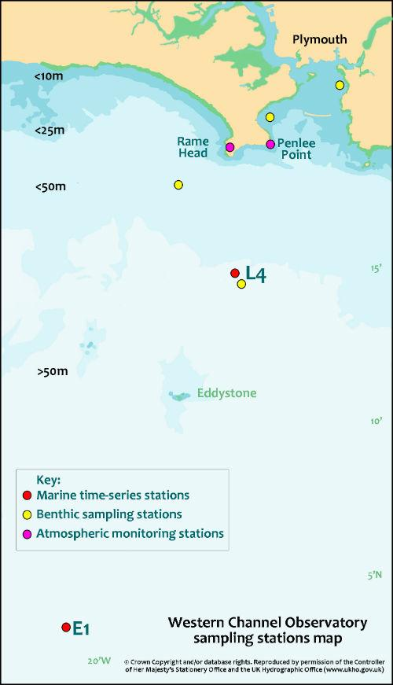

Figure : Stations of the Western Channel Observatory

**Tim Smyth, Peter I. Miller**

Contact: tjsm@pml.ac.uk

### Western Channel Observatory

**Overall conditions for the year – 2017**

Figure : Conditions throughout the water column at station L4 during 2016 from 50 individual profiles taken using a rosette sampler with multi-parameter “CTD”, deployed from the RV Plymouth Quest.

Figure : Inorganic nutrient observations from station L4 during 2016.

Figure 4: E1 temperature time-series and anomaly analysis. Solid lines show mean monthly temperatures, with dashed lines giving the standard deviation around the mean. Asterisks represent individual observations (21) made by the RV Plymouth Quest.

Figure 5: E1 salinity time-series and anomaly analysis. 2017

Figure 6. Monthly median sea-surface temperature maps for 2017, derived from NOAA AVHRR 1km resolution data (NEODAAS-Plymouth).

Figure 7. Monthly SST anomaly maps for 2017, based on Reynolds and Smith OISST data relative to 1971-2000 period on a 1.0° grid (International Research Institute for Climate and Society, Columbia University)

**Plankton Observations**

**V10.7.18**

Contact: **Angus Atkinson** [aat@pml.ac.uk](mailto:aat@pml.ac.uk) **… and others**

**Introduction**

The plankton observations in the 2017 report are based on recorded observations submitted at the SWME meeting, from the monitoring of the Western Channel Observatory sites L4 and E1 by Plymouth Marine Laboratory, and satellite-derived monthly satellite imagery. We have divided them into “Phytoplankton” (capturing all single-celled organisms and including the satellite imagery) and zooplankton, which includes the recorded observations of larger species such as jellyfish.

**Phytoplankton Observations**

**Claire/Paul, have you any data ?E1? for 2017?. Interesting observations? A few lines on what the 2017 season was like? New species? Anything from Gerald?**

**Peter: would you be able to provide the monthly phytoplankton concentration/anomalies like for last year’s report???**

**Zooplankton Observations**

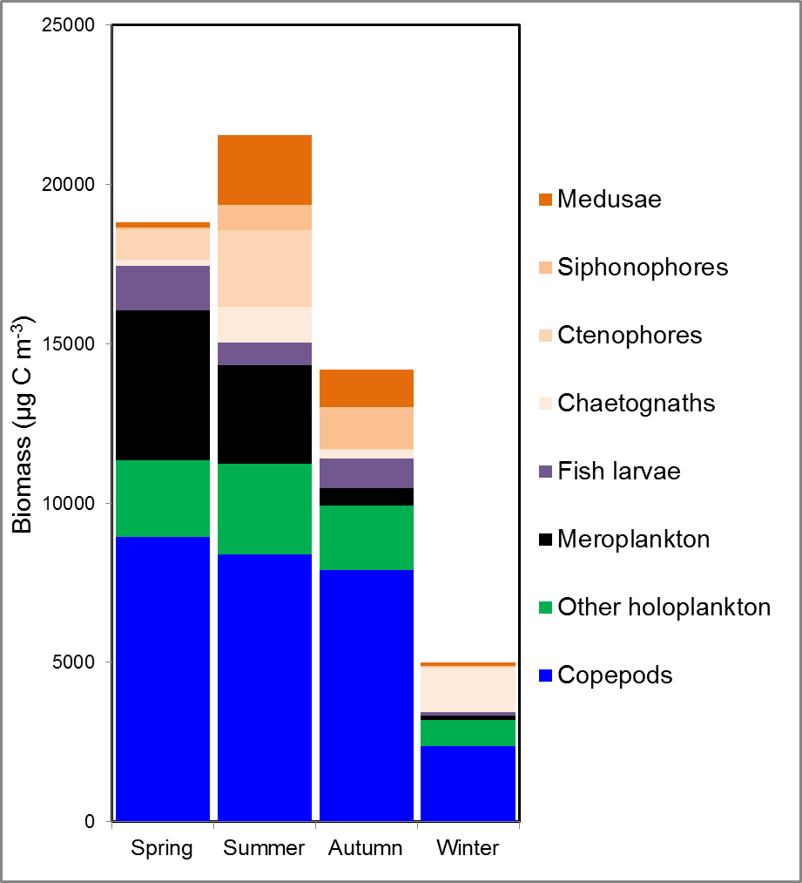**Andrea- ditto, new taxa not previously recorded at Ll4, observations of normality or unusual observations for 2017?**

**Fig. v.** A multi-season average picture of the relative biomasses of the main zooplankton taxa at the Plymouth L4 site. These values are based on catches with a 57 cm diameter, 200 µm mesh nets). Seasons are defined in successive 3-month blocks with “spring” corresponding to March-April-May. The plot shows the strong contribution of crustaceans, chiefly copepods, with meroplankton (pelagic larvae of benthic species, chiefly barnacles, bivalve larve, decapods and polychaetes) featuring mainly in spring. Shades of orange depict gelatinous taxa.

**Fig v** above depicts the average seasonal breakdown of biomass of the main functional types of biomass at the Plymouth L4 site. March 2018 marked the 30th anniversary of its weekly resolution sampling, so this 2017 report provides a good opportunity to take stock and present the 2017 plankton data in the context of the previous 29 years. **Fig w** shows that results in any given year need to be interpreted in the context of year to year fluctuations, longer-term cycles and multi-decadal trends. Some of the fluctuations show irregular periodicity, with sequences of several successive years showing positive and negative anomalies.

Thus despite the lack of a noticeable change in total plankton biomass over the whole time period (**Fig. w A**), its composition has shown change, with evidence for a general increase in some carnivorous gelatinous taxa such as chaetognaths and a general decline in total copepods. Other functional groups such as meroplankton showed less evidence for directional trends, although 2017 was noteworthy in having by far the lowest total meroplankton numbers in the whole time series.

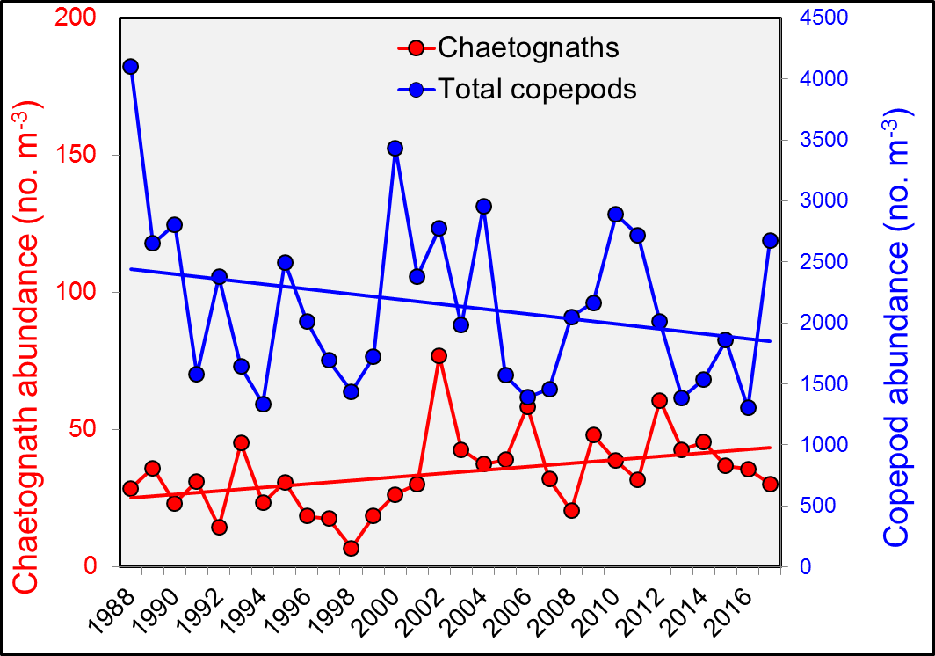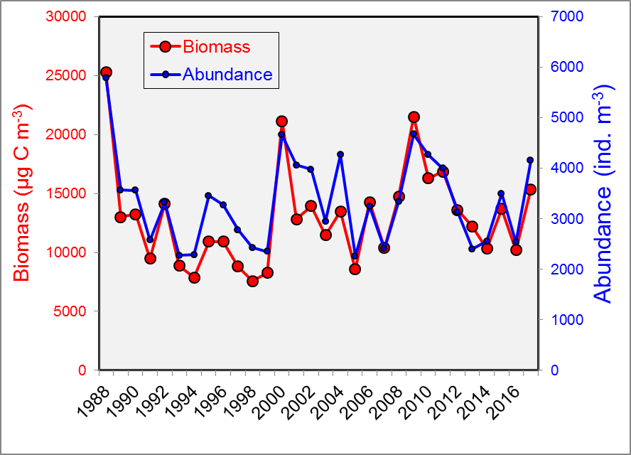

**B**

**A**

Looking at copepods in more detail, the decline in overall abundance reflects declines in a couple of the key species and non-replacement in terms of increases in any other abundant species. This decline in copepods over a similar time period has been found across larger areas of the NE Atlantic (IGMETS report website link here) and we are currently examining causes for this.

**Fig w**. 30 year time series of weekly resolution observations at the Plymouth Ll4 site, with all available data averaged into annual means. The 2017 data are at the extreme right of the plot. **A**. Abundance and biomass of total zooplankton. The tendency for the trajectories for abundance and biomass to converge over the last 10 years reflects an increase in the mean size of the zooplankton. **B.** This increase in mean size reflects an increasing proportion of larger, gelatinous and semi-gelatinous (mainly carnivorous taxa). This illustrated here by the trajectories of Chaetognaths (arrow worms) and copepods.

One of the largest abundant copepods, *Calanus helgolandicus*, has been under particular study at L4 given its important contribution to biomass and as food for commercially important fish. In picking out *Calanus* for egg production and other experiments at PML, scientists at PML have noticed that they are particularly rare in the summer months – often too rare to set up egg production experiments. This species is not showing an overall decline **(Fig. y),** and indeed seem remarkably stable in its annual average abundance. However summer abundances have dropped considerably over the last 4 years, to levels not seen since the 1990s. Whether this reflects 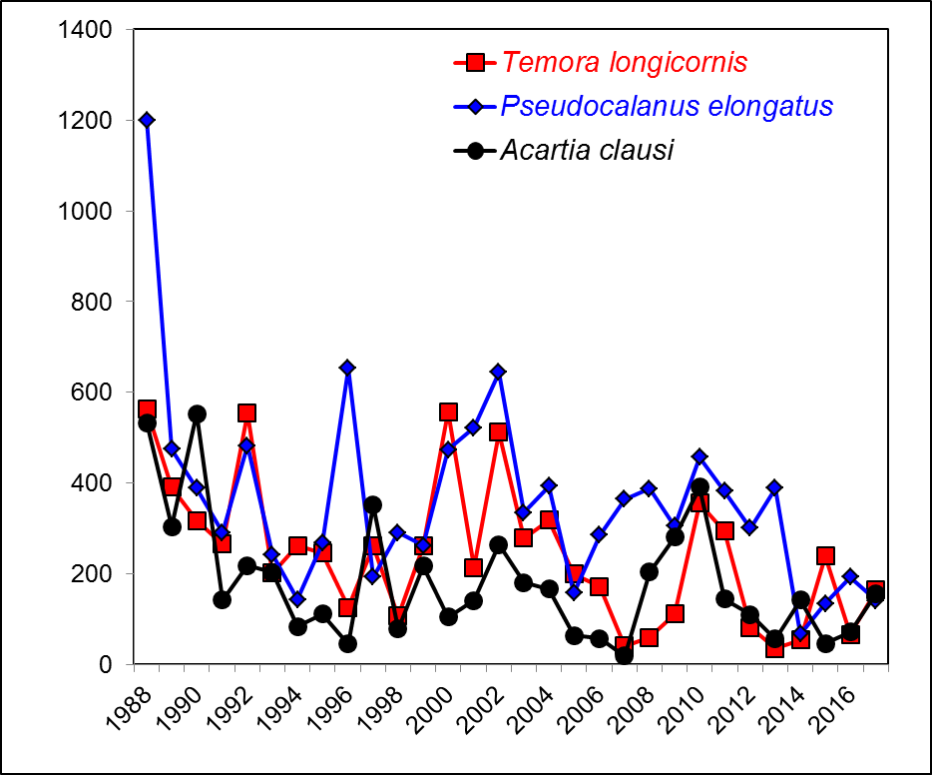temperature effects on phenological timing or increasing pressure; perhaps from gelatinous predators is unclear, and another topic for study.

**Fig x.** Several copepod species, important contributors to both biomass and abundance, have shown high variability but a general decline in abundance over the whole time series

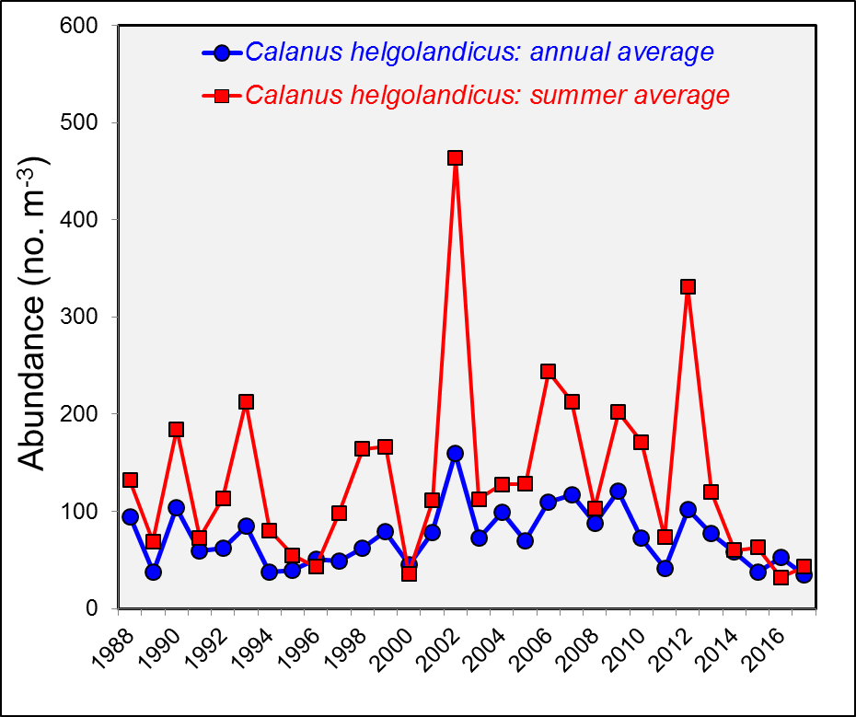

**Fig. y**. *Calanus helgolandicus* population densities at Plymouth L4 seem to be more stable than those of many other taxa, but nevertheless decadal-scale cycles might be apparent. 2017 marks part of a period of lower abundances, particularly over the summer months

**Reported observations from the SWME meeting**

**(I will weave these into some text)**

**Highlights to SWME in 2017 Keith Hiscock** The ’invasion’ by Portuguese man o’war from early August onwards was remarkable. More than 10,000 individuals were reported to Cornwall Wildlife Trust (Matt Slater). The strandings were concentrated in the far south-west but extended to North Devon and Dorset.

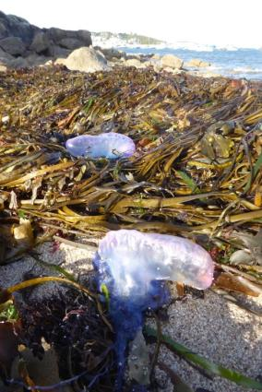

Portugese man o’war *Velella velella* stranded at Thomas Porth in the Isles of Scilly on 14th September. Image: Keith Hiscock

**3. Matt Slater** Pelagia noctiluca – LOADS of records in October/November – CWT (MSN). Very mild autumn/winter – strong may bloom off North Coast May/June

**4.** **Nikki Banfield – IOS Wildlife Trust**

(a) 1000’s of Mauve Stingers stranded on Scilly’s beaches during November 2017. Not seen anything like it on the Islands’ during my lifetime (30+ years)

**16. Pennie Lindeque** Increase of Portuguese Man O’ War observations in Bigbury Bay – autumn 2017

**7. Meg Hayward-Smith – Falmouth Marine Conservation**

Portuguese Man O’ War – high numbers of PMOW wash up on the Cornish coast

**19. Nigel Mortimer** (a) Surface plankton – Portuguese Man O War in large numbers between Salcombe Estuary and Start Point & Velella velella

**Matt Slater** (Physalia physalis) - Portuguese Man O’ War - unprecedented quantity of live strandings in Cornwall > 10k individuals logged on CWT (MSN)

**26. Dan Jarvis** The significant influx in Portuguese Man O’ War around the coast this winter (also of By the Wind Sailors) was notably interesting and sparked a lot of media interest that was used well by Cornwall Wildlife Trust to educate people

**See the article on Plankton & Micro-plastics in the Plastics section**

**Influx of Portuguese Man O War and By-the-Wind-Sailors into UK waters 2003-2017**

**Victoria Hobson**1, Peter Richardson2, Matthew Witt1,3

1. University of Exeter, Centre for Ecology & Conservation, Penryn Campus, Treliever Road, Penryn, Cornwall, TR10 9FE
2. MCSUK, Overross House, Ross Park, Ross-on-Wye, Herefordshire, HR9 7US
3. University of Exeter, Prince of Wales Road, Exeter, EX4 4PS

Contact: [v.hobson@exeter.ac.uk](mailto:v.hobson@exeter.ac.uk); 07766 338962

The occurrence in the autumn of 2017 of a large number of *Physalia physalis* L. strandings on the south-west coast of the British Isles has prompted an interrogation into records of its appearance on the Atlantic coasts of the UK during the past 15 years. MCSUK records for reported strandings for Portuguese Man O War and By-the-Wind-Sailors (*Velella velella*) are considered in detail in conjunction with environmental data for the period involved.

See the [SWME 2018 Conference Archive](https://swmecosystems.co.uk/archive) and her talk for more details and results

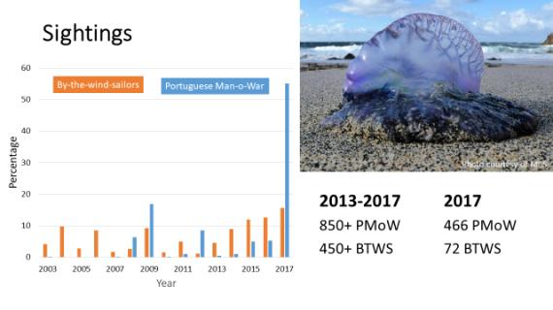

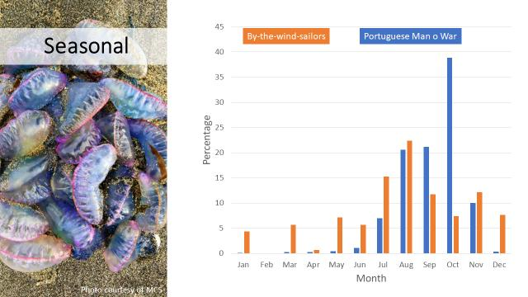

**The Seashore and Seabed**

Editor: **Keith Hiscock**

Contact: khis@mba.ac.uk

**Introduction**

Overall, seashore and seabed marine life was much as in 2016.

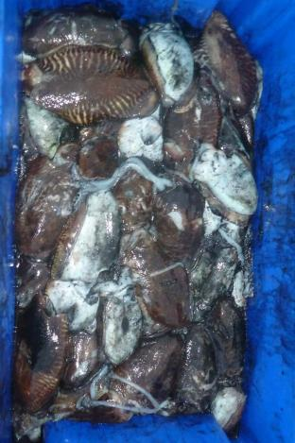

Cuttlefish *Sepia officinalis* in a fishbox at Lyme Regis. Image: Keith Hiscock

It was a remarkable year for cephalopods with cuttlefish numbers creating a ‘black gold rush’. The Plymouth Herald reported on 24 September ‘This week, a record £700,000 was rung through the tills at Brixham fish market with 90 per cent stacked into freezer vans and transported to foreign markets.’ Mating and egg laying seemed earlier than usual (end of April start is usual).

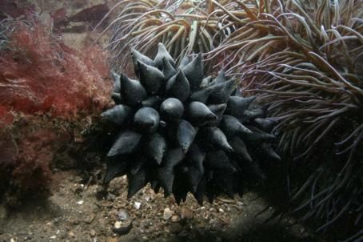

Eggs of *Sepia officinalis* at Firestone Bay, Plymouth Sound on 9th April. Image: Keith Hiscock

The increased abundance (sightings) of curled/northern octopus *Elodne cirrhosa* continued from 2016 when Charlotte Bolton reported “There were significantly more sightings of curled octopus (*Elodne cirrhosa*) along the south coast of Devon and off Dorset compared with previous years. Trend started in 2015”. Large numbers of were washed-up or even seen crawling up beaches in late October after storm ‘Brian’ hit the coast. More on http://www.beachstuff.uk/octopus.

Crawfish (*Palinurus elephas*) continued to recruit and those that had outgrown the holes in boilers and crevices could often be found nearby in more open ledges. Increasing numbers (Charlotte Bolton, Matt Slater, Keith Hiscock, Chris Wood)

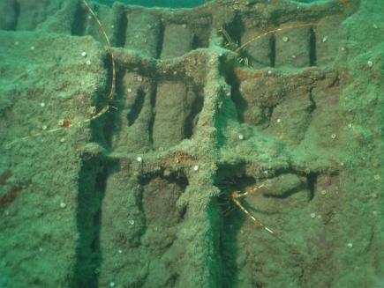

Spiny lobsters (*Palinurus elephas*) on the wreck of the Volnay. Image: Micky Love.

Decreased catches of edible crabs *Cancer pagurus* reported to the Cornwall IFCA (David Muirhead). Many divers report ‘not much marine life’, by which they mean few crabs and lobsters on dives.

Evidence that native oysters at all six sites of the Solent oyster restoration project spawned in summer releasing millions of larvae into the water column. Now roughly 23,000 native oysters have been reintroduced (Vicki Gravestock, Catherine Whitley)

Mass strandings of common starfish *Asterias rubens* in Dorset (and elsewhere in Britain). Could this be related to ‘star balling’ behaviour co-occurring with strong tide & onshore wind? See: [www.sheehanresearchgroup.com](http://www.sheehanresearchgroup.com).

David Fenwick reports on 23 November: “Looks like we have a new species of sea slug for the UK in *Hermaea cantabra*. I found six individuals in 2015 on *Ceramium* at Great Hogus,   
Marazion.” (David Fenwick)

David Fenwick reports on 22 January 2018: “*Tubulanus nothus*. Albert Pier reef, Penzance, Cornwall. SW47843052. 07.06.16. Single specimen found on a reef in shallow water beyond the extreme low water mark. Verified by Professor Juan Junoy. (David Fenwick)

The nudibranch *Felimida kronhi* was recorded at Porthkerris by David Rogers and Sue Gates on 4th October. There were three individuals on the seaward side of Drawna Rocks in about 14 meters of water. The following day the same individuals were seen and more were spotted in the main gulley by the pinnacle on the reef, this time much shallower at around 8 metres -the gulley is more than 100 metres from the original sighting. Bernard Picton believes that 2017 was the first year in which they were reported on the north side of the English Channel. Image: Des Glover/Kennack Diving.

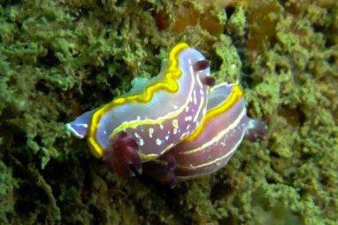

Image: The nudibranch *Felimida kronhi* was recorded at Porthkerris by David Rogers and Sue Gates

The species that have been reported as ‘new’ to the south-west in previous years persist although I am finding it more difficult to see black-faced blennies in Plymouth Sound. There have been no additional non-native species reported.

**Non-native species**

Pacific oysters are taken from the Yealm by some for consumption. Image: Keith Hiscock

Increased spread of Pacific oysters around the coasts of Devon & Cornwall (David Muirhead). The extensive and often dense populations of Pacific oysters in the Yealm continue to be monitored and were much as in 2016. There are occasional collections for consumption. ‘Taking over’ the Fowey Estuary & Fal Helford. Huge recruitment in the intertidal (Matt Slater).

There were no records submitted of additional non-native species occurring or of spread of other than Pacific oysters.

**Records from Dave Fenwick 2017**

David Fenwick Snr [<mailto:davidfenwicksnr@googlemail.com>

‘Hope this helps Keith, of course can supply any amount of images. A pretty lean year but the find of *Perophora japonica* in North Devon was predicted. I was talking to the Bristol Co-Coast team in 2016 and supplied images to them so they could turn it into a poster and I said that there was a real possibility it would turn up. Little did I know it would be me who would find it. I guess *Perophora japonica* and I have the same taste in habitat lol.

February 2017 - Probably my best ever find the nemertean *Lineus grubei* found in Mounts Bay. The species is quite similar to *Lineus longissimus* but has a white bar across the front of its head. The species is a Mediterranean species and has been confirmed by Spanish experts. It has only been found a handful of times since it was described by Hubrecht in 1879, a very rare thing. The nearest record to the UK appears to be from the Morocco side of the Straights of Gibraltar.

Numerous small algae were identified for the purpose of recording in 2017. Some were very under-recorded, or reported from just one place, but some were found to be a quite common. The species include *Microspora ficulinae*, a green algal parasite of three species of sponge; others include *Tetraselmis marinus, Rhodophysema georgii* on Eelgrass, *Stylonema alsidii and Ostreobium quekettii* which was found running through Devonshire Cup Coral.

Feb. - March 2017, the spider crab *Macropodia deflexa* is being recorded on the south coast of Cornwall from Newlyn to Hannafore, and appears to be more common that *M. rostrata*.

The new nudibranch *Rubramoena sp. nova*. found in Mounts Bay between March and September in Mounts Bay. The new species is currently being described and will be published soon, see 2018 for update.

10.04.17 Yelland near Barnstaple, bacterial parasite on tentacles of *Cirratulus cirratus*. This appears to be a 200um long sulphur bacteria, it was found in Mounts Bay in 2018 and has been sent off to France for sequencing to determine what it is, and be described if there's a need.

27.04.17 Gunwalloe Fishing Cove - The parasitic red algae *Rhodymeniocolax* was found, the parasite is far rarer than its host, the common epiphyte of kelp stipes, Rosy Fan Weed, *Rhodymenia pseudopalmata.* Surprisingly, no one wanted it for study, despite the species not having a species name.

May - July 2017 Numerous records of the Lagoon Sea Slug, *Tenellia adspersa* in Mounts Bay.

A new *Eulalia sp*., has now, with the NHM, been given the appropriate name *Eulalia sp*. "Emits yellow mucus A". Specimens were found at Newlyn and Wherry Rocks, Penzance, June and August. This species will potentially be published by David Fenwick and Arne Nygren in the next year or so. Its final species name has now been agreed and it'll obviously refer to the very obvious yellow mucus.

23.06.17 Battery Rocks, Penzance - Potentially a new species of *Entobius* discovered. *Entobius* is a copepod parasite, here of the intestine of the polychaete *Polycirrus*.

03.07.17 Newlyn Marina - New species of polychaete *Amblyosyllis* discovered. *Amblyosyllis* is currently under review and data will be published later in 2018.

Numerous *Pruvotfolia pselliotes* found in Newlyn Harbour in August and September 2017, this nudibranch has thought to have spread from France, in places via commercial fishing e.g. Brixham, Devon.

05.09.17 Penzance Harbour - *Grateloupia turuturu* present under road bridge, also large numbers of *Magallana gigas* present in the harbour.

06.09.17 Wherrytown n Lariggan - *Grateloupia turuturu* present on middleshore, sea and beach red with *Antithamnionella ternifolia*.

13.09.17 Sennen Cove - Unusual stranding of 20+ stalked jellyfish, *Craterolophus convolvulus*, found as blobs on the sand, on checking with a microscope, all were too badly damaged to survive. Numerous Portuguese Man-o-war washed ashore.

19.09.17 Barricane (North Devon) - *Perophora japonica* found at the back of a gulley around level of water in the gulley.

20.09.17 Lee Bay (North Devon) - *Perophora japonica* on lowest part of the shore on a spring tide, quite frequent on the east side and center of the bay.

22.09.18 Lee Bay Bioblitz (North Devon) - *Rubramoena sp. nova*., turned up, the species previously recorded at Newlyn, Mounts Bay and Portugal.

06.10.17 The NNS Pacific red algae *Pikea californica* was found at Battery Rocks, Penzance. This is the first record since it was recorded at Newlyn Harbour. The species has since been found north of Mousehole and a very large amount at Godrevy Point.

08.10.17 Helford - *Perophora japonica* found at Teath

09.10.17 Penzance. A small fragile valve of *Barnea candida*, White Piddock, suggesting there is still a live colony in Mounts Bay.

Previously only dead valves had been found. The species is rare in Cornwall.

19-12-17 Nudibranch *Fjordia chriskaugei* and two juvenile *Pleurobranchus membranaceus* in Mounts Bay

**Seasearch – local to regional perspective**

**The *Palinurus elephas* population revival in the South-West**

**Charlotte Bolton** Seasearch **& Matt Slater,** Cornwall Wildlife Trust

Since 2015 divers in the south west have been recording a veritable population explosion of the spiny lobster/crawfish, *Palinurus elephas*, after they were exploited to virtual extinction in the 1980s. Seasearch have been encouraging divers to send in their records to inform Natural England and the local IFCAs and to assist with the management of the re-emerging *Palinurus* fishery and the Marine Conservation Zones that list this species as a Feature of Conservation Interest. We will present the sightings data and show how all divers can get involved with this project.

Matt Slater, Marine Awareness Officer and Cornwall Seasearch Coordinator, Cornwall Wildlife Trust, Five Acres, Allet, Truro ([www.cornwallwilifetrust.org.uk](http://www.cornwallwilifetrust.org.uk))

Email: [seasearch@cornwallwildlifetrust.org.uk](mailto:seasearch@cornwallwildlifetrust.org.uk), 01872 302251

Charlotte Bolton, National Seasearch Coordinator, Marine Conservation Society, Overross House, Ross on Wye ([www.seasearch.org.uk](http://www.seasearch.org.uk))

Email: [info@seasearch.org.uk](mailto:info@seasearch.org.uk), 07776 142096

**Is sticky ecology protecting our sandy beaches?**

**Robyn Samuel, Plymouth University**

[robynsam145@gmail.com](mailto:robynsam145@gmail.com)

As part of the BLUECoast project with Plymouth University, we are investigating the role of ecology on sediment dynamics.  Perranporth beach on the north coast of Cornwall is a site where extensive research has been undertaken to understand the physical mechanism for sediment transport and now we are starting to look at the role of ecology there.

This research looked at 2 factors:

1. The amount of extracellular polymeric substance (EPS), a sticky carbohydrate matrix produced predominantly by diatoms, which has been shown have a significant role in sediment cohesion.
2. And the abundance and distribution of macrofauna.

By measuring these factors across the intertidal and out to -30m, in the winter and summer we found:

* EPS across Perranporth was significantly greater in the winter survey and some samples contained quantities of EPS that have been shown to play a role in sediment stabilization.
* An increase in macrofauna abundance and diversity was identified in all but the shallowest depths during the summer survey
* The intertidal and seaward of the inner depth of closure (-15m) are the area’s most likely to have sediment transport affected by ecological factors.

**Biofluorescence and rocky-shore organisms**

**Rebecca Allen** Centre for Applied Zoology, Cornwall College Newquay

[rebecca.allen@cornwall.ac.uk](mailto:rebecca.allen@cornwall.ac.uk) 01637 857957

Bioflourescence – the unseen disco on the sea shore: a brief exploration of this phenomenon which shows appearances can be deceiving in even the humblest occupants of the Cornish coastline. Website: <https://www.cornwall.ac.uk/cornwallcollege/marine-natural-environment/fdsc-marine-conservation-2> & <https://www.cornwall.ac.uk/cornwallcollege/marine-natural-environment/bsc-hons-applied-marine-zoology-2>

**Fish & Reptiles**

Edited by **Doug Herdson**

Contact: [douglas.herdson@btinternet.com](mailto:douglas.herdson@btinternet.com)

*Note: Observations form the April 2018 SWME meeting added*

**Fish**

**Overview**

**Elasmobranchs**

Basking Sharks

Poor year for basking shark sightings.

Very low numbers of basking sharks again in 2017. The last year in which significant numbers were seen out of Plymouth was 2009 (Keith Hiscock).

**15. Sally Sharrock** No local (Devon South East) sightings of Baskers in 2017, whereas, as a diver a few years ago they were seen on several occasions each year off South Devon

(a) Paul Naylor Photographs of a Nursehound (*Scyliorhinus stellaris*) taken several months apart in Wembury Bay showed it was the same individual, revealed by denticle pattern around eye (increasing use of photography to identify individual fish)

**Pelagic species**

Large Pelagics

Bluefin tuna again showed-up in occasional high numbers mainly in west Cornwall. The image below was taken on a blue shark photographic trip.

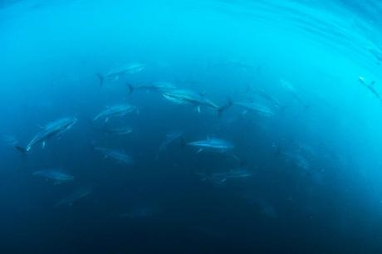

Bluefin tuna attracted to ‘chum’ put into the water to bring in blue sharks on 28th August. Image: Simon Rogerson.

**Small pelagic fish**

Dan Jarvis Huge amounts of mackerel and other commercial species around the coast through most of the winter (2017-18) – lots of flocks of feeding gannets and other seabirds in West Cornwall in particular, and even sightings of Minke whales coming inshore to feed as well. We heard directly from fishermen who also said similar about the large amounts of fish around the coast too, and that some boats were catching their full capacity in less than two hours within St Ives Bay and surrounding area week after week, worth tens of thousands of pounds per day

**13. Rebecca Allen**

August bank holiday, beautiful weather – bait balls of fish close to shore

**27. Liz Bailey**

Very small mackerel

**Sunfish**

**4. Nikki Banfield – Isle of Scilly Wildlife Trust**

(a) Large increase in the quantity of Ocean Sunfish seen to the west of Scilly during wildlife trips in 2017. Ocean Sunfish seen weekly whereas only seen once or twice in a season in previous years

**Demersal species**

**8. Paul Naylor**

(a) Paul Naylor Photographs of a Nursehound (*Scyliorhinus stellaris*) taken several months apart in Wembury Bay showed it was the same individual, revealed by denticle pattern around eye (increasing use of photography to identify individual fish)

(b) ‘Sneaker’ fertilisation behaviour by male tompot blenny (*Parablennius gattorugine*) reported for the first time

(c) Retention of the same crevice for egg-guarding by the same male tompot blenny (*Parablennius gattorugine*) in Wembury Bay for a 4th consecutive year – 2014, 15, 16, 17

(d) Quick (within 15 minutes) colour changes by both male & female tompot blennies (*Parablennius gattorugine*) that appeared to correlate with the individual’s roles in interactions, darker when dominant, paler when submissive or laying eggs

The inshore Wrasse fishery continued – see Management

Keith Hiscock The fishery for wrasse (to supply Scottish fish farms as a lice cleaner fish) ‘took off’ in the summer with much concern being expressed about possible impacts and the need for management of the fishery.

**17. Emma Magee** The efforts of the DWT in raising the profile on the wrasse harvesting (presented by IFCA today)

Triggerfish

**Fishy notes**

Realised how many species of fish can change in colour in response to, apparently, different stimuli. Changes also surprisingly rapid. [Paul Naylor]

First proof of fish larvae ingesting microplastics in natural environment in a PML paper. [Pennie Lindeque]

**TURTLES**

**18. Dave Hudson**

Weather/Turtles – Kemps Ridley turtle stranded alive on Holywell Bay beach in Nov 2017. Rescued but sadly later died during rehab at Newquay Aquarium

**Lasers and Labridae in Lyme Bay; exploring a novel method to investigate territoriality in wild fishes**

**Pete Davies** Bournemouth University [daviesp92@gmail.com](mailto:daviesp92@gmail.com) 07449364328

The extent of animal territory and ‘home-range’ are key considerations when designing spatial conservation measures, such as marine protected areas. In Lyme Bay, southwest England, territorial wrasses have frequently been observed pursuing a laser projected onto the seabed during towed video surveys. In this brief presentation, Pete Davies describes his MSc research spent investigating this ‘laser-chasing’ behaviour, to reveal aspects of wrasse territoriality and territory size. Using this novel, opportunistic method, fascinating behavioural differences were found within and between species, which may be related to their reproductive biology. The potential for this method to be applied more widely to study fish territoriality is discussed. 

**Marine and Coastal Birds South West**

**Alex Banks**

Contact: [alex.banks@naturalengland.org.uk](mailto:alex.banks@naturalengland.org.uk)

**Nesting seabirds**

**Seabirds Count**

Various coastal and inland stretches around the south west were surveyed for seabirds in 2017, under the auspices of the national seabird census 2015 – 2019, Seabirds Count. The majority were counted from boat surveys funded by Natural England and led by the same organisation or Cornwall Bird Watching & Preservation Society. The latter also collaborated with the Cornwall Seal Group to survey birds from seal surveys. [Was this true in 2017?]

Nearly 18,000 birds or nests were recorded, the most abundant species being guillemot *Uria aalge* with 50% of the total. Counts entered into the Seabird Monitoring Programme (SMP) database for Cornwall, Devon and the Isles of Scilly are summarised in Table X. No data were received from Dorset or Somerset.

Plans for comprehensive surveys of Manx shearwaters on Lundy, led by RSPB with support from Natural England, were disrupted by storms in late May and early June. Efforts were re-scheduled for 2018.

Anecdotally, guillemot numbers at sites surveyed seemed healthy in comparison to previous counts. Once all data are collected for the census, we expect to see large declines in herring gulls nesting at ‘natural’ coastal sites. Similarly, black-legged kittiwakes are faring very poorly in the south west. Boat surveys of Torbay and the south Devon coast confirmed (as expected) that all of the colonies formerly occupied at Start Bay are now abandoned.

Table X. Count data for south west counties held by SMP database for 2017. PU: Atlantic puffin; BH: black-headed gull; GU: guillemot; CN: common tern; TM: European storm petrel; F.: Northern fulmar; GB: great black-backed gull; CA: great cormorant; HG: herring gull; KI: black-legged kittiwake; LB: lesser black-backed gull; MX: Manx shearwater; RA: razorbill; SA: European shag. PU, TM, MX – Apparently Occupied Burrows; BH, CN, BG, CA, HG, KI, LB – Apparently Occupied Nests; F. – Apparently Occupied Sites; GU, RA – individuals.

|  |  |  |  |  |  |  |  |  |  |  |  |  |  |  |  |
| --- | --- | --- | --- | --- | --- | --- | --- | --- | --- | --- | --- | --- | --- | --- | --- |
|  | **PU** | **BH** | **GU** | **CN** | **TM** | **F.** | **GB** | **CA** | **HG** | **KI** | **LB** | **MX** | **RA** | **SA** | **Total** |
| **Cornwall** | **5** | **7** | **1,373** |  |  | **1,017** | **150** | **62** | **2,091** | **695** | **13** |  | **509** | **379** | **6,301** |
| Bodmin Moor |  | 7 |  |  |  |  |  |  |  |  |  |  |  |  | 7 |
| Bounds Cliff - North Cornwall |  |  | 20 |  |  | 74 |  | 3 | 72 |  |  |  | 48 | 2 | 219 |
| Cadgwith - Helford River (East Lizard) |  |  |  |  |  | 19 | 3 | 0 | 76 |  | 2 |  |  | 3 | 103 |
| Carnweather Point, North Cornwall |  |  |  |  |  | 25 |  |  | 9 |  |  |  | 2 |  | 36 |
| Chapel Porth to Perranporth | 2 |  | 132 |  |  | 72 | 6 | 1 | 474 |  | 5 |  | 153 | 52 | 897 |
| Church Cove 2 - Cadgwith |  |  |  |  |  | 16 | 3 |  | 26 |  | 1 |  |  | 1 | 47 |
| Com Head - North Cornwall |  |  |  |  |  | 23 |  |  | 9 |  |  |  |  |  | 32 |
| Delabole Point - North Cornwall |  |  |  |  |  | 19 |  |  | 39 |  |  |  |  |  | 58 |
| Doyden Point, North Cornwall |  |  |  |  |  |  |  |  | 2 |  |  |  |  |  | 2 |
| Falmouth Bay ( North Helford to Falmouth) |  |  |  |  |  |  |  |  | 3 |  |  |  |  |  | 3 |
| Gulland Rock - North Cornwall |  |  | 580 |  |  |  | 2 |  | 55 |  |  |  |  | 12 | 649 |
| Gunwalloe Fishing Cove to Kynance Cove |  |  |  |  |  | 39 | 7 |  | 154 |  | 2 |  |  | 34 | 236 |
| Hayle - Chapel Porth |  |  |  |  |  |  |  | 1 | 0 |  |  |  |  |  | 1 |
| Ligger Point to Porth |  |  | 4 |  |  | 97 | 7 |  | 83 |  | 1 |  | 16 | 36 | 244 |
| Newland Island, North Cornwall |  |  |  |  |  |  |  |  | 24 |  |  |  |  |  | 24 |
| North Cornwall Coast |  |  | 216 |  |  | 113 |  |  | 208 | 694 |  |  | 148 | 9 | 1388 |
| Pentire Point - North Cornwall |  |  |  |  |  |  |  |  | 6 |  |  |  |  |  | 6 |
| Plymouth - Falmouth |  |  | 300 |  |  | 74 | 104 | 57 | 217 |  | 2 |  | 18 | 115 | 887 |
| Port Isaac, North Cornwall |  |  |  |  |  | 60 |  |  | 104 |  |  |  |  |  | 164 |
| Ramparts - North Cornwall |  |  |  |  |  | 5 |  |  | 5 |  |  |  |  |  | 10 |
| Reedy Cliff, North Cornwall |  |  |  |  |  | 17 |  |  | 13 |  |  |  | 10 | 5 | 45 |
| Tregonnick Tail |  |  |  |  |  | 1 |  |  | 8 |  |  |  |  | 2 | 11 |
| Trerubies Cove - North Cornwall |  |  |  |  |  | 15 |  |  | 28 |  |  |  | 13 |  | 56 |
| Tresungers Point, North Cornwall |  |  | 38 |  |  | 96 |  |  | 47 |  |  |  | 70 |  | 251 |
| Trevan Point, North Cornwall |  |  |  |  |  | 13 |  |  | 8 |  |  |  |  |  | 21 |
| Trevelgue Head to Merope Rocks |  |  |  |  |  | 148 |  |  | 326 |  |  |  |  | 39 | 513 |
| West Penwith | 3 |  | 83 |  |  | 91 | 18 |  | 95 | 1 |  |  | 31 | 69 | 391 |
| **Devon** | **375** |  | **7,682** |  |  | **352** | **35** | **6** | **180** | **238** |  |  | **1,760** | **89** | **10,717** |
| Clovelly to Hartland Quay |  |  |  |  |  | 22 |  |  | 33 |  |  |  |  |  | 55 |
| Berry Head |  |  | 1,145 |  |  |  |  |  |  |  |  |  |  |  | 1,145 |
| Lundy | 375 |  | 6,198 |  |  | 227 |  |  |  | 238 |  |  | 1,735 | 55 | 8,828 |
| North Devon Coast |  |  |  |  |  | 60 |  |  | 23 |  |  |  |  |  | 83 |
| Northern End of Torbay |  |  | 339 |  |  | 0 | 30 | 4 | 27 |  |  |  | 25 | 17 | 442 |
| Sharkham Point to Start Point (South Hams) |  |  |  |  |  | 40 | 2 | 2 | 92 | 0 |  |  |  | 17 | 153 |
| Welcombe Mouth to Hartland Quay |  |  |  |  |  | 3 |  |  | 3 |  |  |  |  |  | 6 |
| Mew Stone & Cod Rock |  |  |  |  |  |  | 3 |  | 2 |  |  |  |  |  | 5 |
| Rockham Bay |  |  |  |  |  | 0 |  |  |  |  |  |  |  |  | 0 |
| **IoS** |  |  |  | **27** | **146** | **52** | **224** |  | **53** | **30** | **304** | **59** | **5** | **76** | **976** |
| Annet |  |  |  | 27 | 132 | 41 | 222 |  | 12 |  | 7 |  | 5 | 74 | 520 |
| Great Crebawethan Island |  |  |  |  |  |  |  |  | 0 |  | 0 |  |  | 0 | 0 |
| Gugh |  |  |  | 0 | 3 | 3 | 2 |  | 20 | 30 | 296 | 36 |  | 2 | 392 |
| St Agnes Island |  |  |  | 0 | 11 | 8 | 0 |  | 7 | 0 | 1 | 23 |  | 0 | 50 |
| Hugh Town |  |  |  |  |  |  |  |  | 14 |  |  |  |  |  | 14 |
| **Grand Total** | **380** | **7** | **9,055** | **27** | **146** | **1,421** | **409** | **68** | **2,324** | **963** | **317** | **59** | **2,274** | **544** | **17,994** |

Contact: Senior Marine Ornithologist, Natural England, Sterling House, Dix’s Field, Exeter EX1 1QA. E: [alex.banks@naturalengland.org.uk](mailto:alex.banks@naturalengland.org.uk). T: 0208 026 7355 W: <http://jncc.defra.gov.uk/smp/>

**Productivity monitoring**

Very little productivity monitoring occurs at seabird sites in the south west, but the most important seabird islands are usually watched to some extent. For 2017, the SMP database holds data from a handful of sites on the Isles of Scilly, and Lundy, as well as data from Looe Island (Table Y).

Table Y. Productivity data (chicks per pair) for south west counties held by SMP database for 2017.

|  |  |  |  |  |  |  |  |  |  |  |
| --- | --- | --- | --- | --- | --- | --- | --- | --- | --- | --- |
|  | **PU** | **GU** | **TM** | **F.** | **HG** | **KI** | **LB** | **MX** | **CA** | **SA** |
| Lundy | 0.75 | 0.72 |  |  |  | 0.66 |  |  |  |  |
| Isles of Scilly |  |  |  |  |  |  |  |  |  |  |
| *Gugh* |  |  | 1.00 |  |  | 0.30 | 0.80 | 0.92 |  |  |
| *Hugh Town* |  |  |  |  | 1.36 |  |  | 0 |  |  |
| *Menawethan Island* |  |  |  | 0.24 |  |  |  |  |  |  |
| *Samson Island* |  |  |  |  | 0.45 |  |  |  |  |  |
| *St Agnes Island* |  |  | 0.18 |  |  |  |  | 0.43 |  |  |
| *St Martin's Island* |  |  |  | 0.26 |  |  |  |  |  |  |
| Looe Island |  |  |  | 1.00 |  |  |  |  | 1.88 | 2.22 |

In addition, monitoring by RSPB continues at the little tern colony at Chesil Beach. In 2017, 38 pairs produced up to 73 fledglings, giving a productivity estimate of 1.92 fledged chicks per pair. This fine result is testament to the 24-hour wardening and management by professionals and volunteers at the site.

**Breeding seabird sightings away from nesting areas**

Manx Shearwater gathering/rafting & feeding in the middle of the day in their 100’s if not 1000’s, off the coast of St Agnes. Again seen on a regular basis during 2017 when only seen one or two times in a season previously – Nikki Banfield, IoS Wildlife Trust.

**Seabird feeding locations, abundance and type of food taken**

No information?

**Non-breeding coastal and marine bird sightings**

Spoonbills present on River Dart & local area (not strictly marine) but bird migrations clearly changeable – not seen in > 10 years. Emma Magee.

A good year for large numbers of larger Shearwaters i.e. Great & Cory’s & several records of Wilson’s Petrel – West Cornwall -> Scillies etc. Brian Craven.

Late 2017 – a very good year for White Gulls – Glaucous & Iceland Gulls. Cornwall (well into 2018 also). Brian Craven.

Huge numbers of Lapwing, Golden Plover & Oystercatchers came ashore to occupy intertidal region on Portwrinkle beach when Storm Emma snow descended on us. Emma Sheehan.

Last year was an amazing year for great shearwater and Wilson’s petrel.  Whilst exciting for seawatchers in the south west, on the eastern seaboard of the US there were large numbers of great shearwaters washed up dead on the beaches, apparently starving (e.g. <https://www.nytimes.com/2017/07/14/nyregion/seabird-deaths-long-island.html>). Paul St Pierre, RSPB.

**New marine Special Protection Areas (SPAs)**

December 2017 saw the classification of the [Falmouth Bay to St Austell Bay SPA](http://publications.naturalengland.org.uk/publication/5504097741438976?category=5374002071601152), the top site in the UK for non-breeding black-throated divers, the top site in England for non-breeding great northern divers, and also offering protection to the Slavonian grebe, increasingly scarce in south west England. It’s a shame [the Guardian thought the site was for little terns and hoopoes](https://www.theguardian.com/environment/2017/dec/03/cornwall-safe-haven-for-rare-seabirds)!

Poole Harbour SPA was also extended to include marine waters (above MHW) at the same time. Three new bird features were also added: breeding Sandwich terns, and non-breeding little egrets and Eurasian spoonbills (<http://www.cmscoms.com/?p=12256>).

These classifications are the result of years of effort from a variety of statutory and non-statutory organisations.

**Island recovery? Lundy - Scilly**

**Capturing seabird data in the South West – bringing monitoring and citizen science together**

**Sophy Allen** Natural England

Seabird monitoring in the UK tends to be focused on breeding birds nesting within managed sites, with wider monitoring outside of these sites and at sea more sporadic and disparate. However, there may be missed opportunities for data capture through observations made by professionals and citizen scientists not currently feeding information into bird recording schemes. This talk publicises the main data storage systems for seabirds, the **Seabird Monitoring Programme and BirdTrack**, highlights key data gaps and describes the value of submitting observations to these schemes. Of particular interest to the conference, such observations could be used to inform annual South West Marine Ecosystems reports, and to make linkages with emerging patterns in other taxa.

**Seals**

**Sue Sayer**

**Contact** Cornwall Seal Group Research Trust, Copperleaf Cottage, Phillack Hill, Phillack, Hayle, Cornwall, TR275AD T: 01736 754562 E: [sue@cornwallsealgroup.co.uk](mailto:sue@cornwallsealgroup.co.uk)

**Summary of conference input**

**Observations**

**Cornwall**

*Unprecedented level of seal pup rescues in winter*

*Seals/Weather – Busiest year on record for rescued seal pups in Cornwall by the BDMLR, with over 200 pups going through the BDMLR rehab centre*

*Seal pup rescue crisis – more seal pups rescued in Cornwall than born in Cornwall (washed in potentially from Isles of Scilly, Skomer, Romsey, Isle of Man)*

*Seals/Weather – Two large severe storms in October caused huge mortality of grey seal pups across SW England and Wales (losses of 70-75% at some sites in one night) and resulted also in a big increase in the number of pups having to be rescued by BDMLR and rehabbed by CSS and RSPCA. This is further exacerbated by increasing numbers of people and dogs on beaches causing disturbance to weakened/debilitated animals. The storms then continued again just after Christmas and well into 2018, with seals continuing to be badly affected*

*‘Ghost’ pupped for 16th consecutive year on the exact same beach – we think this is a world record!*

**Devon**

*Common Seals – small population in the Exe Estuary*

*Common (Harbour) seal eating a thick-lipped grey mullet a few metres off the viewing platform to the River Clyst Estuary at Bowling Green Marsh (March 2017? Can supply exact date)*

*Humpback whale in Start Bay – also ‘large’ numbers of porpoise alongside*

**West Sussex**

*Common & Grey Seal – Chichester harbour x 10 – small population*

**Research reports out in 2017**

Reports were written for all team systematic surveys detailed below.

* 2017 Ghost Gear report
* North Devon Photo ID Project (NODPIP) report 2017
* Roseland Photo ID Project (ROSPIP) report 2009 to 2016
* Census April 2017
* SMRU Bycatch report to DEFRA 2016 – 310 estimated bycaught seals around Cornish coast in 2015 alone – mostly tangle/trammel nets. Increasing trend in across all areas 2012 370; 2013 469; 2014 417; 2015 580 bycaught seals.

CSGRT collaborated with the following research projects:

* University of Exeter MSc student Billy Heaney to assess impact of disturbance
* Falmouth University student Ellie Bearcroft on film production ‘Food for Thought’

University of Portsmouth Darby Bonner - disturbance impact in natural cf human environment

University of Plymouth Kimberley Lloyd assessing the seasonality and variables of a wild haulout in S Devon.

**Cornwall and Isles of Scilly**

**Species**

**Common seals**

There were a total of 11 common seal sightings at seven different locations in Cornwall – Camel, Fowey, Lizard East, Looe, Looe, Pentire, Roseland and Trevose. All remaining sightings were Atlantic grey seals.

**Grey seals**

**Seal sightings and highlights**

Team systematic surveys completed

* CASPIP (3) Jan, Apr and Oct
* STAPIP (4) Mar, Apr, Jun and Oct in conjunction with Newquay Marine Group
* POLPIP (3) Apr, Aug and Nov in conjunction with Polzeath Marine Conservation Group
* LISPIP (10) All but Feb and Oct in conjunction with Looe Marine Conservation Group

Throughout 2017 CSGRT received 3945 seal records (11 every day) from 285 volunteers (including 45 individual systematic repeat surveyors)

CSGRT processed a staggering 101,017 photos for seal ID and data from 271 locations across Cornwall, Devon and the Isles of Scilly.

CSGRT Seal census 2017

For the first time ever, CSGRT extended our annual census from just April to taking place across all four quarters of the year. So, surveys were completed in Apr, Jul and Oct (along with Jan 2018)

**Anthropogenic impacts**

Disturbance at all sites (including West Cornwall onshore)

Recorded by 33 (9) different volunteers, there were 1105 (615) seals disturbed into the sea (so worst level disturbance only with considerable physiological consequences for the individual seals) at 24 different locations from 27 (10) different land (4); air (3) sea (2) and unknown (1) disturbance stimuli in 129 (63 making up 44% of all surveys) incidents which is 1 every 3 days. The worst survey for disturbance was recorded at West Cornwall involving 8 stampedes in one survey (01/09/17).

Compared to previous years for all sites this was the worst level of disturbance in terms of both incidents and number of seals entering the sea since CSGRT records began in 2011. Five months (Jan, Apr, Sep, Oct, Nov) had worse disturbance incidents than the seven year mean. Eight months (Jan, Feb, Mar, Jun, Jul, Aug, Nov and Dec) had higher numbers of seals disturbed into the sea than the seven year mean. In comparison the West Cornwall site was only the fifth highest for disturbance incidents and third highest for the number of seals disturbed into the sea out of the seven years of records.

Entanglement at all sites

In 12 months a total of 102 different seals were identified with evidence of current or previous entanglement at 15 different locations across the north and south coasts. Most at the two big haul out sites of West and North Cornwall (91) but also at Pentire (11); Lizard South (2); Roseland (2); South Devon (2) and Gurnards Head, Isles of Scilly, Bude, North Devon, Porthtowan, Portreath, St Austell Bay, Trevose and West Penwith North (1) (NB Some of the entangled seals were seen at more than one site.

Out of 102, 24 seals had visible entangling material: two were hooked, 20 were entangled in monofilament net and two with trawl net; 21 with small amounts of entangling material and three with large quantities of entangling material. Eight were adult males, 12 were adult females and four were juveniles. 22 had deep constrictions and two still had their skin intact.

Of the remaining 78 seals with no the entangling material visible:

* 33 were males and 45 females
* 65 had deep constrictions and 13 had their skin still intact
* All had been entangled around their necks apart from three who were injured around their abdomens
* Six were rescued by British Divers Marine Life Rescue (BDMLR)

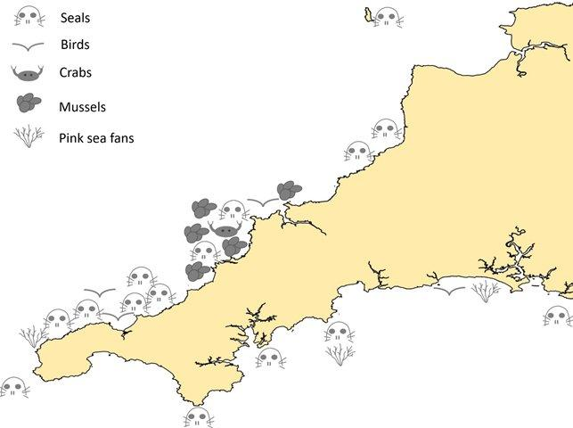At all sites, on days that entangled seals were observed, they formed 4% of all seals recorded. From CSGRT’s long term research monitoring and identification project at West Cornwall during the survey period all entangled seals comprised a mean of 3% (compared to 3% in 2014/15 and 2015/16) of all seals sighted on all surveys, with a minimum of zero and maximum 12 different entangled seals observed at one time on 17/02/17 (compared to 22/01/15 and 25/01/16).

One seal surveyor was able to photograph a seal interacting with a trawl net. Seals are inquisitive animals and will investigate ghost fishing gear. A seal’s panic response is to spin which is dangerous in proximity to floating ghost gear. As a result, this seal appeared to roll itself up in the trawl net but it was lucky enough to be able to free itself, others have not been so lucky. Seal with trawl net *Photos: M Stephens*

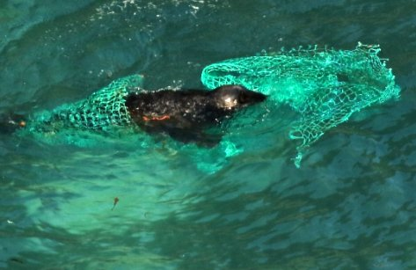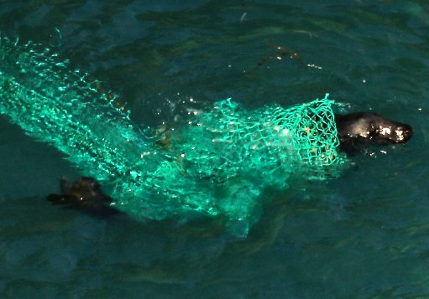

Other marine life was recorded entangled including birds (6); Crabs (2); Lobsters (1); Mussel clumps (15) and Pink Sea Fans (3).

Ghost Gear

Effort (visits)

* 210 surveys; 842 new item records; 89 raw sites (36 standard sites); 39 volunteers, 4 organisations and 4 photo ID teams (2015/16: 334 surveys)

Ghost gear amounts (items, volume and types)

* 842 items; 10050 litres or 10 tonnes
* 32% of the items were rope with all other types being between 4% and 17% of the total.

Ghost gear spatial distribution

* Ghost gear found at 36 standardised sites right around the Cornish coast.
* A greater number of items were found on the south coast, but greater volumes of ghost gear were found on the north coast
* More monofilament net and line were found on the south coast and more trawl net on the north coast
* More items per visit were found in south central (SC) standardised area of Cornwall (mostly small volume monofilament line).

418 items (50%) and 3988 litres or four tonnes (40%) of ghost gear were removed by recorders reducing the risk of serious interaction and entanglement by 2% at all sites and by 5% at seal sites, making a positive difference to levels of risk posed by ghost gear.

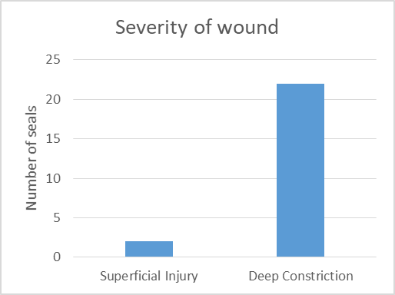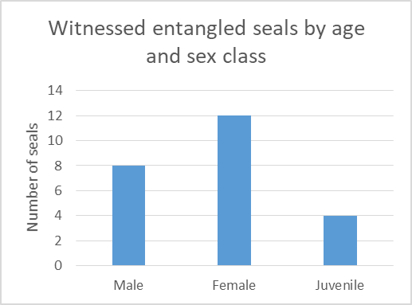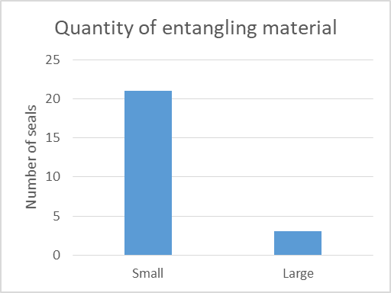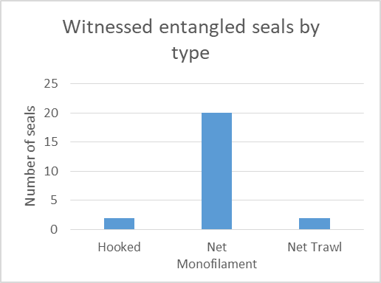

**Rescues and rehabilitation (sources Dave Jarvis British Divers Marine Life Rescue; Paul Oaten RSPCA West Hatch)**

BDMLR (2017/18 season)

Data provided by BDMLR National Welfare Development and Field Support Officer Dan Jarvis and Veterinary Clinical Director and Manager Darryl Thorpe

BDMLR responded to 420 seal related call outs, resulting in 202 rescues (48%).

Of these 121 (60%) were treated at BDMLR holding facilities in Cornwall. Most were:

* Less than 20kg (80%)
* Male (54%)
* Moulted (83.5%)

The destination outcome for these pups were

* Relocated and released after assessment 11%
* Cornish Seal Sanctuary 23%
* RSPCA West Hatch Wildlife Hospital 56%
* RSPCA Mallydams Wildlife Hospital 3%
* Hunstanton Sea Life Centre 1%
* RSPCA Stapley Grange 5%

Of these 9% died during treatment at the various holding or destination centres.

**Strandings and PMEs (data from Cornwall Wildlife Trust’s Marine Strandings Network (CWT MSN and post mortem summaries from James Barnett, veterinary pathologist)**

Summary of post mortem findings in grey seals in Cornwall, 2017

14 grey seal pups stranded on the coasts of Cornwall and one grey seal pup picked up offshore were subjected to post mortem examination at the Environment and Sustainability Institute on the University of Exeter’s Penryn Campus. Of these, 10 were found alive and died or were euthanased at rescue or in the first week of rehabilitation.

The findings in five pups were consistent with infectious disease, conditions seen including parasitic and bacterial pneumonia, peritonitis, hepatitis, purulent arthritis and septicaemia. In two pups, lesions suspicious of bycatch were seen (moderate to good body condition, persistent froth in the trachea, pulmonary congestion and oedema with no other significant findings) and one pup, found offshore, was entangled in a net (although this animal also had severe parasitic bronchopneumonia). Three pups had other forms of trauma; two had intracranial haemorrhage associated with blunt trauma to the head and one had an irreparable tear to the abdominal wall. Three pups with miscellaneous conditions also were seen; one with brain pathology of unknown origin (vasogenic oedema with neuroparenchymal necrosis), one with a developmental defect of the mandible and one with gastric impaction and perforation due to ingesting feathers.

Two adult grey seals also were subjected to post mortem examination. One male had lesions suspicious of bycatch as described above but also had a linear indentation in the pelage of the neck, fore flipper webbing abrasions, hyphaema and haemorrhages in some joints, muscles and the renal capsules. The second was a severely malnourished female with aphakia resulting in blindness and severe gastric ulceration associated with ascarid parasitism.

**James Barnett, University of Exeter.**

**Notable seal highlights**

* **Trevose site:** in six months was linked by 12 seals with 44 links to 12 sites from SW Wales to West Penwith North, North Devon and Lundy – including 2 European Marine Sites.
* **Common seals:** Juvenile female in Camel – ex rehab seal from Gweek.
* **South Devon:** First re-ID BRXF4.
* **Interesting injuries / conditions being monitored:** Ellis on Roseland, Yogi on Lizard, Pox at W Cornwall, follicle infection, broken jaw, and adaptive behaviour in response to injury/pain. Cleft palet example in Cornwall used to advise about young seal with similar condition in Holland.
* **Lizard South:** Yogi wound development – not fully healed in 12 month and now beachmastering on north coast; DP2 ex beachmaster reappeared after year’s absence at Lizard South in retirement!
* **Septimus skeleton:** 2**.**3m – third longest dead seal in cornwal - exhumed.
* **Lucky bunting:** sighted 12 months after her rescue from entanglement in trawl net back at WC.
* **Holland:** 27 year old grey seal female (branded on Isle of May in 2000).
* **Skomer:** Ex rehab seal (Snowdrop) from West Hatch and CSS in 2009/10 was released Gwithian, pupped on Skomer at age of six in 2015; Firedragon pupped and Horns beachmastered in 2015.
* **France:** Sate seal back in France 2017 (left there 2013) after sightings in Cornwall 2013/15/16 and 17
* **Birds:** Kittiwake tracked from Suffolk by CBWPS from STAPIP survey; Kingfisher on Looe survey.
* **Rescues:** Entangled seal (1) – was resighted 20 days later looking partially healed and first white coat pup rescue to CSS and starving 2 week old to CSS.
* **Strandings:** ID of young adult male ‘Fork’ at Sennen retrieved for post mortem – COD bycatch.

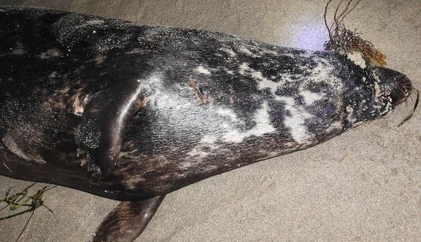

Fork bycaught approx. aged 8

* **Porthtowan site:** Linked by 72 seals to 11 other standardised sites including two SACs and two SSSIs.
* **Pups 2017:** First born NC 11/08/17.
* **New sites surveyed:** East Fal and Lizard East.
* **Common seals:** Serena Lowen returned to Fowey from Looe; Fal juvenile.
* **North Devon:** Dave Jenkins and Kate Williams identified 34 different seals (Sep) 13 (Oct) 8 (Nov) and 0 (Dec); Ex rehabbed and ex entangled seal MPF256 ‘Slipper’’s calendar demonstrated attendance at the West Cornwall site in Jan-Mar 2013-2017 and sightings in North Devon Apr-Oct 2014-2017;
* **LP382 Multi nettie:** Juvenile entangled seal was alive 31/07/17 and confirmed dead 16/10/17.
* **Skomer:** Ex rehab seal (Trixie) from West Hatch was identified on Skomer in Pembrokeshire.
* **Birds:** 2 red necked grebes on Nov Looe survey.
* **Seal site links ups:** 3 of 111 seals in Sept Ille (northern France) catalogue were identified from West Cornwall, Dorset to Roseland (returner!), North Cornwall to Looe, Gurnards Head to West Cornwall. Trevose to North Devon (Circle smiley); Gwennap to Lizard South (Splat); Gurnards to St Ives (Box Desk); Longships to Scilly and West Cornwall (2 - Double back scar and Screwdriver); Lizard and WC (DP2); Porthgwarra to Gwennap (Hickey Ned); Lizard East to Lizard South; Cudden to Gwennap (White cross); WC and NC (H and Reindeer); Roseland to N Devon (L and Lewis).First identified adult female hauled on Pendeen beach, previously identified at West Cornwall; Cudden linked to Lizard South (LIZ173); Skomer and West Cornwall (S700); North Devon linked to West Cornwall (LP389 and S587); Gulland and West Cornwall (S1638); Trevose and Lizard South (LIZ146); Trevose and West Cornwall (S1739); North Cornwall and West Cornwall (numerous seals); Manacles and Lizard South; West Cornwall and Lizard South (LIZ247, S355 and S35); West Penwith North and West Cornwall (numerous seals); Looe and Roseland (LF1, LF3 and LF125); North Devon and North Cornwall; Roseland and St Austell Bay (numerous seals); Pentire and North Cornwall; Pentire and West Cornwall.
* **Mums and pups 2017:** S262 Ghost 2 returned from North Devon to pup at West Cornwall for 9th time; S112 Ghost returned to pup for the 15th consecutive year – thought to be a world record for a grey seal; LIZ33 Celtic Cross from Lizard South pupped at West Cornwall possibly for the first time; LIZ227 Buttons returned to pup at Lizard South (pup 2017Z); LIZ15 Key pupped for third year running at Lizard South and mated twice with same beachmaster LIZ177 Tom Harts; LIZ4 Archer Lady pupped at Lizard West; Large numbers of pups lost in Ophelia (Isle of Man), Brian (SW Wales) and Eleanor and in unknown numbers from Isles of Scilly beaches leading to a seal pup rescue crisis being heroically managed by BDMLR, RSPCA and CSS.
* **Beachmasters 2017:** LIZ14 Yogi from Lizard South beachmastering at Porthtowan having been injured by LIZ177 Tom Harts last year. LIZ14 returned to Lizard South with three new injuries. Next Porthtowan Beachmaster was NM7 Medallion Man from Newquay.
* **Aging females:** Two four year old tagged females (Shuttle and Orion) were photographed next to adult female Panda who is at least 11 years old (but much smaller!)
* **Interesting behaviour:** Shag (4) and seals (0) interaction, hauling out repeatedly on fishing tender on Lizard and repeating a few months later. Rocket adult male aged 10 beachmastering on the beach he was born on; Woody hauling out on boat for second season and then tracking SUPs Lizard East. Adult female S112 Ghost filmed protecting her own and another pup during a rough high tide and using the ‘stick followed by carrot’ method of getting her pup further up the beach – both pups survived! A moulted pup was filmed making a considerable effort to climb rocks just to avoid passing an unmoulted pup; White coated pup filmed suckling underwater; In Nov and Dec 2017 24 seals were identified that had not been identified at West Cornwall since 2014 or before (one had not been identified at West Cornwall for for nine years!)
* **Common seals:** Adult male Ellis continues to be resighted despite apparently spreading back wounds; juvenile (possibly two) identified on Camel in Dec by Adrian Langdon and BDMLR.
* **Portugese man o war** sightings on pupping beaches at West Cornwall raised some concern.
* **West Hatch:** Innovated with very effective seal pup enrichment using drfitwood and seaweed.
* **CSGRT Quiz team:** won the Cornwall Mammal Group christmas Quiz!

**South Devon**

**Species**

Common seal 1 rescued South Devon and two recorded on the Exe Estuary

**Seal sightings and highlights**

**Strandings**

**North Devon mainland**

**Species**

**Seal sightings and highlights**

There are now eight full years of survey data for the key mainland site in North Devon (NODPIP) mostly submitted by Dave Jenkins alongside other volunteer surveyors.

A summary report for 2017 has been prepared by data manager Kate Williams.

Survey effort

Survey effort was amazing at 240 days(66% of the year). This demonstrates a real commitment to the NODPIP project, this commitment now ongoing for more than nine years.

Seal counts

Seal numbers observed ranged from zero to a maximum of 23 (04/07/17) seals with a mean of 5 seals. Whilst seals were observed all year round they only began hauling out in June.

Part of the haul out on 04/07/17 – see image below

Of the 126 seals identified in 2017:

* 79 were new additions to the catalogue
* 50 of the 126 seals were only identified once (probable migrant seals)
* 32 seals were identified more than 10 times (eleven of these being probable semi residents)

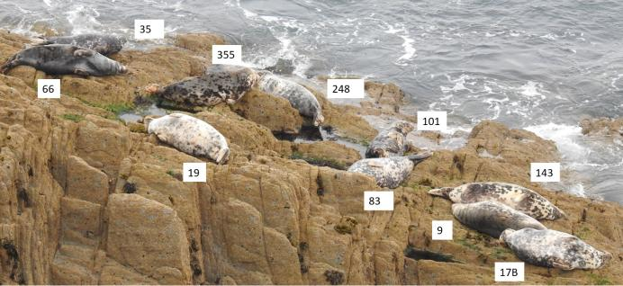The vast majority of the seals photographed were adult females, there were a few adult males seen, mostly in July, August and September. A few juvenile seals were observed this year.

The most frequently observed seal in 2017 was MPF6 ‘Starfish’ who was identified on 72 different days (30% of visits).

Six seals were identified at this site over 35 times in 2017. They were all adult females:

* MPF6 ‘Starfish’ 72 times
* MPF12 ‘Smiling monster’ 62 times
* MPF258 ‘Dribble C Snaggle tooth’ 43 times
* MPF248 ‘Circle Smiley’ 42 times
* MPF8 ‘Bat boxes’ 40 times
* 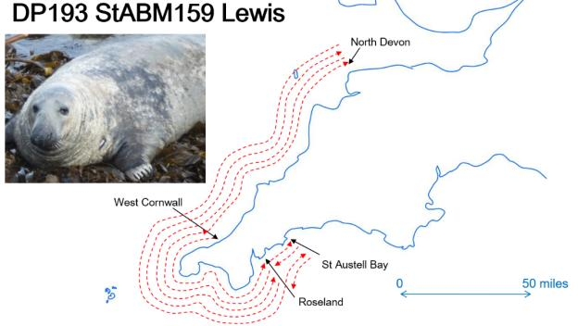MPF83 ‘Puppet’ 39 times

In the past, adult male seals have been quite a rare sight at the North Devon site but in 2017 there were 12 different adult male seals recorded. Some stayed one day but others made several visits up to a maximum of 15 for MPM235 Battlefield X.

Lewis travelled from south Cornwall to north Devon.

**Anthropogenic impacts**

Entanglement

One previously entangled seal –‘ex rehab seal ‘Slipper’ was observed

**Disturbance**

2017 was a busy year for trip boats visiting the North Devon location but, on the whole, they kept their distance and did not disturb the seals. However, 12 disturbance events were observed during surveys:

Five were caused by trip boats:

* a large rib arrived at the site at a faster speed than is usually observed,
* a trip boat arrived but there was also a large group of walkers on the coast path at the same time,
* trip boat came too close,
* trip boats didn’t come close but the engine noise was loud on a still day,
* jet skis followed five different trip boats to the area.

Two events were caused by search and rescue helicopters.

Two events by kayakers paddling through the area.

One event by coast path walkers shouting.

One by jet skis.

One by a potting boat.

**Rescues**

**Strandings**

Strandings were reported from Lynmouth west to Clovelly from several recorders. During the period 12/9/2017 to 28/11/2017, there were 11 dead white coat seal pups plus an adult male on 28/11/2017 and a juvenile on 10/12/2017.

It should be noted that virtually no grey seal pups were thought to have been born on this stretch of the north Devon coast. This suggests that many of these strandings could have washed in from elsewhere – most likely Lundy.

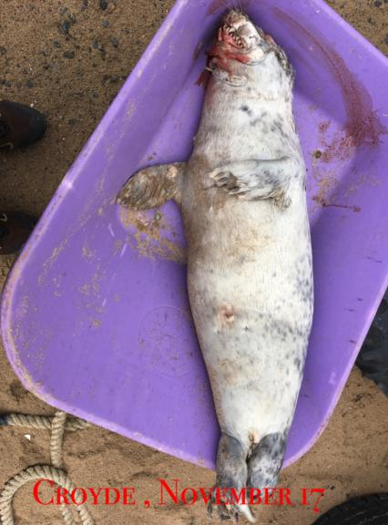

Kate Williams and Dave Jenkins

**North Devon Lundy: Dean Woodfin Jones and Mel Parker**

The Atlantic Grey seal population has been monitored annually on Lundy since 2011 to a varying degree and intermittently beforehand. In 2016 the survey method was reviewed to enable the data collected at Lundy to contribute to wider seal population assessments, such as the Sea Mammal Research Unit (SMRU) national seal surveys. Lundy’s coastline has been divided into 46 subsections (Figure 4) which are easily viewed from a boat. The highest abundance of Grey Seals around Lundy during the study period was on the 6th October, when a total of 176 animals were noted along the east - observed from the charter boat ‘Obsession 2’.

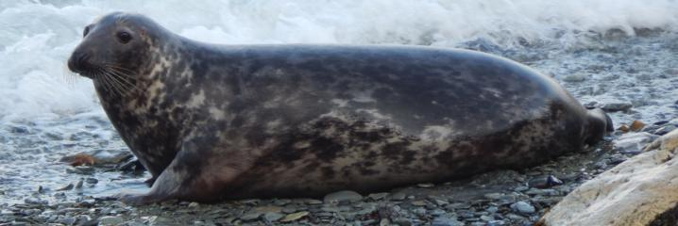

At the start of the survey period, the majority of animals around the island were females with some of those, from observational notes, showing obvious signs of pregnancy in some of the popular haul out areas. From here the numbers of females dropped rather dramatically, possibly due to some of the pregnant females moving off into the island’s inaccessible coastal caves to pup. The number of females reduced further though at a more gradual pace up until the 20th October where another marked decrease in numbers was noted (see Figure 1). Shortly before this drop in abundance, the number of males present around the island increased as the pupping season got well underway, possibly to patrol beaches and females in order to conceive next year’s pups. The number of juvenile animals varied throughout again dropping off somewhere between the 6th and 20th October. Adverse weather conditions and the onset of the end of the peak pupping season could be the reason for this drop in abundance, though without detailed meteorological data and observations during this period, this is hard to tell. 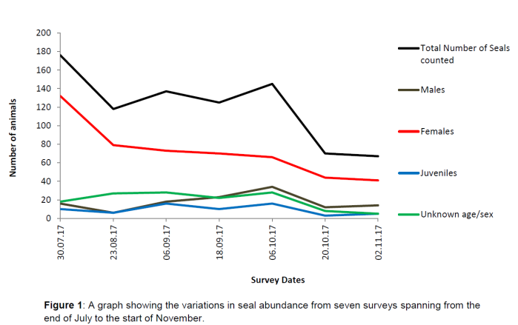

Unsurprisingly the distribution of seals around Lundy is heavily influenced by both weather and sea state. From observations at times when the winds came directly from either the north or south, animals seemed to disappear and move off from some of the more popular haul outs e.g. Rat and Mouse Island either to areas away from the island or to some of the caves or more sheltered bays on the island (3/4 Wall Bay). The two most popular haul outs during the study were Mouse and Rat Island, during times of settled weather and/or some of the north eastern bays, namely ¾ Wall Bay and Frenchman’s landing. The highest number of animals recorded from within the 46 sub-sections was from within ¾ Wall Bay on the 18/09/17 where 49 individuals were counted (See Figure 2).

On average, 82.26% of the seals throughout the study were recorded to be hauled out onto the shore at low tide rather than in the water.

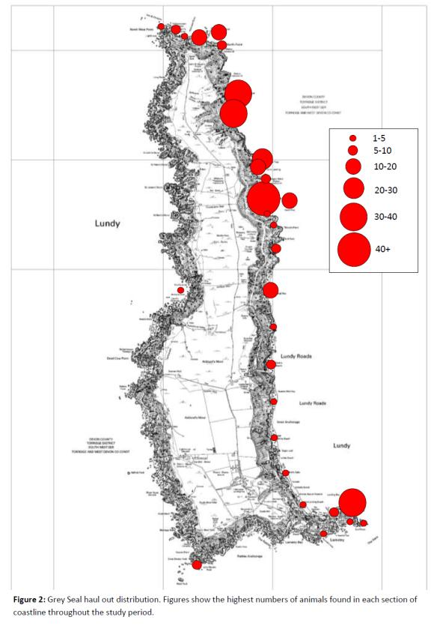

**Productivity**

A total of 26 pups were recorded from August 28th – November 20th, only seven of which were found during the surveys (see table 2). White Beach proved the most popular for pups this season with a total of 5 pups being recorded here through the study period.

Numerous other larger weaner pups were noted during the latter part of the season (outside of the survey dates) but were not included here as the origin of these individuals were unknown and it is known that young pups are very able to travel vast distances at very young ages.

Mortality

Regrettably at least seven of these pups perished, all at very young ages. Unfortunately all the pups which were born around the Lamentor and Mermaids Hole area (SE point) all disappeared during a period of very strong winds and swell created from Storm Ophelia. Another pup was found in Lametry Bay shortly after Ophelia but again was lost after a second bout of stormy weather during storm Brian. The reasons and birthing locations for the other three corpses are unknown.

**Anthropogenic impacts**

Entanglement

Only two records of entanglement were recorded during the survey periods, both of which involved the same individual

Disturbance

Instances of disturbance were recorded on three out of the eight surveys. Although the seal code of conduct was adhered to during each survey, two of these disturbances occurred due to the presence of the survey vessel.

* 30th July: 15 animals were disturbed into the seal due to the presence of the survey boat. (Charter Boat, Obsession 2).
* 06th September: 10 animals were disturbed by a walker present on the low shore of Brazen Ward (Land based).
* 02nd November: 6 animals were disturbed into the sea by survey boat (Island RIB).

For a copy of the full Lundy Seal report, please contact the warden at warden@lundyisland.co.uk

**Dorset (report submitted by Sarah Hodgson of Dorset Wildlife Trust)**

**Species**

Grey and common seals were both recorded

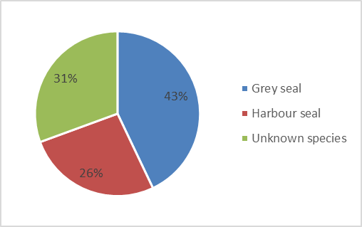

**Seal sightings and highlights**

In 2017, a total of 170 seal sightings were recorded. This figure has gone up from 151 sightings during 2016, an increase of 13%. Grey seals were spotted most frequently, 73 times. Common seals were recorded on 45 occasions and the remaining 52 sightings were unconfirmed species.

Seals were recorded from the Dorset coast throughout the year, although more were spotted in August (23%) than any other month of the year. Otherwise, the sightings were fairly evenly spread throughout the year except for April, September & October which received significantly fewer sightings.

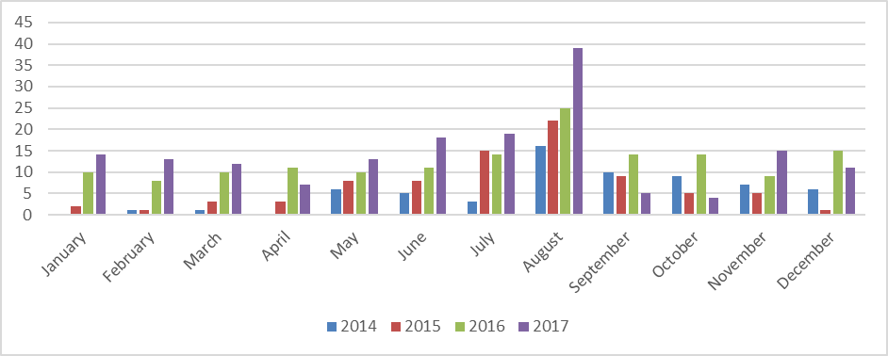 The Dorset Seal photo id catalogue increased to 40 individuals and includes both grey and common seals.

The first seal to be added to the Dorset seal photo ID catalogue in 2014, ‘Fiver’, was positively matched a further 4 times during 2017 and has now been recorded 24 times over 4 consecutive years.

**Rescues and rehabilitation**

During the 2017, 4 common seal pups that had been rescued and rehabilitated at RSPCA West Hatch were released in Poole Harbour. The first, Bongo, was released in August, followed by Enzo, Kit & Dodge, 2 male & 1 female harbour seals in November. Both Enzo & Dodge were rescued from Portland Harbour during August, with Kit joining them from South Devon. Since their release, we have had 1 photo id catalogue match for Kit, who was spotted in Poole harbour in December. There have been no confirmed re sightings of Dodge.

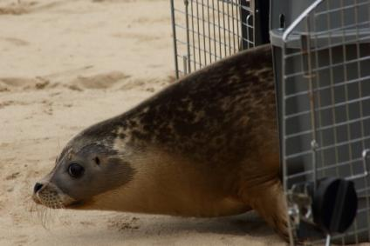

© Julie Hatcher

Bongo, the pup released in August received a lot of attention from members of the public. For her own safety and wellbeing and that of the public, it was decided that she would be relocated.

**Strandings and PMEs**

Unfortunately, one of the pups released in Poole Harbour in November, Enzo, was discovered dead on a beach on the Isle of Wight on 28th December. It is believed that he suffered a boat strike, due to the traumatic nature of his injuries.

**Management actions**

Thanks to a grant from Sea Changers, a seal watching code of conduct infographic was designed to educate people on how to behave when encountering a seal.

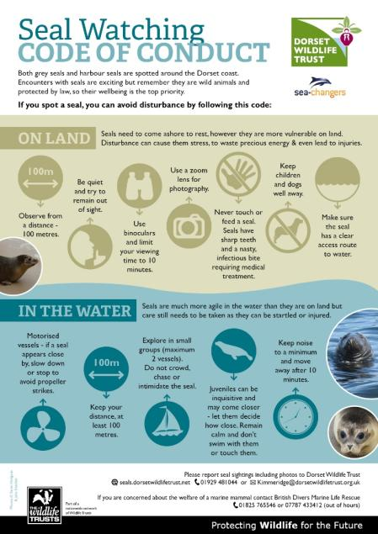

CSGRT are hugely grateful to all the volunteers who contributed to this invaluable work on seals in the SW and to everyone who has provided information and content for this report.

**Cetaceans**

**Edited and complied by Colin Speedie, Dan Jarvis & Duncan Jones**

[bob.earll@coastms.co.uk](mailto:bob.earll@coastms.co.uk)

**Introduction & Highlights**

This section is compiled from the observations and presentations from the meeting.

**Baleen whales**

**Dan Jarvis**

Data contributed by Niki Clear (Environmental Records Centre for Cornwall and the Isles of Scilly/Cornwall Wildlife Trust); Ellie Knott (Devon Biological Records Centre); Sarah Hodgson (Dorset Wildlife Trust); Duncan Jones (Marine Discovery Penzance); Annabelle Lowe (Newquay Sea Safaris and Fishing); Jenny Simpson (Padstow Sea Safaris); and Dan Jarvis (British Divers Marine Life Rescue).

**Minke whale (*Balaenoptera acutorostrata*).**

2017 saw a relatively good number of minke whale sightings, with 46 sightings in total collected for this report, all of them from around Cornwall. The majority of the sightings were of lone animals, but there were three reports of pairs and one sighting of a group of four. The latter of these sightings is of particular interest as minke whales are rarely seen in groups, and this one consisted of three adults and a juvenile that were foraging together. Most of the observers reported that the whales they saw were either feeding/foraging or travelling, and another noteworthy sighting involved a loosely associated pair of minke whales, one of which was being closely accompanied by a mixed group of common dolphins and blue fin tuna as they departed an earlier feeding frenzy that also involved dozens of gannets.

It is notable from the temporal data that there appeared to be peaks in sightings during April and August, which may potentially indicate some form of seasonality and/or be linked to increased prey availability in certain areas. Spatially, most of the sightings were reported from the South and West of Cornwall, particularly between Gwennap Head and Mount’s Bay, but there were also smaller concentrations around the Newquay – Padstow area, however it must be pointed out that these are areas with relatively high observer effort.

There were no strandings of minke whales in South West England in 2017.

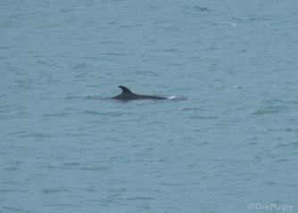

Image: Dan Murphy

Fin whale (*Balaenoptera physalus*).

Seldom seen close to the coast, there are typically very few sightings of this species each year, and 2017 was no different. There were five sightings altogether, four individuals and one pair, all of which were seen in Cornwall during August and in the vicinity of Gwennap Head. Three sightings occurred on one day, so are likely to be of the same animal rather than three different animals. These sightings coincided with the peak in minke whale sightings in this area at the same time and appear to have been related to abundant prey availability.

There was a single stranding of a fin whale at Hartland Quay, North Devon, during March. It was a moderately decomposed carcass that was unsuitable for post mortem examination. Photos and other information was forwarded to the Cetacean Strandings Investigation Programme.

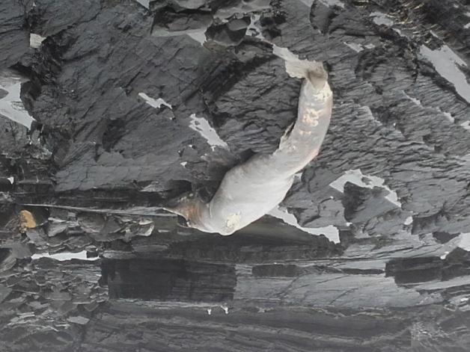

Image: Steve Threlkeld, Devon Wildlife Trust You get an idea of the scale from the two gulls above

Humpback whale (*Megaptera novaeangeliae*).

There were three sightings of humpback whales in 2017, down on 2016. One unconfirmed sighting was made by birdwatchers off St Anthony’s Head in April, while there was a confirmed sighting of a young animal captured on film and reported widely in the media in Falmouth Bay at a similar time.

The third sighting was of a 45’ long individual in Start Bay, South Devon, that arrived in early March and remained in the area almost consistently until early April and was widely reported in the media and on social media, which drew large crowds to see it due to its ease of being sighted from nearby vantage points and from its habit of staying relatively close to the coast. There was strong evidence of high prey availability in the area for much of the time it remained in the area and it may well have stopped off here during its migration for that reason. Fortunately, there was very little in the way of disturbance issues being caused by people attempting to approach the animal despite the very public nature of this animal’s extended visit, and several organisations repeatedly publicised codes of conduct when dealing with the media to help reinforce this message. On 22nd March the whale became entangled in whelk pot ropes, requiring intervention from a combined rescue team from British Divers Marine Life Rescue, HM Coastguard team at Dartmouth, the RNLI Lifeboats at Dartmouth (Inshore) and Salcombe (All Weather) and the fisherman whose ropes it had accidentally become caught in, which took several hours to cut free. Unfortunately, the whale became entangled a second time on 1st April in a twisted mass of ghost gear whelk pots that fully immobilised it. BDMLR, the Coastguard and the Salcombe RNLI Lifeboat (All Weather) were once again called upon to rescue the creature, which this time took just a couple of hours to free.

There were no humpback whale strandings in South West England in 2017.

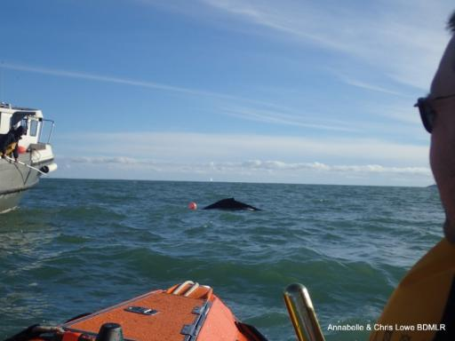

**Toothed whales**

*Notes below from the April 2018 meeting*

**Sperm whales Risso’s dolphins Porpoises Common Dolphins Bottlenose Dolphins**

**Solitary Bottlenose dolphin** **5. Nicola Dewey – Cornwall College Newquay**

(Large male) dolphin spent most of August & September accompanying Newquay Sea Safaris catamaran on sea safaris (sometimes up to five 2-hour trips in a day) – the dolphin would wait outside the harbour while the boat dropped off/picked up passengers then follow us all day, disappearing after the final daily trip & reappearing the next morning. The dolphin did not track any other boats & we did nothing to encourage him. The dolphin had quite large rake marks along the dorsal side & we think that he may have been ostracised from his pod (maybe a hierarchy issue). The dolphin was sighted around Penzance during the winter and has not yet been seen back in Newquay this season.

**High level of early year strandings 13. Rebecca Allen** Very high level of cetacean strandings early part of year. [Reported at the 2017 SWME meeting

**3. Matt Slater** (a) Terrible year in Cornwall for cetacean strandings – 250 individuals peak in Jan, Feb & March. Reason unknown (MSN)

**14. Dave Curno**

(a) Atlantic white beaked dolphins (2). My first sighting of this species. Approx 6 miles off Fowey, followed boat for 20 minutes

(b) Harbour porpoises, large number (50+) on one day between Fowey & Falmouth

**Harbour Porpoises off Slapton at the time the Humpback was around 23. Douglas Herdson** Harbour Porpoises off Slapton at the time the Humpback was around (March 2017? Can supply exact date). Bob Earll Yes, the porpoises were obvious at Slapton at the time of the 2017 Meeting even when the humpback was absent. This is the first time I have seem porpoises off the south Devon (South Hams) coast in many years of seawatching.

A stranded (dead) harbour porpoise on the beach adjacent to Hope Cove in August (Bob Earll); contact xxxxx for stranded cetaceans in Devon - Picture

**England’s only resident bottlenose dolphin population: Introducing the south west community**

**Dr Simon Ingram** Plymouth University

 +44(0)1752 584591 / Simon.ingram@plymouth.ac.uk / Skype dr.simon.ingram

'Bottlenose dolphins (*Tursiops truncatus*), have been sighted regularly in the southwest region of the UK since 1991. However, the degree of residency for this population remained poorly understood. Citizen science data was used to analyse the social structure, distribution and abundance of bottlenose dolphins in southwest waters.  A total of 193 photo-identified encounters from 2008 to 2016 were acquired from various sources throughout the region. [Evidence for a discrete coastal community restricted to waters <50 m is presented](http://www.cmscoms.com/?p=12184), along with the existence of other pelagic animals and lone individuals, who appear to be spatially and behaviourally segregated. Although kernel density methods demonstrated that the community appeared to have two distinct core areas of use, ranging behaviour determined that individuals travelled appreciable distances and were not confined to these core areas. Seasonal distribution indicated that dolphins within the coastal community are year-round residents, with an increase in sightings during the summer. Mark-recapture analysis produced an estimate of only 28 (±4) individuals within the resident population. Therefore, until demographic isolation can be fully determined a precautionary conservation approach should be applied. It is clear that this population requires specific measures of protection, such as the designation of a Special Area of Conservation (SAC) or Marine Conservation Zone (MCZ) in southwest waters.'

**Distribution of small cetaceans along the SW coast using passive acoustic & visual surveys**

**Clare Embling** Plymouth University

Embling, C.B.1, Edwards, W.1, McCallien, A.2, Ingram, S.N.1

1School of Biological & Marine Sciences, Plymouth University, Plymouth, PL4 8AA

2School of Engineering, Plymouth University, Plymouth, PL4 8AA

[Clare.embling@plymouth.ac.uk](mailto:Clare.embling@plymouth.ac.uk) 01752 586137

The southwest of the UK has one of the highest diversities of cetaceans in the UK, with high numbers of small cetaceans including harbour porpoises (*Phocoena phocoena*), common dolphins (*Delphinus delphis*) and the small vulnerable population of coastal bottlenose dolphins (*Tursiops truncatus*). The southwest also has one of the highest fisheries bycatch rates of small cetaceans in UK waters, making these populations particularly at risk. However, we know very little about cetacean populations along the SW coast except in localised areas. We have therefore recently started carrying out systematic broad scale visual-acoustic surveys of the SW coast of Cornwall from the university sailing yacht (*Take the Helm*) to gain a better understanding of the distribution and relative abundance of small cetaceans in the area. Acoustic surveys are particularly useful for detecting harbour porpoises, which are difficult to spot visually in poor sea states. We report on the first survey carried out in August 2017, surveying the coast from Plymouth to the Lizard Peninsula out to the 6 mile limit. There were a total of 116 harbour porpoises, 47 common dolphins, and 3 minke whales detected visually, with highest densities of harbour porpoises found off Whitsand Bay, Fowey, and the Lizard Peninsula. This forms the first of a series of regular surveys of cetaceans off the SW coast to inform conservation management of these populations and help understand and mitigate bycatch rates.

**Management Issues: Fisheries, MPAs & Marine Spatial Planning**

**Sarah Clark** [s.clark@devonandsevernifca.gov.uk](mailto:s.clark@devonandsevernifca.gov.uk) 01803 854648

**Fisheries**

**Bass Research**

D&S IFCA started co-funding a PhD project with Plymouth University entitled: The ecology and distribution of European sea bass (*Dicentrarchus labrax*) in the South West UK. The PhD student (Thomas Stamp) is working with Emma Sheehan at Plymouth University and IFCA officers. The PhD is now in it’s second year, and has three defined research chapters; 1) Acoustic tracking of juvenile European Seabass, 2) Assessing the quality of juvenile fish habitat within Managed Re-alignment Schemes, 3) Static netting review:

1. **Acoustic tracking of juvenile European Seabass**

Plymouth University and the Devon Severn IFCA submitted a successful funding application to the European Maritime and Fisheries Fund, for the amount of £241 685.40. The grant will be used to track 150 juvenile European Bass across 3 Bass Nursery Areas (BNAs) of the southwest UK; the Dart and Taw/Torridge estuaries, and Salcombe Harbour. The tracking system will work by implanting a small acoustic transmitter within the abdominal cavity. The transmitters will emit a unique ping which can be detected and recorded by strategically placed acoustic receivers. Receivers will be placed at and adjacent to boundaries, aswell as at major confluence and pinch/narrow points within BNA. Specifically, 2 age classes will be targeted within the project; 20-30cm & 31-42cm (total length), these age classes have been selected due to their potential vulnerability from capture in commercial and recreational fisheries. The data will have high relevance to management of coastal European bass fisheries in the southwest UK, as well as wider relevance within northwest Europe.

The project has involved obtaining various licenses and dispensation from statutory nature conservation bodies. To date permission has been secured from the Environment Agency, Natural England and the Marine Management Organisation. Permission has also been granted from relevant port authorities and the Crown estate to fix acoustic receivers throughout each estuary. Due to the implantation of transmitters within live seabass, home office licensing is also required for the project. In this regard, 6 staff members from Plymouth University have been trained and have successfully gained personal home office licenses. An application for a home office project license has also been written and is currently being assessed by Plymouth university ethical review board; following this the project license will be assessed by the home office. Currently it is hoped the acoustic receivers will be deployed from June 2017 and fish tagging will begin in July. Once setup the system will continuously monitor fish movement for a period of 1.5-2 years.

The project has also attracted additional funding from interested parties, who aim to monitor other fish species which use the same habitats as European Seabass. CEFAS have provided additional funding for 20 transmitter tags which will be used to monitor Gilthead Bream (*Sparus aurata*) in Salcombe Harbour. The Environment Agency has also provided additional funding to monitor Sea trout (*Salmo trutta*) movement in the Dart and Taw/Torridge estuaries.

1. **Assessing the quality of juvenile fish habitat within Managed Re-alignment Schemes**

This chapter aims to quantify the quality of juvenile fish habitat within managed re-alignment schemes (man-made saltmarshes) when compared to natural saltmarsh. There will be emphasis on Steart marsh, the largest managed re-alignment scheme in the UK, however samples will also be collected from Medmerry Nature Reserve (Sussex) and Wallasea Island (Essex). Fyke and seine nets will be used to record fish diversity, and a sub-sample of juvenile bass will also be retained to analyse diet and growth. Using otolith growth rings juvenile bass growth will be recorded when they have accessed managed re-alignment schemes. Furthermore, stomach contents and stable isotope analyses will be used to measure if there is any difference in diet when seabass exploit managed re-alignment vs natural saltmarshes. In 2017, permission has been granted from the Environment Agency, Natural England, the Marine Management Organisation, and land owners. Sampling for this project began in May and continued until September.

1. **Static netting review**

During the consultation process for the D&S IFCA netting permit byelaw, the Environment Agency (EA) submitted a report to the IFCA which suggests that salmonids were highly associated with the top 0-5m of water depth and the EA recommended that in areas where salmonid bycatch is expected, coastal static net headline depth should be extended from 3 to 5m. It is proposed that static nets be deployed by local fishermen with 0, 3 and 5m headline depths. The catch from each net will then be used to identify if salmonid by-catch is significantly reduced when headline depth is increased to 5m. The catch will also be used to estimate the potential economic impact on individual fishermen if a 5m headline depth was imposed. As mentioned previously, the EA are also interested in tagging seatrout with acoustic transmitters in the Dart and Taw/Torridge estuaries. It will be proposed that the EA tag sea trout with acoustic transmitter with in-built depth sensors. If depth sensors are included within the acoustic tracking, the depth data could compliment the static netting review and provide detailed information on sea trout movement in areas where coastal netting operates.

**Wrasse Fishery**

The Live Wrasse Fishery developed in Cornwall, Devon and Dorset during 2016 and continued through 2017. The use of wrasse to remove fish lice from salmon in cages is based on the observations of cleaner fish behaviour and removes the need for chemicals to control lice infestations within the salmon farms.

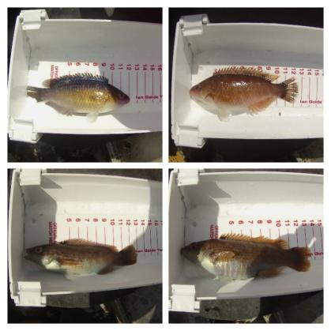Wrasse are being targeted in Plymouth Sound for use as a cleaner fish. A fully documented fishery was implemented into the permit conditions of Devon and Severn IFCA (D&S IFCA) Potting Permit Byelaw, to include an intensive data collection program. Devon & Severn IFCA officers have undertaken on- board surveys of the live wrasse fishery, taking place within the Plymouth Sound in 2017. These surveys gathered information on how the fishery works and collected in-depth data on wrasse including the catch composition, size distribution and breeding season. Data from observer surveys and landings data were analysed and a scientific report was presented to the D&S IFCA Byelaw Sub-committee in November. This report presents the results of the data collection from the first full season of the Live Wrasse Fishery. The two main types of data presented were from landings data recorded by fishers from April to October 2017 and twenty on-board surveys carried out by IFCA Officers. On-board survey effort equated to 7.5% observer coverage of boats surveyed, or 5.5% of the entire fleet. As a result of the wrasse research some suggestions to changes in the management measures for the wrasse fishery were discussed and recommendations will be put 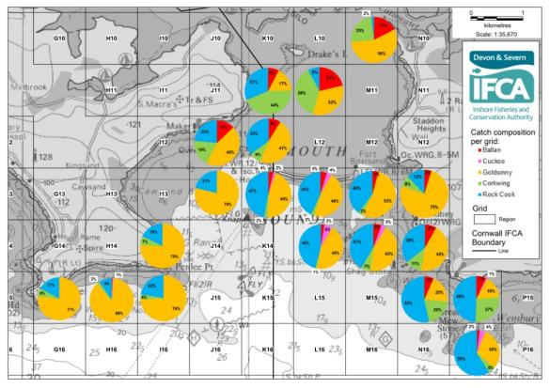before the main authority in December.

There was no consistent decline in Catch per Unit Effort (CPUE) or Landings per Unit Effort (LPUE). There were observed seasonal fluctuations in CPUE and LPUE and these could be attributed to spatial movements of fishers and their pots, fish behaviour or environmental changes. Continued data collection in the future is vital to determine changes in LPUE and CPUE over time and space.

*Chart showing the catch composition per grid in Plymouth Sound during 2017*

Spatial fishing effort varied over time across the Plymouth Sound area. Goldsinny and rock cook represented the majority of catch for all vessels. The proportion of species varied considerably spatially and this can be attributed to species preference for exposure and depth, for example, corkwing were found in more sheltered, inshore areas. The majority of observed spawning took place between May to mid-July. The data indicated the current closed season from 1st April to 30th June covers the majority of, though not all, the spawning season for goldsinny and rock cook.

The size frequency histograms illustrated the importance of Minimum (Min) and Maximum (Max) Conservation Reference Sizes (CRS) for wrasse. The Min CRS (12cm) for goldsinny and rock cook allows a significant proportion of the catch to be returned to sea and to spawn. The introduction of the Min and Max CRS (15-23cm) for ballan demonstrated an increased proportion of the catch returned to the sea from 4% to 28%, protecting both juveniles and mature adults. However, the current Min and Max CRS (12-23cm) for corkwing is allowing over 90% of the fish caught to be landed. Due to the complex life history of corkwing, and the results of the data analysis, amendments to the slot sizes would be recommended to allow a proportion of immature and *mature fish to return to sea.*

The results presented in this report highlight the importance of a fully documented fishery and the need to continue data collection to monitor the live-capture fishery for wrasse.

*Size Frequency histogram for all corkwing caught during surveys in 2017*

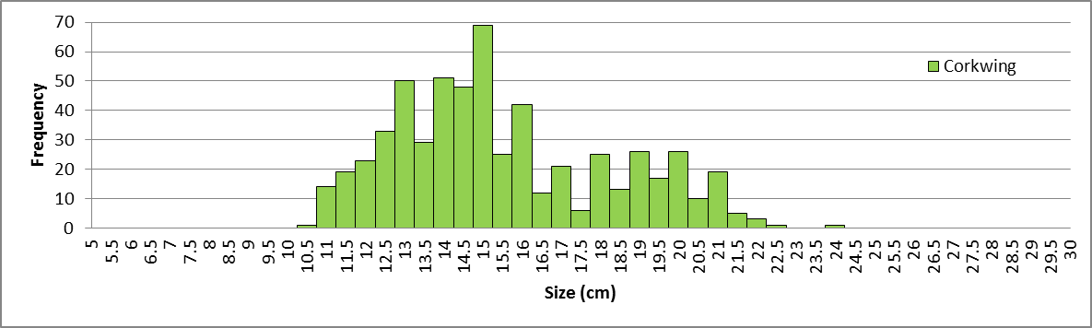

Devon & Severn IFCA has brought in formal management through its Potting Permit Byelaw – introducing a wide range of measures making the fishery one of the most restricted fisheries in the country. D&S IFCA has also introduced voluntary close areas with the Plymouth Sound. [Devon & Severn IFCA Wrasse Fishery Management Measures can be read here](https://secure.toolkitfiles.co.uk/clients/15340/sitedata/Wrasse/Live-wrasse-news-Oct-2017.pdf).

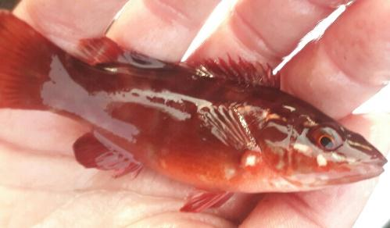

© Steph Davis

Southern IFCA and Cornwall IFCA have also developed voluntary regulations through guidance documents, which are now in place. These guidance documents can be found:

* [Southern IFCA Wrasse Fishery Guidance](https://secure.toolkitfiles.co.uk/clients/25364/sitedata/files/Wrasse-Guidance.pdf)
* [Cornwall IFCA Wrasse Fishery Guidance](https://secure.toolkitfiles.co.uk/clients/17099/sitedata/Code_of_practice/live-wrasse-fishery-guidnece.pdf)

© Keith Hiscock

**Other Observations**

Sally Sharrack of Sea Search made the following observation: Occasional potting for crustaceans has taken place in the Wembury Voluntary Marine Conservation Area for many years but in the last couple of years it has been noticeable that pots are appearing more frequently and much nearer inshore – too shallow for viable crab sizes, so presumable strings of wrasse pots – especially in Wembury bay itself to the east on Church rocks towards the Tomb eelgrass beds and also across the entrance to Bovisand Harbour. Juvenile wrasse together with nesting adults are well known in these areas and there is video footage of nesting corkwings from April. Although the area is a voluntary conservation zone it seems a shame that the local wrasse fishery targets this area so heavily especially as no studies on stock numbers have yet been done to ascertain if the fishery is properly sustainable. The wrasse do, after all, belong to the snorkelers and divers and anglers just as much as the fishermen!

Emma Magee wanted to highlight the efforts of Devon Wildlife Trust in raising the profile on the wrasse harvesting.

**Crawfish Research**

**Modelling the dispersal of spiny lobster (Palinurus elephas) larvae: Implications for future fisheries management and conservation measures**

There are two species of spiny lobster, *Palinurus elephas* and *Palinurus mauritanicus* that have been recorded in UK landings. Of these, *P. elephas* is by far the more prevalent. It is fished throughout its distribution along the eastern Atlantic coast from Norway to Morocco and throughout the Mediterranean. The collapse of the population within south west UK fisheries has been attributed to a change in capture gear from pots and traps to the use of less selective tangle and trammel nets. One stock of *P. elephas* that is still being commercially exploited is the Isles of Scilly.

There are no Total Allowable Catch (TAC) limits or quotas applied for this species. No scientific stock assessments have been undertaken, but the long term trends in fishery statistics indicate significant overfishing. *P. elephas* are a species of conservation importance, with a conservation objective of ‘recover’ within several Marine Conservation Zones (MCZ), including many of the sub-sites around the Isles of Scilly.

In 2017, the Isles of Scilly IFCA in collaboration with Cornwall IFCA, Devon and Severn IFCA and CEFAS, undertook a study to model the dispersal of *P. elephas* larvae and identify the connectivity of key populations around the English Channel and Celtic Sea. A General Individuals Transport Model (GITM) was used to simulate the diffusion of particles around the region. ‘Release locations’ within the model included the Isles of Scilly SAC, Skerries Bank and Surrounds MCZ, Lundy SAC, Bideford to Foreland Point MCZ, Lizard Point SAC and Padstow Bay and Surrounds SAC.

The model reinforces how many MCZs have very limited self-seeding and are reliant on recruitment from elsehwere. This highlights the importance of managing fisheries across their full potential geographic range, and the need to manage *P. elephas* in a way that takes into account their whole life cycle, prioritising the stages of the cycle which could have the greatest benefits in terms of future recruitment. Due to this connectivity, failure to protect a feature or manage an activity at just one key site could have unforseen effects on the overall conservation network.

**Summarised from:** *Whomersley P, Van der Molen J, Holt D, Trundle C, Clark S and Fletcher D (2018) Modeling the Dispersal of Spiny Lobster (Palinurus elephas) Larvae: Implications for Future Fisheries Management and Conservation Measures. Front. Mar. Sci. 5:58. doi: 10.3389/fmars.2018.00058*

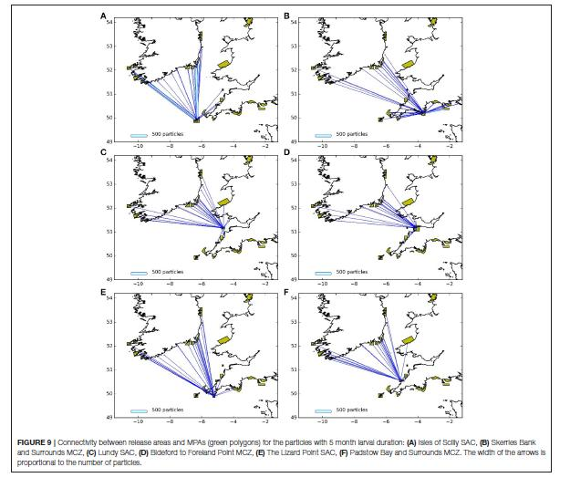The follow figures are taken from the above paper.

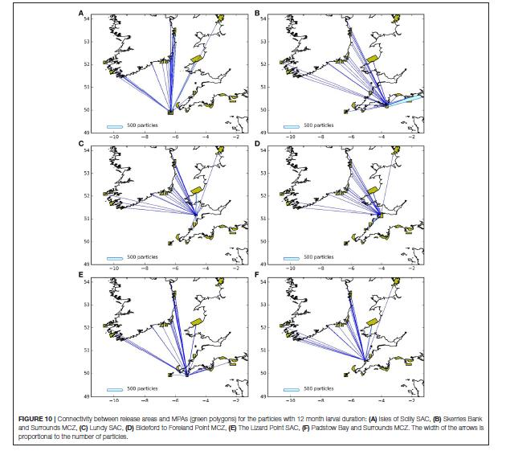

**Recreational Sea Angling**

**Marine Pioneer**

**Biosecurity Plans for Estuaries and Harbours**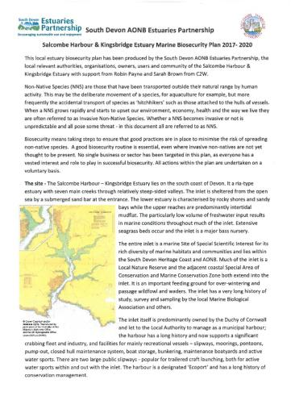

The effective control and management of marine Invasive Non-Native Species (mINNS) within the marine environment is inherently problematic and at best, hugely expensive in terms of time, resources and cost, not to mention playing catch-up with the science. Hence, the priority for mINNS has to be awareness and prevention, rather than cure.

In the South-West, most of our estuaries are rias or post glacial drowned river valleys; being deep watered and sheltered, they have a long history as ports and harbours, and more recently with recreational craft ranging from liveaboard yachts to trailered dayboats and roof-racked canoes, etc. – all potential vectors of mINNS.

As a last trawl of the formal review of our South Devon AONB Estuaries Environmental Management Plan, we were challenged by the Marine Biological Association to escalate the pro-action of our mINNS awareness action and to prepare an ‘Estuaries BioSecurity Plan’. With a growing political awareness of the wider dangers of mINNS, Natural England secured funding from Defra to assist in the production of local BioSecurity plans and commissioned C2W to help. Early on, we decided that our local BioSecurity plans needed to be individual to each of our five estuaries – their geography, ecology, ownership, use and management capacity dictated this and maybe helps the local need to take BioSecurity seriously. In full consultation and partnership with the wider local community through our estuary Forum groups we prepared and completed our suite of Biosecurity plans.

Each plan describes the particular character of the estuary, a description of its top 10 most unwanted mINNS, how these species might spread between estuaries, simple but effective precautions to take to avoid the spread and where to report sightings. The plans are simply prepared as an illustrated text-document to assist their ease of update … already for some, the top 10 catchy title has been lost as more mINNS are discovered and identified.

The BioSecurity plans are available as downloads under the relevant estuary section of our South Devon AONB website, and the estuary’s Harbour Authority’s where they exist. Copies have also been sent out to all relevant marina, boatyard and mooring managers for sending out to their customers for this 2018 boating season.

**Marine Protect Area Management**

**Marine Conservation Society’s MPA Reality Checker**

*The MPA Reality Check is a website that allows the public and interested stakeholders to see how fisheries management measures are progressing in Marine Protected Areas. We have focused our mapping into byelaws that restrict the most damaging and widely pervasive fishing activities, namely bottom trawling and scallop dredging. The website came about because of the revised approach to managing fishing in MPAs in 2012, that has prompted pro-active management by regulators. The website is available at:*[*https://map.mpa-reality-check.org/*](https://map.mpa-reality-check.org/)*. MCS and the webpage designer, Tom Mullier of marinemapping are recorded in an online Webinar describing the tool:*[*https://www.openchannels.org/webinars/2018/mpa-reality-check-chance-see-fisheries-management-english-mpas*](https://www.openchannels.org/webinars/2018/mpa-reality-check-chance-see-fisheries-management-english-mpas).

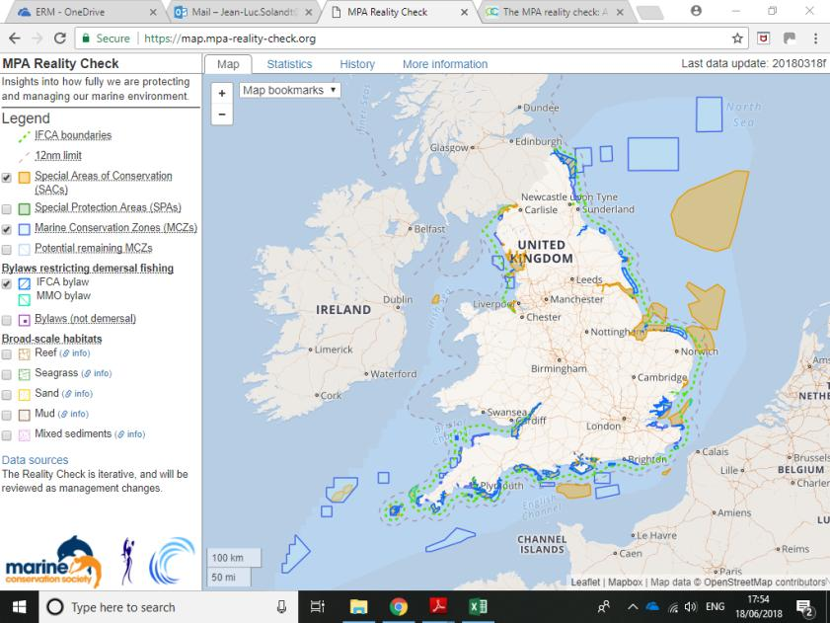

**Devon and Severn IFCA’s** district covers a coastal area of 4522 km2, has two coasts, and in the north of the district extends along the median line with Wales to the tidal limit of the Severn Estuary. Over 42% of the district is designated as Marine Protected Areas (MPA) due to the diverse range of habitats and species, which are found in these waters. 93% of the MPA are closed to bottomed towed fishing gear. There are nine European Marine Sites and six designated Marine Conservation Zones in the district most of which are designated for reef features, along with other sensitive features such as seagrass, *Sabellaria* and the spiny lobster.

**Management of European Marine Sites**

**Management of Marine Conservation Zones**

**Devon & Severn IFCA**

In Devon & Severn IFCA district Tranche 1 MCZ include Lundy MCZ, Torbay MCZ, Skerries Bank MCZ and Tamar MCZ.

Need to add info on what was done last year

**Torbay MCZ**

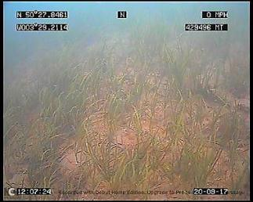Torbay MCZ has 12 designated features, three of which have a recover to favourable condition general management approach. These features are subtidal mud, seagrass beds and the long-snouted seahorse. Seagrass beds have been protected from the impacts of bottom towed gear since 2014 under the D&S IFCA mobile fishing permit Byelaw. As seagrass provides a habitat and ecosystem for the long-snouted seahorse protection has been afforded to this feature as well. D&S IFCA undertakes surveys of the sea grass, which evaluates the location, extend and density of the seagrass beds.

The biennial seagrass survey was carried out in 2017. A drop-down camera was used to carry out transects on the known seagrass beds to determine density of the seagrass, and the any changes in the extent. There had been reports of previously unknown beds in Torbay, these areas were also surveyed. Analysis of the result so this survey is currently being analysed and maps of the extent of the beds are being created in Map Info. The results will feed into the management of the MCZ, as the outer limits of the seagrass beds determine the closing line to towed gear fishing.

Seagrass in Torbay MCZ

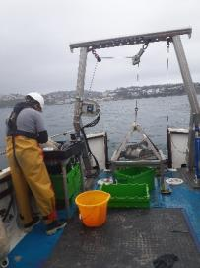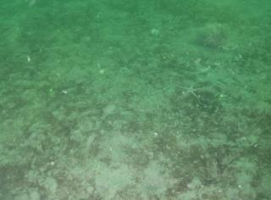Defra and Natural England provided £40,000 for the IFCA to carry out research to investigate the impact of light otter trawls, used to target cuttlefish in the spring, on the mud feature of the Torbay MCZ. Survey planning was undertaken to identify survey areas and ensure that sampling level was sufficient to for robust analysis. Before and after impact survey work was carried out which involved taking sediment samples, using Ocean Ecology Ltd vessel and grab equipment, and in-house underwater filming of the MCZ benthic habitat. A Torbay cuttle fisherman was also involved in the survey and planned trawls tows were undertaken to mimic the fishing effort during the fishery season. SeaFish Authority was also involved in the survey work undertaking a two-day sea trial to evaluate the area of impact of the single trawl and trawl doors used by the fisherman on the mud habitat in the MCZ. All data collected are currently being analysed.

Mud habitat in Torbay MCZ

Grab Sampling with Ocean Ecology Ltd

**Bait Collection Survey work in Torbay MCZ**

Bait collection takes place on the intertidal features and survey work has taken place in 2016 and 2017 to gather information on the location and level of effort. The data collected will be analysed and feed into bait collection assessments in 2018.

**Tranche 2 MCZ**

**Southern IFCA**

In 2017, Southern IFCA introduced additional protection from bottom towed fishing gear for sensitive habitats and species of Marine Protected Areas. Further areas were permanently closed through the amendment of an existing byelaw, Bottom Towed Fishing Gear byelaw 2016, closing 26% of the Southern IFCA district to bottom towed fishing gear. Further measures were introduced to manage amber interactions, between shellfish dredging and sedimentary habitats, in the Solent Maritime SAC, leading to the introduction of temporal closures, limiting the activity to 4 months of the year. In 2015 the Authority introduced a limited access permit byelaw for a clam and cockle dredge fishery in Poole Harbour SPA. Permit conditions provide protection for designated features through spatial and temporal closures. This type of permit byelaw was the first of its kind in the UK and has delivered significant achievements, including a 95% decline in illegal activity, increased earnings and additional evidence to support management through an annual stock assessment. The successes of this management have been further validated and celebrated by the achievement of an MSC sustainable fisheries certification, the first for a Manila clam in the UK.

**Marine Spatial Planning - South West Marine Plan**

In spring of 2017, the Marine Management Organisation identified and engaged with stakeholders on common issues that the South West Marine Plan should address. The aim of the engagement was to present our thinking about the causes and effects of issues to targeted groups of stakeholders. The engagement helped validate already identified issues and also provided an opportunity to ask stakeholders what they think the causes or effects of issues in the area are. Throughout the summer we began analysing the results of the engagement and validating the issues that were identified. A draft vision for South West Marine Plan was produced for a round stakeholder engagement in the spring of 2018 . The vision gives an overview of how the south west marine plan area is targeted to look in 2041 across the environmental, social and economic sectors. The MMO is now undertaking a stage of policy development in preparation for a series of stakeholder engagement in the spring of 2019.

**Alex Curd** Marine Officer (Planning) South-West), Marine Planning Team, Marine Management Organisation, The Fish Quay, Sutton Harbour, Plymouth, PL4 0LH.  E: [alex.curd@marinemanagement.org.uk](mailto:alex.curd@marinemanagement.org.uk)

Direct Line: 02085654835

Web: [www.gov.uk/government/organisations/marine-management-organisation](http://www.gov.uk/government/organisations/marine-management-organisation)

**Partnership Working**

Dafni Sifnioti of Teignbridge District Council observed the importance of partnerships and partnership working. Partnership working between organisations for example: RMAs, consultancies and academia that aim to protect and manage the coastal marine environment. Dawlish Warren, Mount’s Bay Blue Coast/SWEEP. Exmouth’s tidal station are a few examples where partnerships have been developed and are of the utmost importance to achieve the results needed.

**Litter, Plastics, Nurdles and Microplastics**

**Claire Wallerstein**

**Contact**: Cornish Plastic Pollution Coalition, Pilgrims, 56 Fore Street, Kingsand, Torpoint, PL10 1NAT: 01752 823308 E: [claire.wallerstein@gmail.com](mailto:claire.wallerstein@gmail.com)

**Litter General**

**Marine Plastics**

**Claire Wallerstein & Delia Webb**

**Contact**: Cornish Plastic Pollution Coalition, Westside, 56 Fore Street, Kingsand, Torpoint, PL10 1NAT: 01752 823308 E: [claire.wallerstein@gmail.com](mailto:claire.wallerstein@gmail.com) or [deliawebb@btinternet.com](mailto:deliawebb@btinternet.com)

**Plastics General**

This was a steady but not significant year for marine plastics. Several beach cleaners reported an apparent decrease in the number of large, more easily-retrievable items. Overall numbers of items remained static or even increased, but the size of the pieces seemed to have become smaller.

Pennie Lindeque from PML, for example, reported a visual increase in **microplastic debris** on the strandline at various beaches around the South West.

Microplastics were found during plankton trawls (Meg Hayward-Smith, Falmouth Marine Conservation) while the Cornwall Seal Group Research Trust began trawls offshore along coastal transects this year for microplastics and found plenty (Sue Sayer).

**Plastiglomerates**

Research has started in order to map the prevalence of plastiglomerates, a type of plastic pollution on our beaches that few people would even notice as they look like rocks and pebbles. The Cornish Plastic Pollution Coalition is endeavouring to gather more evidence about these ‘plastic rocks’, presumed to originate from people burning or incinerating plastic debris on beaches, coastal areas, or at sea, possibly in the misguided belief that this is an effective way of getting rid of rubbish and marine plastic.

Plastiglomerates were first described by Dr Patricia Corcoran (Western Ontario University) in 2014 after she found specimens on beaches in Hawaii. Her research has found that the molten plastic can mix with beach sediments, and other organic matter so forming large agglomerations which often attach to bedrock or boulders. These large lumps are then weathered by the action of the wind, waves, and the climate system, so allowing small pieces to break off becoming smoothed and rounded. Colour variations exist depending on the nature of plastic that has been burned – but the spectrum of resulting shades mimics natural rock tones very successfully.

The CPPC has so far received reports of this sinister form of marine plastic, which will so often be overlooked by beach cleaners, being found on beaches in Cornwall (North and South Coasts), Devon, Dorset, Guernsey, Wales, Scotland, SW Ireland, Portugal, Canada and the Azores.

A close up of a rock

Description generated with very high confidence

**The remains of a plastic bonfire, showing melted plastic mixed with stones, sand and wood. Tregonhawke beach, Whitsand Bay, South East Cornwall**

**A selection of plastiglomerates found on beaches in Mount’s Bay West Cornwall.**

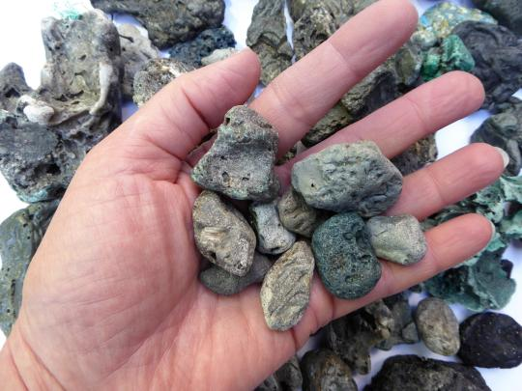

**Once they have been weathered by the sea plastiglomerates look just like real rocks… but float**

A picture containing table, food, plate, beverage

Description generated with high confidence

**Balloons**

Balloons and their associated debris (nozzles, streamers etc.) continue to form a significant proportion of marine litter found washed up on South West beaches, with 2,223 pieces of balloon debris being reported by beach cleaners at 39 locations over a six-month period and published in the January 2017 *Just a Balloon* report compiled by the Cornish Plastic Pollution Coalition. This report was used as a basis for an article by the CPPC in the Journal of Litter and Environmental Quality (Vol 2 No 1 May 2018):

<http://www.keepbritaintidy.org/sites/default/files/resources/15913_Journal%20of%20Litter%20and%20Environmental%20Quality_v7-online.pdf>

Traceable balloons (usually branded corporate promotional balloons) often demonstrate just how far balloons can travel from their source before falling back to Earth.

Despite often being marketed as ‘100% biodegradable’ latex, it seems that balloons, like other supposedly biodegradable materials, biodegrade poorly in the cold, oxygen-poor conditions of the sea, or if they do so this probably takes far longer than most consumers would imagine – and certainly long enough to pose a risk to marine wildlife.

Citizen science experiments by CPPC members (clearly not replicating true environmental conditions) do give some indication of balloons’ longevity).

A close up of a piece of wood

Description generated with high confidence

**A Triceratops 100% biodegradable latex balloon three years after being placed in a jar of seawater with holes in the lid, left outdoors exposed to sunlight.**

Researchers at Plymouth University are now starting to investigate the true biodegradability of balloons in the marine environment, using a selection of balloons supplied by the National Association of Balloon Artists and Suppliers. These trails will commence during the summer of 2018 and proceed for approx 1-2yrs in order to fully establish degradation times. It is hoped that the results of this research could prove useful demonstrating the need for legislation around balloon releases, which are not currently classed as littering.

**Cornish seal pup with McDonalds Happy Meal balloon**

**Picture: Rob Wells**

**Cornish seal pup with McDonalds Happy Meal balloon Picture: Rob Wells**

A picture containing outdoor, ground, beach, laying

Description generated with very high confidence

A picture containing ground, animal, indoor, sitting

Description generated with high confidence

**A dead shearwater next to a plastic straw and pieces of a red balloon found inside it on North Stradbroke Island, off the coast of Brisbane, Australia. (CSIRO via AP)**

**Bio-beads**

Bio-beads (specially-machined pellets, superficially similar to nurdles, used as biomedia in some South West Water wastewater treatment plants and possibly other industries) have continued to be found in huge numbers on Cornish beaches. On Tregantle beach (Whitsand Bay, South East Cornwall), volunteers have removed an estimated 10 million mixed pellets from a 100m stretch of beach in seven sessions over the past year, using a dedicated microplastics separation machine. Bio-beads account for over 50% of the pellets removed.

**Smooth, lentil-shaped black nurdles (left) and wrinkly black bio-beads, deliberately misshapen to give them a larger surface area to support the growth of a biofilm of bacteria to digest ammonia in wastewater (right).**

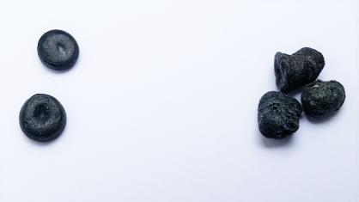

The Cornish Plastic Pollution Coalition’s report on bio-bead pollution on Cornish beaches is shortly due to be updated to reflect numerous additional reports of finds.

Since the original report’s release in October 2017, analysis carried out by Dr Hideshige Takada of International Pellet Watch at the Tokyo University of Agriculture and Technology interestingly revealed a chemical distinction between bio-beads and regular nurdles (pre-industrial pellets) through the signature of adsorbed contaminants.

Analysis of 200 bio-beads and 200 nurdles found within the same 1m 2 area on Tregantle beach, Whitsand Bay, in Cornwall, showed similar levels of PCBs, DDT etc. on bio-beads and nurdles. However, the bio-beads had levels of polycyclic aromatic hydrocarbons (PAH) three to four times higher than those found on the nurdles. Given that PAHs derive from burning hydrocarbons the most logical explanation would be that the PAHs originated in roadwater run-off passing through wastewater treatment plants – strongly suggesting that the bio-beads were lost from such plants, and not from container ship spills during transit to their destinations from the point of manufacture.

Subsequent analysis by Dr Andrew Turner at the University of Plymouth, looking at the additives in black bio-beads compared with regular black nurdles, from a range of sites around the South West as well as Sussex, South Wales, Holland and northern France, has revealed extremely high levels of lead, antimony, bismuth and bromines in the bio-beads, with negligible levels of these additives in the nurdles.

Once again, this strongly suggests a very different source for the bio-beads and nurdles, and that the bio-beads were made from recycled electronics.

For more information or a copy of the updated report please contact Claire Wallerstein on claire.wallerstein@gmail.com

**A snapshot of plastic pollution on one beach**

Rame Peninsula Beach Care has recently released the results of its three-year, quarterly survey of the same 100m stretch of Polhawn beach on Whitsand bay, conducted as part of a nationwide study of 19 sites around the UK for the Marine Conservation Society on behalf of Defra.

A huge amount of work went into collecting, sorting, categorising and counting the waste according to the OSPAR protocol, with a total of 68,739 pieces of manmade debris being picked up over the 12 surveys (an average of 5,728 each time).

Nearly all of the items recorded were plastic (the figures do not include microplastics and nurdles, which are too small to be meaningfully collected.)

By far the largest category was found to be simply indistinguishable smashed up fragments of plastic - totalling 34,546 bits, most of which were in the 0 to 2.5cm category.

However, there were also significant amounts in the fishing-related, consumer-related food and drink packaging, and industrial waste categories (probably largely due to the area offshore having historically been used for Dockyard dumping of solid waste).

Some of the more unusual items included a cut-up piece of credit card with an expiry date in 1993, a World War II anti-aircraft fuse, Lego from a 1997 container ship spill off Land's End, a Canadian lobster pot tag from 2009, and HP printer cartridges from a container ship spill in the Atlantic in 2014.

The amount of items varied a lot from survey to survey, with no obviously seasonal link, and no clear reduction over time either (with the highest being 10,580 pieces in January 2016 and the lowest 1,929 in September of the same year).

It is hoped that these figures, when combined with those from the other locations, will help to provide a useful set of baseline data about marine plastic on UK shorelines that can be used in future to draw up more effective policy to tackle the marine litter problem.

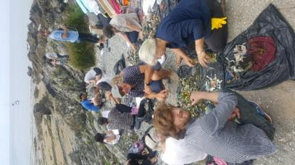

**Mermaids Tears and Witches Britches: Plastic Pollution Research**

**Dr Pennie Lindeque** Plymouth Marine Laboratory (PML) [pkw@pml.ac.uk](mailto:pkw@pml.ac.uk) +44 (0)1752 633415

[www.pml.ac.uk/Research/Research_topics/Facing_the_challenge_of_new_pollutants/Marine_plastics](http://www.pml.ac.uk/Research/Research_topics/Facing_the_challenge_of_new_pollutants/Marine_plastics)

Over 322 million tonnes of plastic are produced globally each year, and it is predicted more plastic will be produced in the next decade than in the whole of the last century. Of this plastic, 40% is used for single-use items such as food packaging and drinks bottles. While plastic has vast societal benefits with countless applications, due to poor waste management, road run-off and littering, plastic is entering our oceans at an unprecedented rate, where it has become a widespread environmental pollutant, contaminating oceans, seas, coastlines and rivers worldwide. Of increasing concern are ‘microplastics’ (microscopic plastics, 0.1 µm–5 mm), which come in a variety of shapes, sizes and polymers, with microplastic fibres, stemming from synthetic fabrics and ropes, being particularly prevalent. It is estimated that over 4.75 trillion individual microplastic particles are floating on the world’s oceans, and they’ve been identified in polar ice, deep-sea sediments, and beaches of remote oceanic islands.

This ‘rocket’ talk will give a quick update of the research of the microplastic team at Plymouth Marine Laboratory including:

* Analysis of a 10-year nationwide assessment of marine anthropogenic litter using citizen science data from the Marine Conservation Society.
* Assessment of microplastic pollution in coastal waters off Plymouth; a comparison of sampling with different mesh sizes.
* Fate and impact of microplastic; ingestion of microplastic by zooplankton in their natural environment.
* Investigation of microplastic trophic transfer to marine top predator.

**Marine Planning, Management, Development and Pollution**

**Richard White**

**2017 Development and Planning**

Discussions around **dredging in the Fal** are ongoing. The Marine Management Organisation continues to liaise with the Falmouth Harbour Commissioners and held meetings in early 2017 to discuss the results of the MMO’s draft ‘shadow’ assessment and the implications of the project on designated feature in the Fal and Helford Special Area of Conservation (SAC). An independent report assessing the legal interpretation of case law by both parties has yet to be accepted.

* MMO project history: <https://www.gov.uk/government/publications/falmouth-habour--2#history>

Plans for the development of **Dean Quarry** appear to be on hold as the developers, Shire Oak Quarries, are ‘…reviewing the operational requirements for the quarry…’, expressing an aim of working closely with local communities to reduce the project’s impact. However, claims and counter-claims regarding possible financial inducements offered suggest that the developers are finding community engagement somewhat challenging.

* Local views: <http://www.cads2015.com/>
* Developer comments: <http://www.cmscoms.com/?p=11612>

The Dean Quarry proposals are linked to ongoing plans for development of a **tidal lagoon in Swansea Bay** by Tidal Lagoon Power. This is seen by the developers as the first of a series of tidal lagoons around the Bristol Channel/Severn Estuary. The scale of these possible developments and their potential environmental and wildlife impacts are causing concern. As part of the ongoing debate, UK Government commissioned the Hendry Review on the future of tidal lagoons which was published in January 2017. The report recognises the potential value of tidal lagoons and proposed that government commission a ‘pathfinder’ scheme to investigate key issues around their development. UK Government has still to decide whether to approve the scheme.

* Hendry Review: <https://hendryreview.files.wordpress.com/2016/08/summary-of-recommendations.pdf>
* Response from an environmental NGO: <https://www.wildlifetrusts.org/news/hendry-review-tidal-power-published-today>

*In June 2018 the proposal for Swansea tidal lagoon was rejected by the Government; it is not clear how this leaves the future of the project.*

After many years of research into the impacts of the disposal of dredged material at the **Rame Head disposal site** and because of much local lobbying, a new disposal site, Plymouth Deep, was announced by the MMO in March this year. It is perhaps worth noting that the Rame Head site will not immediately disappear, rather it will fade away, being classified as ‘unused’ after five years and then as ‘closed’ after ten.

* MMO announcement: <https://www.gov.uk/government/news/south-west-characterisation-disposal-project-new-site-announced>

Aquaculture has been given a big ‘thumbs-up’ in the UK Marine Policy Statement, albeit with recognition of the possible challenges and constraints. It is interesting to note therefore that the **Lyme Bay Mussel farm** has moved on from the initial pilot stage to the development of increased-scale production in recent years. The University of Plymouth has been carrying out monitoring for the start of the project, looking at any potential environmental impacts. Initial results suggest an increase in local biodiversity around the rope installations. As the pressure for developing similar schemes is likely to increase in the coming years, the results of this work will continue to provide important evidence to feed into future planning.

* Developers website: <https://www.offshoreshellfish.com/>
* Monitoring overview: <https://sheehanresearchgroup.com/offshore-mussels/>

**Bathing Water Quality** Following prolonged **‘poor’ water quality** results at **Instow Beach**, a consultation into removing the beach from the list of designated bathing waters in Spring 2017.

* Announcement: <https://www.gov.uk/government/consultations/bathing-waters-removing-instow-from-the-list-of-designated-bathing-waters>

Despite a majority of respondents begin opposed to de-designation, the Environment Agency have concluded that increasing water quality is not technically feasible and the beach has been removed form the list of UK bathing waters (March 2018) *Whilst Not technically a 2017 event – but seems churlish to ask people to wait another year to find out what happened!* Richard White

**Marine planning** provides the high-level context for these and future developments. The Marine and Coastal Access Act (2009) charged the Marine Management Organisation (MMO) with developing marine plans for English waters by 2020. These plans aim to:

‘…guide those who use and regulate the marine area to encourage sustainable development while considering the environment, economy and society.’[1]

The south-west of England falls into two of the MMO plan areas, South and South-west and these plans are at different stages of their development. Published in November 2016, consultation on the draft **South Marine Plan** closed in February 2017. Initial thoughts on the **South-west Marine Plan** were published in February 2017 to feed into stakeholder consultation events.

* South Marine Plan: <https://www.gov.uk/government/collections/south-marine-plans>
* South-west Marine Plan: <https://www.gov.uk/government/collections/south-west-marine-plan>

Outside the region, but with waters immediately adjacent, the draft **Welsh National Marine Plan** was published for consultation in December 2017.

* Welsh National Marine Plan: <https://beta.gov.wales/draft-welsh-national-marine-plan>.

**Salcombe Harbour & Kingsbridge Estuary Marine Biosecurity Plan 2017- 2020**

**Nigel Mortimer**

[South Devon AONB Estuaries Partnership](http://www.southdevonaonb.org.uk/coast-countryside/estuaries/salcombe-kingsbridge-estuary/) Salcombe Harbour & Kingsbridge Estuary Marine Biosecurity Plan 2017- 2020 This local estuary biosecurity plan has been produced by the South Devon AONB Estuaries Partnership, the local relevant authorities, organisations, owners, users and community of the Salcombe Harbour & Kingsbridge Estuary with support from Robin Payne and Sarah Brown from C2W. Non-Native Species (NNS) are those that have been transported outside their natural range by human activity. This may be the deliberate movement of a species, for aquaculture for example, but more frequently the accidental transport of species as ‘hitchhikers’ such as those attached to the hulls of vessels. When a NNS grows rapidly and starts to upset our environment, economy, health and the way we live they are often referred to as Invasive Non-Native Species. Whether a NNS becomes invasive or not is unpredictable and all pose some threat – in this document all are referred to as NNS. Biosecurity means taking steps to ensure that good practices are in place to minimise the risk of spreading non-native species. A good biosecurity routine is essential, even where invasive non-natives are not yet thought to be present. No single business or sector has been targeted in this plan, as everyone has a vested interest and role to play in successful biosecurity. All actions within the plan are undertaken on a voluntary basis. [Download the Biosecurity plan here.](http://www.southdevonaonb.org.uk/uploads/files/Estuaries/salcombe_kingsbridge/Salcombe_Biosecurity_Plan.pdf)

**Recreational impacts in the Plymouth Sound & Estuaries EMS: bridging science to policy**

**Beth Siddons** Plymouth City Council

[Beth.Siddons@plymouth.gov.uk](mailto:Beth.Siddons@plymouth.gov.uk)

**Olivia Langmead** Plymouth University

Olivia.Langmead@plymouth.ac.uk

The Plymouth Sound and Tamar Estuaries European Marine Site (EMS) is a complex site of inlets and bays, providing ideal conditions for a range of coastal and marine recreational activities. Its proximity to the city of Plymouth, and infrastructure enabling access (slipways, car parks, coastal paths), makes it a popular site for walking, sailing, kayaking, swimming, angling and diving. Understanding the location, intensity and seasonality of recreational activities and their pressures is key to identifying any potential impacts and disturbance to features of conservation importance. Forming part of the Habitats Regulations Assessment of the Joint Local Plan, developed by the four local authorities bordering the site (Plymouth City Council, Cornwall Council, South Hams District Council and West Devon Borough Council), the survey helps inform management plans to deliver sustainable recreational use. An assessment of recreational activities was undertaken using three complimentary methods: 1) Volunteer surveys conducted on-site; 2) Targeted workshops for key activities and 3) Online questionnaires. This revealed that recreational users are predominately local (to Devon and Cornwall) and there were seasonal trends, with more non-local visitors in summer. Terrestrial activities accounted for the majority of visitors surveyed, with their distribution reflecting the main access points within the EMS.

**Development of a real-time, regional coastal flood warning system for southwest England**

**Christopher Stokes** Plymouth University/SW partnership for Environment and Economic Prosperity (SWEEP) project.

Christopher Stokes1, Timothy Poate1, Gerd Masselink1, Jak McCarrol1, Erin King1

1 Plymouth University, School of Biological and Marine Sciences, Drake Circus, Plymouth, PL4 8AA, UK. [Christopher.stokes@plymouth.ac.uk](mailto:Christopher.stokes@plymouth.ac.uk)

An operational, real-time coastal flood warning system for the entire southwest of England has been developed as part of the [South West Partnership for Environment and Economic Prosperity](https://sweep.ac.uk/) (SWEEP) project, funded by the UK’s Natural Environment Research Council. Previous flood warnings for the region only accounted for predicted tide and storm surge levels, and ignored wave runup and wave set-up, which can contribute many meters to the total elevation of the sea and cause significant flooding during a storm.

To improve coastal flood warning requires a system that is capable of predicting wave runup and overtopping volumes along the unique, macrotidal southwest coastline, which features embayed, sandy, gravel, and engineered regions. First, a 1 km wave and hydrodynamic model was developed to forecast inshore waves and water levels up to 5 days ahead. Bathymetric profiles, representing the most at risk profile within each kilometre of the ~900 km coastline, were extracted for the calculation of wave runup, and three different empirical models were used to predict wave runup and overwash volume for different profile types, in real-time, from the output of the hydrodynamic model. Various stakeholders, including the Environment Agency, have partnered with SWEEP, and it is hoped that the system will now be used to inform and prioritise the roll-out of emergency resources across the southwest of England during extreme storm events. Prior to such events, automated alerts will be emailed to partnering authorities when certain thresholds of wave overtopping are predicted to occur in the forecast window, which will allow for pinpointed proactive flooding responses by the authorities at the locations predicted to be affected. The automation of this interlinked system of models for such a unique and diverse length of coastline represents a novel approach to predicting coastal flooding. The core wave and hydrodynamic model will next be used to develop other ‘bolt-on’ coastal monitoring and management tools, potentially including a lifeguard search and rescue tool, and a high-resolution lifeguard rip current model. Opportunities are now being sought to use the model to help predict the dynamics of coastal ecological systems in the southwest.

**Ocean Education, Citizen Science and Recording**

**Capturing the Coast using citizen science to record marine life around the UK**

**Nova Mieszkowska Marine Biological Association (MBA)**

[nova@mba.ac.uk](mailto:nova@mba.ac.uk)<https://www.capturingourcoast.co.uk/>

The responsibility for protecting our seas and marine biodiversity belongs to all of us. CoCoast represents a unique collaboration between research, university and conservation organisations around the UK that are concerned with increasing our knowledge base and conserving marine biodiversity. The CoCoast team train members of the public who are interested in learning about marine life to actively assist with data collection in both field and laboratory settings. Across the Training Hubs at seven university, research and conservation organisations around the country, over 3,500 citizen scientists have been trained and are engaging in surveys and experiments on rocky shores across the UK regional seas. CoCoast is investigating the impacts of climate change, extreme weather events, Invasive Non-native Species, and the development of artificial structures in the coastal zone on native biodiversity via studies on phenology, species interactions, and changes in the abundance and distribution of species around the UK coastline. Data are being made available to UK Country Nature Conservation Bodies and published in peer-review literature. CoCoast is empowering members of the community to actively engage with the discovery, recording and protection of intertidal habitats and the biodiversity that these ecosystems support in the UK.

**From Regional to Global: how good data support good stewardship**

**Dan Lear** Marine Biological Association (MBA)

[<dble@MBA.ac.uk](mailto:dble@MBA.ac.uk)

Your data matter. In this presentation we will look at how data collected and managed at the regional scale are contributing to the development of national and European policy and in tackling global challenges. We will explain the sometimes complex data flow pathways and highlight technical improvements that have streamlined data management activities. DASSH, the UK Archive for Marine Species and Habitats is based at the Marine Biological Association and forms part of a thematic network of data centres working towards common standards and guidelines to facilitate data discovery and reuse and improve access for all.

**MARINe-DNA: a forensic approach for detecting marine biodiversity**

**Professor Willie Wilson,** Marine Biological Association

[wilwil@sahfos.ac.uk](mailto:wilwil@sahfos.ac.uk) 01752 426415

As we continue to encroach upon the remaining ‘wild’ areas of our planet, evidence of the presence of rare and endangered species is a prerequisite for the implementation of conservation measures and management actions designed to ensure their survival in the future. But what about those creatures that are seldom seen and provide little or no evidence of population numbers or even whether they exist in an area at all? The evolving technique of analysing environmental DNA (eDNA) which may provide insights into what is, or at least has recently been, present in an area. The powerful tool of eDNA as a technique is now made possible thanks to the great strides that have taken place in molecular biology which enable the smallest of samples to be collected, filtered and sequenced to provide evidence of an organism’s presence within an environment; in a forensic sense, the organism’s genetic fingerprints are left behind. I will discuss the development of these molecular biology techniques to assess biodiversity in the marine environment and how we go about automating the detection methods.

**Sail training (ST) – an opportunity to advance ocean literacy (OL)**

**John Hepburn** The Island Trust

[mewstone.enterprises@gmail.com](mailto:mewstone.enterprises@gmail.com)

T: 01752 863764 / 07974 213301 Skype john.hepburn1 @JohnMewstone

ST - Educational experience that occurs on board sailing vessels of various sizes in various contexts around the world.

OL - Understanding the ocean’s influence on you and your influence on the ocean.

ST & OL should be natural bedfellows, but in UK and Europe they are not.

* Barriers to teaching OL include lack of connection with the Ocean.
* There is an appetite within ST for a qualification in marine environmental education.

Ocean Discoverability

* Project within The Island Trust taking disabled children day sailing in Plymouth waters in traditional sailing vessels.
* Strong educational element with emphasis on OL.
* Day's activities described.
  + Alongside – pontoon and seabed life, CO2/O2, NNIs, adaptation
  + Sailing – I Spy guide, maritime, plankton trawl
  + Alongside – plankton, evaluation
* Demonstrates it can be done. Could it be taken up by other organisations; what are the issues?
  + Make sail trainers marine science educators, or bring MSEs on board?
  + Qualification, toolkit of activities, access to expertise, cooperate with existing MSEs?

Who could take up the challenge?

**Inspiring people to connect to our beautiful UK SEAS**

**Penny Wilson** WWF-UK

[PWilson@wwf.org.uk](mailto:PWilson@wwf.org.uk)

Our seas are amazing. They give a home to wildlife, provide us with food and jobs, and even generate some of our energy, but many people feel disconnected from them. A recent survey by WWF in the UK found that despite oceans being one of the key environmental concerns – only 12% of those surveyed felt they ‘knew a lot’ about marine issues.

There are vast benefits to engaging the public with our oceans, from small scale changes an individual can make, to pushing for more effective management at a national and international scale. The recent success of Blue Planet II shows people care and are excited about the sea, when engaged in the right way.

[WWF’s UK SEAS project is working in North Devon](https://www.wwf.org.uk/what-we-do/projects/uk-seas-project) to inspire and excite local communities with the marine environment on their doorstep. In this presentation we will explore some of the challenges in communicating with the general public about the sea, its wildlife, and the conservation issues facing it. We will also discuss some of the approaches being used by the UK SEAS project in order to engage with local communities in new and innovative ways, and the opportunities for collaborative working in the future. 

**Blue Planet stories**

**Jonathan Smith** BBC Natural History Unit

*Blue Planet Two was screened in the autumn of 2017 to high praise and with the largest TV audiences of the year. The Blue Planet effect has been particularly pronounced after they highlighted the issues of plastics in the marine environment which has been a prompt to tackle single use plastics around the world.*

Jonathan is a natural history film Producer at the BBC Studios Natural History Unit specializing in underwater landmark wildlife films. His career has spanned projects for the BBC and Silverback Films including Life for BBC One, North America for DCI and Bears for Disney Nature. Most recently he produced two episodes of Blue Planet II.

Jonathan strives to push the boundaries of natural history storytelling through surprising storytelling, innovative filming methods and by developing new filming equipment in order to transport viewers into the natural world like never before. He believes that natural history documentaries can play an important role in conservation of species and habitats.

1. <https://www.gov.uk/government/collections/marine-planning-in-england>